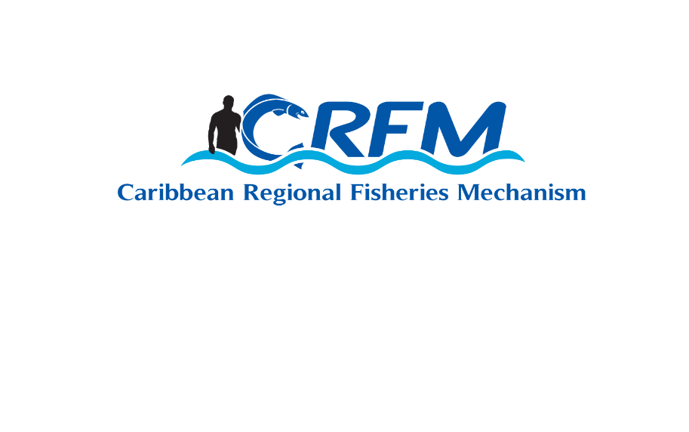

|  |
| --- |
| **Title of the Request for Proposal (RfP):**  **Technical support to Mainstreaming Gender Equality in Fisheries in the Caribbean** |

|  |  |
| --- | --- |
| **Date of this RfP:** 13 November 2019 | **Closing Date for Receipt of RfP:** **8.00am Central Standard Time on 2 December 2019** |

|  |
| --- |
| **RfP Reference: CLME/MGFC/01/19** |

|  |
| --- |
| **DESCRIPTION OF THE ACTION**  The purpose of this assignment is to provide technical support to mainstreaming gender equality in fisheries in the CARICOM / CRFM States. The main target countries for field activities are the CRFM Members (SIDS) involved in the flyingfish fisheries, namely, Barbados, Dominica, Grenada, Saint Lucia, Saint Vincent and the Grenadines, and Trinidad and Tobago.  The main deliverables expected are:   1. A Report which analyse and assess countries’ compliance with regional and international instruments (such as, but not limited to the United Nations’ Convention on the Elimination of all forms of Discrimination against Women (CEDAW); the World Program of Action for Youth to the Year 2000 and Beyond; the ILO Declaration on Fundamental Principles and Rights at Work; and the Sustainable Development Goals); in relation to fisheries; 2. Report on determination of appropriate gender-related data / research priorities; 3. Report on Gender Analysis and Action Plan on Gender Mainstreaming in Fisheries in the Caribbean for CRFM. The Action Plan will include the implementation of programmes to create awareness of decent work and gender issues / gaps; and a core set of appropriate indicators in regional strategic programmes); 4. At least three (3) updated national fisheries sector or related plans revised to incorporate and mainstream gender, decent work and youth issues, to ensure integration into the overall national framework(s); 5. Reports of gender awareness and mainstreaming capacity development and training workshops and activities conducted for Fisheries Departments / Division staff, CRFM Secretariat staff, executives and managers of national and regional fisherfolk organisations, including the portfolio of training material used to actively address equity/equality issues; 6. Report on development of regional and national monitoring and evaluation systems to track gender equality, decent work achievements, and youth involvement; 7. Report on gender sensitive traditional knowledge obtained from men and women on aquatic living resource management and fishing techniques |
| The main tasks / activities are as follows:  Work Package 1   1. Determine what gender-related data / research would be most appropriate at this time for “spring-boarding” the development of an evidenced-based gender mainstreaming strategy for fisheries and aquaculture 2. Based on assessments of existing policy, legal and institutional arrangements and practices to identify the decent work and gender issues / gaps: initiate programmes to create awareness about them; and, devise a strategy / plan for implementation to address the issues and gaps. This Gender Analysis and Action Plan on Gender Mainstreaming in Fisheries in the Caribbean for CRFM countries should, ideally, include an inventory of action plans, policies, rules, regulations that incorporate gender perspective(s) in the Caribbean; especially as they relate to the fisheries sector 3. Develop / adapt and facilitate the adoption by countries of a core set of appropriate indicators in regional strategic programmes (to be used in CLME+ State of the Environment reporting and information portals). This may include development of a gender evaluation / impact assessment tool. 4. Support countries with revision of their national fisheries sector plans or related policy instruments to incorporate and mainstream gender, decent work and youth lens to ensure integration into the overall national framework(s), in place to address these social issues. 5. Review countries’ compliance with regional and international instruments (such as CEDAW) and commitments in relation to fisheries   Work Package 2   1. Organise, in collaboration with appropriate national agencies, organize and conduct national and regional as appropriate gender-aware capacity development, mainstreaming and awareness training workshops or seminars for Fisheries Departments / Division staff, CRFM staff, as well as executives and officers of fisherfolk organisations to actively address equity / equality, decent work and youth issues. At least 1 training course workshop / seminar should be conducted for fisherfolks groups on gender mainstreaming, awareness and decent work and youth empowerment (this may include but not be limited to fisherfolk leadership courses) and 1 training course developed and conducted on gender-based analysis and reporting for CRFM staff. 2. Assist with establishment of regional and national monitoring and evaluation systems to track gender equality and decent work achievements, as well as youth involvement 3. Capture and document gender based traditional knowledge from men and women on aquatic living resource management and fishing techniques   General   1. Prepare impact assessment tools (consistent with Work package 1 (c)) for CRFM use in follow up work 2. Prepare bi-monthly technical activity progress reports. 3. Prepare a final technical report, taking into account comments provided by the CRFM Secretariat. The report would at least contain the following sections: Acknowledgements; Abbreviations and Acronyms; Executive Summary; Introduction; Approach to the Assignment; Comments on Terms of Reference; Organization and Methodology; Delivery of Terms of Reference; Description of Activities Carried Out; Project Mobilization; National Mission Reports (summaries as appropriate); Reporting; Comments and Conclusions; Recommendations (including lessons learned); Annex 1 - Terms of Reference; Annex 2 - Inception Report; Annex 3 - Mission Reports; Annex 4 - Consultancy Products, namely: Work plan; programme reports, namely: Report on determination of appropriate gender-related data / research; Gender Analysis and Action Plan on Gender Mainstreaming in Fisheries in the Caribbean for CRFM; Revision of at least three (3) fisheries or other sector plans along the lines of Ecosystem Approach to Fisheries (EAF) to address gender, decent work and youth issues to ensure integration into the overall national framework(s); Review report on countries’ compliance with international instruments (such as CEDAW) in relation to fisheries; Reports of gender-aware capacity development and awareness training for CRFM, Fisheries Departments / Division staff, executives of fisherfolk organisations, including the portfolio of training material used to actively address equity / equality issues; report on development of regional and national monitoring and evaluation systems to track gender equality, decent work achievements, and youth involvement; report on traditional knowledge obtained from men and women on aquatic living resource management and fishing techniques   d) Drafts of each product/output mentioned above are to be reviewed by the CRFM Secretariat, prior to finalization.  The action should be conducted over 11 months and must be completed no later than the end of November 2020 |
|  |

|  |
| --- |
| **SPECIFIC REQUIREMENTS for PROPOSAL SUBMISSION**   1. Proposals must be written in Standard English and consist of a technical proposal and a financial proposal. 2. The Technical Proposal should provide the following information:    1. A description of the firm’s / company’s / consortium’s or individual experience on comparable assignments    2. At least three client references, with information regarding similar services along with contact information (name, telephone numbers and e-mail addresses).    3. A detailed description of work plan / schedule for performing the assignment    4. Recent CVs of principal / partners / key staff members / key experts    5. A detailed description of the proposed methodology. 3. The Financial Proposal should list all costs associated with the assignment. It is expected that the stipulated costs would be broken down by activity and outputs. 4. In the case of a Firm / Company, proof of Legal status must be submitted.    1. Articles of incorporation 5. The following contact information must be provided:    1. Legal Name of Company / Consortium / Partnership / Individual(s)    2. Company’s / Consortium’s Authorised Representative(s) (Name / Title) (in the case of a Firm)    3. Full address    4. Telephone and Fax numbers    5. Skype Address    6. Email address    7. Website    8. Number of technical persons in the organisation / company 6. The cost of preparing and submitting the proposal is not reimbursable as a direct cost of the assignment. 7. CRFM is not bound to accept any of the proposals submitted. 8. CRFM’s policy requires that respondents provide professional, objective, impartial advice and at all times, hold CRFM’s interests paramount without any consideration for future work, and strictly avoid conflicts with other assignments or their own corporate interests. Respondents shall not be hired for any assignment that would conflict with their prior or current obligations to other clients, or that may place them in a position of not being able to carry out the assignment in the best interest of CRFM. |

|  |
| --- |
| **SUBMISSION, RECEIPT, AND EVALUATION OF PROPOSALS**   1. Proposals shall be evaluated taking into consideration, but not limited to, the requirements listed below: 2. Gender Specialist and Team Leader 3. At least eight (8) years’ experience working with national / regional / international bodies in gender mainstreaming and awareness issues; 4. Proven report-writing, communication and project management skills 5. Specific experience in the process of elaboration and implementation of mainstreaming measures (minimum 3 major assignments); 6. Experience in developing and implementing gender mainstreaming and awareness plans (minimum 2 assignments). Experience in the Caribbean region and in Caribbean fisheries are desirable. 7. Familiarity with the fisheries management agenda in CARICOM and internationally, particularly in the context of the Caribbean Community Common Fisheries Policy (CCCFP) and the FAO Voluntary Guidelines for Securing Sustainable Small-Scale Fisheries in the Context of Food Security and Poverty Eradication (SSF Guidelines) 8. The Gender Specialist and Team Leader should possess a post-graduate degree in management, gender studies, communication and/or related areas. 9. Experience in carrying out consultancy assignments for the UNDP, FAO, GEF or other equivalent international development partners would be an advantage. 10. Fisheries Management Specialist     * 1. At least six (6) years’ experience working in fisheries management       2. Demonstrated knowledge of Caribbean fisheries management policy and policy development       3. Experience in reviewing of fisheries operations (minimum 3 assignments);       4. Working experience in the Caribbean region is a requirement       5. The Fisheries Specialist should possess a degree in fisheries management, living marine resources management and/or related areas 11. Capacity development specialist 12. At least six (6) years’ experience in capacity development and training; 13. Experience developing training material (minimum 3 assignments); 14. Experience in Caribbean region is highly desirable. 15. Specific experience in the development of capacity development for stakeholder organisations; 16. Demonstrated knowledge of fisheries stakeholder organisations would be an advantage; 17. Output manager   An output manager who will be responsible for ensuring the quality and timeliness of agreed outputs (other than and/or in support of the team leader) would be an asset for the proposed team   1. Technical approach and methodology   Adequacy of the Technical Approach and Methodology in responding to the RfP, including proposed countries to be visited and rationale for such approach.   1. Work plan / Implementation schedule   Alignment of the Work Plan / Implementation Schedule with assignment outputs and interrelation of activities.   1. Fees / costs   Alignment of the fees / costs with assignment outputs and interrelation of activities.  The completed technical and financial proposals must be submitted to the Executive Director, CRFM Secretariat no later than **2 December 2019 at 8:00 a.m. (GMT -6)** at the address below. Proposals submitted after this date will not be evaluated.  **Address:**  CRFM Secretariat  Princess Margaret Drive  P.O. Box 642  Belize City, Belize, C.A.  Telephone: (501) 223-4443 / 4 / 5  Proposals are to be submitted in separate envelopes containing, respectively: (a) the technical proposal; (b) the financial proposal; and (c) the legal documents (only applicable for Firms / Companies). All envelopes must be sealed and bear the name of the Firm / Company / Consortium Leader, Title and Number of RfP and the contents of the envelope.  The Evaluation of the submissions will be based on a weighting of 70% for the technical merit and 30% for financial.  *Note: An electronic copy (PDF Format) of the Proposal*  *should also be submitted in the envelope*  **NOTE: Inquiries pertaining to this solicitation are to be directed to the attention of: The Executive Director, CRFM Secretariat, Belize, (**[**secretariat@crfm.int**](mailto:secretariat@crfm.int)**), copied to Deputy Executive Director, CRFM Secretariat, St. Vincent and the Grenadines (**[**crfmsvg@crfm.int**](mailto:crfmsvg@crfm.int)**)**  **and include the RFP reference.** |

This intervention is funded by the Government of Canada through the UNDP / GEF CLME+ Project