

ADMINISTRATIVE INFORMATION NOTE
BE: CLME+ Inception Workshop and 1st Steering Committee Meeting
27-29 September 2023, Panama City, Panama

This note explains in detail the administrative procedures that rule the participation in the Meetings. All participants are encouraged to become familiar with the information herein.

Background

The Project “BE-CLME+: Promoting National Blue Economy Priorities Through Marine Spatial Planning in the Caribbean Large Marine Ecosystem Plus” was conceived to strengthen blue economy opportunities through sustainable healthy coastal and marine ecosystems, address drivers to protect habitats and species, and sustainable biodiversity and fisheries management. The project will be implemented in Barbados, Belize, Guyana, Jamaica, Panama, and Saint Lucia for a period of 4 years from 2023-2027. The project is funded by the Global Environment Facility (GEF), implemented by the Development Bank of Latin America and the Caribbean (CAF) and the Food and Agriculture Organization of the United Nations (FAO), and is executed by the Caribbean Regional Fisheries Mechanism (CRFM) and the governments of the participating countries. The project’s objective is to promote blue economy development in the CLME+ through marine spatial planning and marine protected areas (MPAs), ecosystem approach to fisheries (EAF), and sustainable seafood value chains. The three components are:
• Component 1: Implementing cross-sectoral Marine Spatial Planning (GEF: $3,844,119; Co- financing: $26,461,550),
• Component 2. Inclusive Sustainable Fisheries Value Chains (GEF: $995,581; Co-financing: 7,746,046), and
• Component 3. Regional Coordination, Project Management & Knowledge Management (GEF: 1,168,300; Co-financing: 5,488,818)

- Introduction
The Inception Workshop and First Regional Steering Committee Meeting of the CAF/FAO/CRFM/GEF Project “Promoting National Blue Economy Priorities through Marine Spatial Planning in the Caribbean Large Marine Ecosystem Plus” (BE: CLME+) is being convened from 27-29 September 2023 in Panama City, Panama.

Purpose of the meeting
The CRFM Secretariat, on behalf of the participating countries and project partners has convened the meeting to:
- Review and approve the Project Work Plan and Budget for Year 1 of the Project.
- Review and approve the Terms of Reference (ToRs) for the committees that will provide technical, policy and management direction and oversight for implementation of the Project.
- Review and approve proposed monitoring and evaluation arrangements.

Participants
The GEF National Focal Points and heads of the national fisheries administrations of BE: CLME+ participating countries, or their designated representatives, and representatives from implementing partner organizations of the Project including those that have committed co-financing are invited to attend the meeting. Other regional and international organizations, NGOs, donors, and private sector representatives that have expressed an interest in the BE: CLME+ Project and its objectives are also invited to attend the meeting as observers.

Provisional Annotated Agenda

Day 1 – 27th of September 2023
Time | Agenda Item | Description
9:00 – 9:40 | Agenda Item 1 – Welcome and Opening of Meeting | Opening by CAF, UN FAO, CRFM and the Government of Panama.  Representative of the Government of Panama to declare the meeting opened.
9:40 – 10:00 | Agenda Item 2 – Election of Officers | Election of the following officers: the Chairperson, a Vice-Chairperson, and a Rapporteur. These officers will hold these positions until the Second BE: CLME+ Project Steering Committee Meeting.
10:00 – 10:15 |  | COFFEE BREAK
10:15 – 10:30 | Agenda Item 3 – Introduction of Meeting Participants | Participants to introduce themselves to the meeting.
10:30 – 10:45 | Agenda Item 4 – Review and Adoption of Meeting Agenda | The Meeting will review the Provisional Agenda and propose any changes deemed appropriate.  The meeting will then be asked to note any amendments proposed and adopt the agenda as amended.
10:45 – 11:30 | Agenda Item 5 - Background and Overview of the BE: CLME+ project document. | CAF and FAO to provide an overview of the CLME+ Project, including background to the development of the project, roles, and responsibilities of the GEF implementing agencies and executing agency, project objectives, project components, expected outcomes, project timeline, and summary budget.
11:30 – 12:30 | Agenda Item 6 - Review of the BE: CLME+ project coordination and management arrangements. | The CRFM Secretariat to present the TORS and proposed Rules and Procedures of the Regional Steering Committee, Technical Advisory Committee, and the National Focal Point.  The meeting will be asked to propose any amendments and approve the final versions.
12:30 – 14:00 |  | LUNCH
14:00 – 17:00 | Agenda Item 7 - BE: CLME+ Project and Budget for 2023-2024. | Component 1 - Implementing Cross-sectoral Marine Spatial Planning  The CRFM Secretariat/PMU to provide summary of the planned activities, budget, procurement, identification of key stakeholders, and potential partnerships.  Participating countries and partners will provide summary updates on recent developments regarding MSP & MPAs in their jurisdictions.  Discussion and assessment of opportunities and/or need for adjustment of activities and activity-level budget.
17:00 |  | Closure of Day 1
Day 2 – 28th of September 2023
9:00 – 12:00 | Agenda Item 7 - BE: CLME+ Project and Budget for 2023-2024 | Component 2: Inclusive Sustainable Fisheries Value Chains  The CRFM Secretariat/PMU to provide summary of the planned activities, budget, procurement, identification of key stakeholders, and potential partnerships.  Participating countries and partners will provide summary updates on recent developments regarding Seafood value chains in their jurisdiction.  Discussion and assessment of opportunities and/or need for adjustment of activities and activity-level budget.
12:00 – 13:00 |  | LUNCH
13:00 – 15:00 | Agenda Item 7 - BE: CLME+ Project and Budget for 2023-2024 | Component 3: Regional Coordination, Project Management & Knowledge Management  The CRFM Secretariat/PMU to provide a summary of the planned activities, budget, procurement, identification of key stakeholders, and potential partnerships.  Discussion and assessment of opportunities and/or need for adjustment of activities and activity-level budget.
15.00 – 15:15 |  | COFFEE BREAK
15:15 – 16:30 | Agenda Item 8 - Monitoring and Evaluation Framework of BE: CLME+ Project | The CRFM Secretariat to present the proposed arrangements for monitoring & evaluation (M&E) of implementation and progress in achieving results and outcomes.  Discussion and comments on M&E framework.
16:30 – 17:00 | Agenda Item 9 – Any Other Business | The participants of the Meeting will be invited to raise any other matter not covered by the Provisional Agenda but relevant to the purpose and scope of the Meeting. Observers may also be invited to make short interventions of relevance to the Project
17:00 |  | Closure of Day 2
Day 3 – 29th of September 2023
10:30 – 12:30 | Agenda Item 10 – Adoption of Summary Meeting Decisions | The draft Meeting Decisions will be presented by the Rapporteur for review and adoption, with amendments and corrections as appropriate.
12:30 – 13:00 | Closure of the Meeting | The meeting will be brought to a closed with statements by the Chairperson, the CRFM Secretariat, FAO, CAF, and other participants wishing to make brief statements.
13:00 – 14:30 |  | LUNCH
Note: There will be a running coffee break from the second half of Day 1 onwards.

- Registration and Opening Ceremony

You are kindly asked to register for the meeting online. A brief Opening Ceremony will be held on 27th September 2023 and commence at 9:00a.m. The Workshop will be conducted in English with simultaneous translation in Spanish.

Workshop arrangements

  - Travel arrangements:
- Airline tickets are provided in economy class for funded participants and will be issued by FAO. Flights are arranged for each participant, upon receipt of an e-mail from the relevant national authorities confirming the participant’s approval to attend the Workshop/Meeting.
- When you receive your ticket, please double check to make sure that your name and other particulars are correct and that your connections are clear. If for any reason you miss your flight or connection, immediately contact Ms. Sonya Thompson (Sonya.Thompson@fao.org)
- Please note, no airport pick-up service will be provided. Funded participants will be provided with an allowance to cover Terminal Expenses; hence, you will be responsible for your own transportation to and from the airport.

  - Accommodation arrangements:
Participants will be accommodated at the Hotel RIU Plaza Panama, 50 & 53 E Street, Urb. Marbella, Panama City, Panama (Tel: 507-282-0420) at a nightly rate of US$115.00 inclusive of continental breakfast and taxes. Free Wifi internet access is provided throughout the hotel.

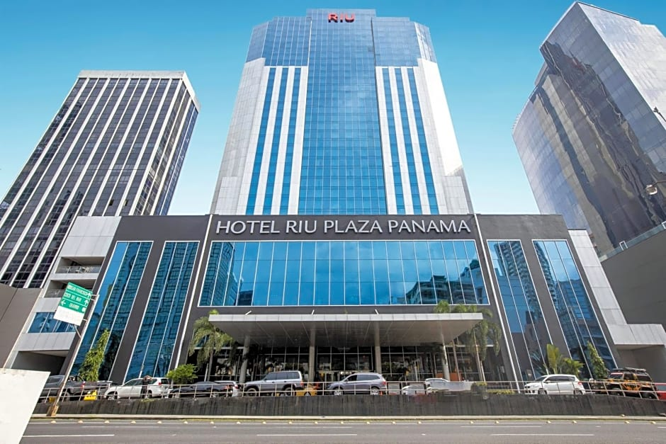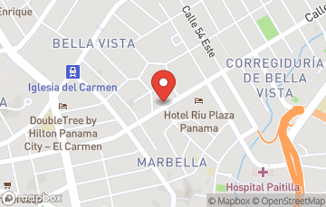

Meeting organizers paid the full cost of accommodation for funded participants. Rooms were blocked for self-funded participants and these participants are asked to make reservations directly with Hotel RIU Plaza Panama. Points of contact at the Hotel are Ms. Aristides Combe (acombe@riu.com) and Mr. Thomas Hand (coordinaciongrupos@riu.com).
Note that room service, laundry services, minibar, and damages will be your responsibility.

5.3 Per Diem Allowance:

Funded participants will be given a reduce Daily Subsistence Allowance (DSA) to cover meals and incidentals, and a terminal (transportation expenses) to and from the airport. Funds will be disbursed by FAO and will be deposited to your bank account.

Coffee breaks will be provided daily during the Workshop/Meeting, in the morning and in the afternoon. Please note, lunch will be provided by the organizers to all participants for the duration of the Workshop/Meeting.

Kindly submit all inbound boarding passes to Mr. Delmar Lanza (delmar.lanza@crfm.int) at the Meeting. Outbound boarding passes should be scanned and emailed to Sherlene Audinett (sherlene.audinett@crfm.int) on return to your country.

5.4 COVID Requirements:
There will be no testing requirements for entering Panama whether you are vaccinated or unvaccinated. In addition, the wearing of masks generally will now be optional.

5.5 Workshop Administration:
CRFM Secretariat will provide technical and administrative support for the Workshop.
Contact:
CRFM Secretariat, Belize, Telephone: (501) 223-4443:
Delmar Lanza: delmar.lanza@crfm.int; or
Sherlene Audinett: sherlene.audinett@crfm.int
secretariat@crfm.int

5.6 Security:
- Participants should exercise due care and attention to their surroundings to ensure that their safety is maintained throughout their stay.
- The hotel has security on and around the property.
- Participants should check their rooms to ensure that sufficient safety facilities are available and properly functioning (door locks, door chains, telephone, windows, etc.).
- Be wary of people hanging around outside the hotel.
- If you notice anything / anyone suspicious, you are asked to kindly notify the hotel, and advise the CRFM Secretariat representative.

Thanks for your kind attention and see you in Panama.

