**Case Study: Belize Fisheries and Tourism Markets-exploring linkages to enhance development, competitiveness and greater local participation**

**prepared by**

**Vincent Gillett**

**1.0 Introduction**

***1.1 background***

Marine fish exports, including aquaculture, have historically contributed significantly to the economic and social development of Belize. Income from exports of marine products grew from BZ$18 million in 1990 to BZ$26 million in 2014 ( Min of Agri., 2003; Stat .Inst. Bz. , 2014). The industry is ranked 5th in export earnings for the national economy. The latest available data list the industry's contribution to GDP as 2.2 percent (Gongora, 2012).

While the figures for fishery export are clear, those for domestic consumption are less so. In 1990, 30% of the Fisheries sector's output was consumed by the Tourism Sector (US lib. of cong. doc.). FAO (2005) estimated that 10% of the production was marketed to domestic consumers and the Tourism Sector. A Belize Fisheries Sector Report on the 2014-2015 Lobster Season stated that lobster consumption within the Tourism Sector was unknown (Gongora, 2015). The report noted, however, that most of the lobster fished in the vicinities of Placencia, Ambergris Caye and Caye Caulker was consumed by tourist.

Belize also has a significant tourism industry. Estimates are that tourism accounts for about 16% of the country's GDP and places the tourism sector at the forefront of the country's economic activity. (Belize Tourism Policy, 2005).

Apart from the nature and adventure based tourism, Belize has also experienced considerable growth in Cruise Tourism. Since 2003, cruise tourism has brought more than 500,000 day visitors per year to Belize. Growth in income is forecasted to exceed $39 million in 2015 representing a 21% increase over 2004 cruise ship arrivals and expenditures (Launchpad Consulting & D. Russel, 2005). Total tourist expenditures in 2006, reached nearly BZ$400 million dollars, which equates to 16.8% of GDP (BTB, 2007). Tourism is the largest contributor to GDP and provides most of Belize's foreign exchange income.

The contributions of Fisheries and Tourism to the economy of Belize have been significant. However, little attempt has been made to explore the synergies existing between the two sectors. Growth and development has been pursued separately and policies and institutions have not recognized nor advanced opportunities for cooperation.

Linking fisheries with tourism has become an important goal. It has become a major objective of the Caribbean Community Common Fisheries Policy and has been identified as a strategic goal of the 2013-2021 Strategic Plan for the Caribbean Regional Fisheries Mechanism (CRFM, 2013).

**Purpose**

The purpose of this study is to identify and document any business relationships that exist between fish producers and processors on the one hand and tourism industry enterprise on the other. It seeks to determine, in the absence of any relationship, if and how this can be achieved. The study will also identify key constraints that need to be addressed in order to advance linkages between the two sectors.

**Methodology**

The methodology adopted included a review of relevant literature, analysis of fisheries and tourism data and assessment of market information including product/production, product supply and accessibility, consumption, demand, employment, cost and income.

Whilst a review and analysis of the traditional fisheries and tourism data was done, it was determined that two other elements needed to be included in the study. These were sport/recreational fishing and climate change/climate variability.

Recreational-sport fishing is a rapidly growing segment of the Fisheries and Tourism Sectors as is evidenced by its economic value and the broad spectrum of stakeholders involved in the industry.

Climate Change and Climate Variability will influence policy, productivity, fish migration, tourism profile, market opportunities and the long term viability and sustainability of both sectors. These dynamics would be critical to the market integration exercise.

The study also constructed several project feasibility matrices. Here issues from each sector were identified, labeled and prioritized as potentially feasible project ideas for consideration and possible funding in the future - depending on the eventual course of this exercise.

**Anticipated outcomes**

It is anticipated that the study would have identified and documented at least one instance in which trade linkages were established or, where attempts were made to establish same or, how linkages could be achieved. And, where linkages can potentially exist, recommendations would be made to advance or enhance these through the identification of potentially enabling projects.

**2.0 Linkages between Tourism and Fisheries**

**2.1** The linkages between the Fisheries Sector and Tourism cover two (2) areas, namely:

* Food production
* Recreational activities

Food production activity dovetails with the tendency of tourists visiting Belize to consume seafood.

The recreational activities of note are recreational fishing and sports fishing. Both activities provoke broad biodiversity consideration in that both the availability of the fishstocks and the integrity of the ecosystems which supports them become relevant.

**2.2** The food production activities involve the participation of the:

* Capture Fishery Sub-Sector
* Aquaculture Sub-Sector

The Capture Fishery Industry refers to wild caught species from both the marine environment and continental water bodies or inland freshwater systems. Most fishery products that would be consumed by tourists come from the Marine Fisheries Subsector (See Table 3, Fig. 1 and PL1).

The main freshwater species that would be on the market is wild-caught Tilapia (See PL13).

A wide variety of imported seafood commodities is also on the market. These include: Tuna cuts (See PL8), salmon portions (See PL9), ‘Bassa’ or imported Vietnamese catfish fillets (See PL7), scallops (See PL12), crab sticks (See PL11), mussels, squids and clam (See PL14).

Commodities that would be available from aquaculture production are Penaeid shrimps and Tilapia (See PLs 5 & 13).

Both the Capture Fishery Industry and Aquaculture are export-oriented.

**2.3 Recreational Activities**

**Sports Fishing**

Sport fishing was the first activity to attract the "specialty" tourist to Belize (Huesner, 1996). This proceeded from the 1950's when keen local fishers would do a "day trip" fishing for King-fish (*Scomberomorus cavall*) and or Tarpon (*Megalops atlanticus*). After five decades of developing the fishery, Belize is now one of the few countries in the world where fishing enthusiast can perform the "Grand Slam". That is;characterized by sequentially catching a Permit (*Tachinotus falcatus*), a Tarpon (*Megalops atlanticus*) and a Bonefish (*Albula spp*.) in one day. Three of the World's Top Ten Permit Fishing destinations are located in Belize (Huesner pers.comm).

While these three fish species are much sought after, they are but three of 22 fish species officially designated as "sport fish" by the Government of Belize through Statutory Instrument 14 of 2009.

**2.4 Stakeholders involved**

Stakeholder engagement in the issue of the interrelationship between Tourism and Fisheries development in the exchange of goods and services between the two sectors is critical. Therefore, it is important to identify who these stakeholders are and the role they play in the provision of goods and services.

**2.4.1 Recreational-Sport Fishing Stakeholders**

Identifying stake holder may be somewhat complicated. They are however, largely determined by the activity or role they play in the sector. In Belize for example, fly fishing is known as "sports fishing", reef fishing, "tourism fishing" and "drop fishing" or "recreational fishing" (Perez-Cobb *et.al.,* 2014).

Service providers in the industry are grouped into five types namely; fishing lodge, tour guide, tournament organizer, shop (equipment and accessories) and hotel and resort.

The major stakeholders are the fishing guides, tour guides, boat owners and captains, and fishing lodges and hotels. Lodges act as conduits linking fishing clients with the guides. Hotels traditionally promote a variety of tours including "sports fishing" tours.

It is worthy to note that the leaders of influence are the fish and tour guides who work closely with their membership (Fish and Tour Guides Association) and members of the International Game Fish Association (IGFA) in establishing codes of conduct and ethic within the sub-sector.

Other major stakeholders include the Belize Fisheries Department (BFD) and the Coastal Zone Management Authority and Institute (CZMAI). Both of these entities are responsible for formal management of recreational and sport fishing as defined in the Fisheries Act ( Chapter 210 of the Laws of Belize; Revised edition 2000 -2003) and the Coastal Zone Management Act ( Chapter 129 of the Laws of Belize; Revised Edition 2000-2003).

**2.4.2 Fisheries Stakeholders**

The primary stakeholders for the Fisheries Sector are the producers and the organizations associated with the goods and services they provide to the sector.

The primary stakeholders in the Capture Fishery Sub-Sector are the Cooperative Fishermen as well as the independent fishers (See Fig. 1). Primary stakeholders also include the Fishing Cooperatives as institutions, - namely:

* Northern Fishermen Cooperative
* National Fishermen Cooperative Society
* Placencia Fishermen Producers Cooperative Society
* Caribena Fishermen Cooperative
* Rio Grande Fishermen Cooperative

A private, non-fishing cooperative seafood trader has entered the market over the last few years – this is Rainforest Seafood (See PL 5).

The secondary stakeholder for the Capture Fishery Subsector is the retailer of seafood. As shown in Fig. 1 below, these include:

* Supermarkets
* Cooperative processing houses and retail outlets
* Open markets
* Fish landing sites
* Independent fish traders

**Fig. 1: Fishery Product Consumption by Tourists**



The primary stakeholders from the aquaculture sector are the shrimp farms and fish farms (See Fig. 1).

The secondary stakeholder for the Aquaculture Subsector is the retailer and distributor. These are mainly the supermarkets (See Fig. 1).

The tertiary stakeholders are the regulatory arms of the industry. In this case the Belize Fisheries Department and the Belize Agriculture Health Authority (BAHA).

**2.5 Importance of Tourism and Fisheries in the National Economy**

**2.5.1 Tourism**

**GDP contribution**

Tourism is the single most important industry in Belize. It contributes significantly to the country's tax revenues and foreign exchange earnings. In 2006 tourism accounted for 16% of GDP. In 2007 GDP was 17% and in 2011 GDP contribution was at 30% (Robertson 2007; NCRIP 2011). A marginal decline of 0.2% was experienced in 2015 as fewer overnight tourists and cruise ship passengers visited Belize in comparison to 2014.

**Revenues derived**

As shown in Table 1 below, over BZ$200 million of reported annual tourist expenditures was recorded in Belize for the 1999 to 2006 period

**Table 1: Economic Impact of tourism in Belize: 1999-2006\***

|  |  |  |  |  |  |  |  |  |
| --- | --- | --- | --- | --- | --- | --- | --- | --- |
|  | **1999** | **2000** | **2001** | **2002** | **2003** | **2004** | **2005** | **2006** |
| Tourism Expenditures  (BZ $millions) | 222.9 | 240.4 | 241.0 | 265.6 | 311.4 | 345.3 | 349.4 | 398.8 |
| Tourism Expenditures (% GDP) | 15.2 | 14.5 | 13.9 | 14.3 | 15.9 | 16.7 | 15.8 | 16.8 |

**\*** Adapted from BTB, 2006

In 2011 the travel and tourism industry directly contributed BZD 350.6 million (USD 176 million) to Belize's GDP (12.0% of GDP). This primarily reflects the economic activity directly generated by industries supported by tourists, such as hotels, restaurants, leisure industries, travel agents, airlines and other transportation services. The total contribution to GDP in 2011 (including wider effects from investment, the supply chain, and induced income impacts) was BZD 971.9 million (USD 486 million) representing 33.2% of GDP ( https//en.wikipedia.org)..: //en.wikippdia.org).wikipedia.org).

**Employment**

Data collected show that employment in tourism rose from one out of every 11 persons in 1998 to almost one out of every seven by 2006 ( A. Q. Novelo *et.al.* , 2007). This is summarized in Fig. 2 Below. Travel and tourism directly generated 14,500 jobs in 2011 (10.9% of total employment) and, including indirect and induced effects, supported 40,000 jobs (http://en.wikipedia.org). The BTB, in 2007, noted that hotel employment had more than doubled between 1993 and 2005.

**Fig 2:Employment in the Tourism Sector;1998 -2006**



**Growth Trends**

Tourist arrivals have been growing steadily; growth being heavily influenced by the Cruise Ship industry. Between 1998 and 2006 passenger arrivals rose from 161,183 to 655,931. Average annual growth in overnight visitors was nearly 4.5% from 1999 to 2006 ( See Table 2 ). Overall, from 2002 to 2008, total international visitor arrivals to Belize increased by 18.6%. From 2004 to 2008, however, total arrivals decreased by an average of 6% per year (Tourism Master Plan, 2011).

In October, 2014 Belize reached its first one million visitor mark. This critical juncture has shown a 9.2% increase in overnight visitors, when compared to 2013 overnight total arrivals ( BTB, 2015).

**Table 2: Stay-over Tourist and Cruise Ship Disembarkations to Belize, 1998 - 2006**



**2.5.2 Fisheries**

**2.5.2.1 Capture Fisheries**

The most reliable statistics that are kept for the Capture Fishery Industry are export volume and value. Export earnings between 2003 and 2014 have ranged from BZ$17.4 Million to BZ$24.8 Million respectively (See Table 3). As shown in Table 3, these values exclude the contribution of white farmed shrimp. The export volume over this timeframe (excluding white farmed shrimp) ranged from 1.0 Million pounds of fishery products, to 1.6 million pounds.

The value of these statistics hinges on two main issues:

Firstly, they give a good representation of the range of fishery products available to the tourism market. Secondly, for the high value lobster and conch species, there is a greater relationship between the total amount of biomass landed and processed and the quantum of exports relative to finfish. Conch exports in 2014 for example, were 758 thousand pounds while that for finfish were 276 thousand pounds; a fact not reflected in the export statistics, since most of the finfishes produced are destined for the domestic market (See Table 3).

**Table 3: Fisheries Export Data**

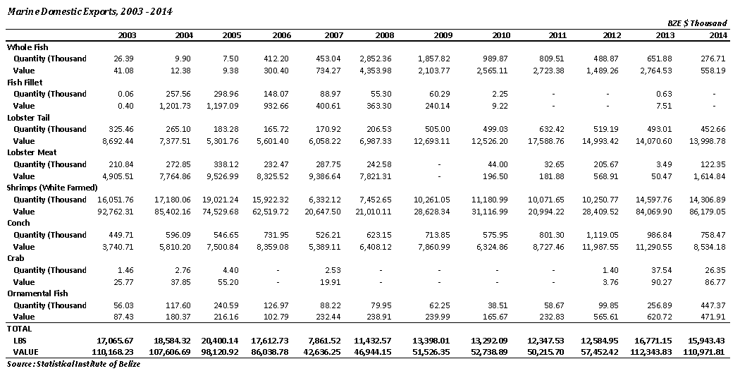

The Fisheries Sector contributed 2.2% to GDP in 2008 (Wade 2010). This value encompasses both the Capture Fishery Sub-Sector and Aquaculture.

The Capture Fishery Sector provides direct employment to over 2,459 fishers and 137 processing plant workers (Villanueva 2015).

**2.5.2.2 Aquaculture**

Aquaculture for food production purposes have varied from one (1) to three (3) species between 2003 and 2014. The most significant species in terms of production, volume, and availability is the Pacific White Shrimp (*Penaeus vannamei*). The other two species cultured in Belize are the Tilapia (*Oreochromis niloticus*) and the Cobia (*Rachycentrum canadum*). The latter species went out of production in 2007 due to high feed costs and poor feed quality and consequently low growth performance and decreased yields.

The Tilapia (*Oreochromis niloticus*) like the White Shrimp (*Penaeus vannamei*) is still in culture. Over the last year however, production is still insignificant to the extent that no export production has been documented for 2014 (See Table 4). The White Shrimp has been the longest species in culture in Belize and accounted for over ninety percent (90%) of the production.

Export revenues from aquaculture varied from Bz$ 92.7 Million in 2003 to BZ$ 86.2 Million in 2014 (See Table 4). Kehr et al reported that the White Farmed Shrimp (*Penaeus vannamei*) accounted for over 80% of total Fishery Product Export revenues in 2007. In 2014 this amounted to 77. 8% (See Table 4).

**Table 4: Aquaculture exports (After Statistical Institute of Belize)**

|  |  |  |
| --- | --- | --- |
| **Year** | **Aquaculture Production Volume and Value**  (Farmed Shrimps) | |
| **Volume** ( X 103 lbs) | **Value** (Bz$ X 103) |
| 2005 | 20,400 lbs | $ 98,121 |
| 2006 | 17,612 lbs | $ 86,039 |
| 2007 | 7,861 lbs | $ 42.636 |
| 2008 | 11,433 lbs | $ 46,944 |
| 2009 | 13,398 lbs | $ 51.526 |
| 2010 | 13,392 lbs | $ 52,739 |
| 2011 | 12,348 lbs | $ 50,216 |
| 2012 | 12,585 lbs | $ 57,452 |
| 2013 | 16,771 lbs | $ 112,344 |
| 2014 | 15,944 lbs | $ 110,972 |

**2.5.2.3 Sport/Recreational Fishing**

**Economic Value of Industry**

Felder and Hayes (2008 estimated that fishing for Bonefish ( *Albula vulpes*), Permit (*Trachinotus falcatus*) and Tarpon (*Megalops atlanticus*) in Belize generated gross revenue of USD 28 million in 2007, of which USD 15 million was earned in annual salaries and wages.

**Employment**

The fishery provides support for 13 fishing lodges which supports the employment of some 1,864 persons, at least 100 of whom are independent fishing guides (Felder & Hayes, 2008).

**Trends going forward**

Projections are that the industry will continue to grow. While Bone fish ( *Albula vulpes*), Tarpon (*Megalops atlanticus*) and Permit (*Trachinotus falcatus*) are the overwhelming target of sport fishermen other reef fish namely, the lane snapper (*Lutjanus synargris)*, the Mutton snapper ( *Lutjanus analis)* and the Yellowtail snapper (*Ocyurus chrysurus)*, form part of the targeted species.

Growth is reflected in an overall increase in sport fishing license fees collected by the Coastal Zone Management Authority (See Table 5) since implementing its sport fisheries administration and licensing program.

**Table 5: Annual Sport fishing license issued and Income.**

|  |  |  |
| --- | --- | --- |
| **Year** | **Number of licenses** | **Annual Income (BZ$)** |
| 2012 | 2,280 | 92,820 |
| 2013 | 1,299 | 61,400 |
| 2014 | 2,687 | 112,230 |

In addition, the Belize Tourist Board is heavily promoting sport fishing for fishing lodges nationally and internationally through its marketing department. Importantly, Felder and Haynes (2008) predicts that by the end of this decade annual sport fishing revenue may reach or exceed USD 300 million if the quality of the fishing is maintained and the practice of catch-and-release is continued.

**2.6 Relationship between fish production, processing, packaging, warehousing/storage, distribution and marketing**

**2.6.1 Aquaculture**

The two (2) species being cultured for food production at a commercial scale are the Pacific White Shrimp (*Penaeus vannamei*) and the Tilapia (*Oreochromis niloticus*). Currently thirteen (13) farms are in operation in Belize only one of which - a fish farm - operates on an industrial scale (See Table 6).

A number of the shrimp farms in Belize are vertically integrated with a hatchery or seed stock production facilities, a processing plant and the production ponds or on-growing systems. The hatcheries are designed to supply the seed stocks that would be stocked into the production ponds: The processing plants process the harvested produce from the ponds.

**Table 6: Status of Shrimp Farm Certification**

|  |  |  |
| --- | --- | --- |
| **Farm** | **Operational Status**  (As of Dec.31, 2014) | **ASC Certification**  (As of Dec. 31, 2015) |
| Aqua-Mar Shrimp Farm | √ | √ |
| Aqua-Sur | √ |  |
| Bel-Euro Aquaculture Ltd | √ | √ |
| Belize Aquaculture Ltd | √ | √ |
| Cardelli Farms Ltd | √ | √ |
| Destiny Aquaculture Ltd | √ |  |
| Four Hands Aquaculture Ltd | √ |  |
| Haney Farm | √ |  |
| Paradise Shrimp Farm Ltd | √ | √ |
| Royal Mayan Shrimp Farm Ltd | √ | √ |
| Tex-Mar Shrimp Farm Ltd (North) | √ | √ |
| Tex-Mar Shrimp Farm Ltd (South) | √ | √ |
| Tropical Aquaculture Investment Ltd (TAIL) | √ |  |

After processing, packaging and warehousing shrimps are marketed as ‘Fresh Frozen” products.

The vast majority of shrimps are marketed overseas – mainly to the United States and to a lesser extent the Caribbean and Europe. A small and indeterminate proportion of the shrimps produced remain in Belize. This is marketed to consumers in general, including the tourism market (See Fig. 1).

Over the last three to four years much of the farmed shrimp production from Belize was marketed to Mexico in an unprocessed form. Once harvested from the ponds, shrimps are iced and transported by Mexican Container Trucks across the northern border to lower Yucatan, including the City of Merida for processing and marketing (Pers. Comm. R. Quintana).

All of the shrimp processing plants in Belize have been HACCP Certified by the Belize Agriculture Health Authority (BAHA).

Farmed Tilapia is marketed as fresh-frozen fillets. Most of this is exported to the United States with a limited amount being left on the local market

Most of the farmed shrimps and Tilapia produced are marketed through the supermarket (See Fig. 1).

Apart from fresh-frozen tails, at least one shrimp farm has gone into further processing to produce a range of value-added forms – these included:

* Headless – shell on
* Peeled Pull Vein
* Ez-Peeled
* Peeled

The processed and packaged farmed shrimp and Tilapia are available in Belize City, Belmopan, the District Towns and much of the lager villages and cayes within the country.

There are no special or strategic marketing arrangements between the farms and the supermarkets for shrimps and Tilapia. There are also instances where middle-men retailers operate between the farms and supermarkets: These middle-men also supply directly restaurants.

**2.6.2 Capture Fishery Industry**

Fishery products on the domestic market from Capture Fishery sources derive from two (2) main streams, viz:

* Formal organized sources
* Informal sources

The formal source is the fishing cooperatives which process, package, store and market their products under strict industry standards mandated and enforced by BAHA under the BAHA Act Chapter 211 of the Laws of Belize.

Fishery produce are supplied to the Fishing Cooperatives Processing Houses by fishers who are members of the cooperative. There are two main Fishing Cooperative Processing Houses in Belize: the National Producers Cooperative Society Limited and Northern Fishermen Cooperative. These processing centers are located in Belize City with receiving stations in the south of the country. Commodities processed, handled and marketed by these cooperatives include:

* Lobster or Spiny Lobster (*Panulirus argus*)
* Conch or Queen Conch (*Strombud gigas*)
* Stone Crab (*Minnipe mercenaria*)
* Shrimps or Marine Shrimps including the Pink Shrimp (*Penaeus duorarum*), the Caribbean White Shrimp (*Penaeus schmitti*) and the Brown Shrimp (*Peneaus aztecus*)
* Finfishes (a number of grouper (Serranidae) and snapper (Lutjanidae) species, jacks (Carangidae), mackerels (Scombridae), and barracudas (Sphyraenidae)

The production volume and export value of these species are detailed in Table 3. These products are marketed as fresh frozen commodities. The processing houses have a ‘Retail Outlet’ to deal with local purchases including those establishments servicing the tourism sector. The vast majority of the Capture Fishery production is destined for the export market.

Produce from the informal stream are distinguished by the lack of any meaningful processing intervention. These markets are supplied by both Cooperative and Independent Fishers (See Fig. 1).

Production from the informal stream is generally sold at ‘Open Market Sites’ and ‘Fish Landing Sites’ in Belize City and other coastal municipalities, as well as in the Capital City of Belmopan (See Fig.1). Produce also reaches the public through ‘Independent Fish Traders’ (See Fig. 1). Fish Traders are instrumental in moving fishery produce from the coast to inland market locations such as the Twin Towns of San Ignacio and Santa Elena, as well as Belmopan City and Orange Walk Town.

**2.7 Recreational/Sports Fishing**

**Background**

All kinds of fishing including spin, fly, cast, trolling - can be experienced all year long along the coast of Belize; from the Port Honduras in the south to Rocky Point on Ambergris Caye in the North. Any of the many rivers which empty into the Caribbean along Belize's coasts can guarantee a daily catch. The estuaries, inlets and mouths to the many rivers are known for their tarpon (*Megalops atlanticus*), snook (Centropomus spp.) and jacks (Caranx spp.). The lagoons and grass flats are known for the bonefish (*Albula vulpes*), permit (*Trachinotus falcatus*) and barracuda (Sphyraena). The coral reefs support groupers (Serranidae), snappers (Lutjanidae), jacks (Carangidae) and barracuda (Sphyraenadea) while the deeper waters of the drop off are home to sailfish (Istiophorus alicans), marlin (*Makaira nigricans*) , bonito and pompano (*Alectis ciliaris*). Most types of fish can be caught year-round; from a dock, in tidal flats or in blue water hundreds of feet deep.

**Geographic scope**

Sport/recreational fishing for Bone fish (*Albula vulpes)* , Tarpon (*Megalops atlanticus)* and Permit (*Trachinotus falcatus*)is done along the entire coast of Belize, from Ambergris Caye in the north to Punta Gorda in the south. Bone fish (*Albula vulpes)* and Permit (*Trachinotus falcatus*) are primarily caught in the shallow back reef flats whereas Tarpon (*Megalops atlanticus)*are caught in creeks, channels and rivers.

**Species**

While anglers primarily target the Bonefish (*Albula vulpes)*, Tarpon (*Megalops atlanticus)* and Permit (*Trachinotus falcatus*), the Belize Fisheries Department {BFD) has identified and designated in S. I. 114 of 2009, 22 species of fish as "sport fish". However, the number of recreational fish species targeted and caught exceed this number (See Table 4) as documented by Perez-Cobb *et.al.,* (2014).

**Habitat and Distribution**

**Bonefish**

The habitats for Bonefish (*Albula vulpes)*, are the sand flats along the coast and cays. In Northern Belize they are found around the coastal sand flats on the eastern side of Ambergris Caye and the Cayo Francis and San Pedro Lagoons, and along the coastal mainland - from Midwinter's Lagoon to the Belize River. In Southern Belize and the outer Atolls, they occur on the sand flats around the south small cayes and the windward side of Black Bird Caye. They appear to be more abundant in Northern Belize than in the south**.**

Spawning aggregations of Bonefish occur in deep water within a few miles of the Belize Barrier Reef. Spawning peaks during the full and new moons in March and April of each year.

**Permits**

The Permit (*Trachinotus falcatus)* inhabits sandy beach flats and open sand flats throughout the Belize Barrier Reef region; particularly in the central reaches of the Barrier Reef lagoon and the Turneffe Islands.

Spawning aggregations occur every month from February through October during full moons in deep water promontories within the Bacalar Chico Marine Reserve area, the southern end of the Turneffe and Light House Reef Atolls, and Gladden Spit

**Tarpon**

Tarpons (*Megalops atlanticus)* occupy wetland habitats including most mangroves around cayes, along coastal lagoons and mangrove fringe along river mouths. They are particularly prevalent along river mouths in Southern Belize; from the Sarstoon to the Sibun River.

After years of residence in wetlands, juvenile tarpons (*Megalops atlanticus)* migrate from wetlands to coastal flats and estuarine habitats. In Northern Belize, this includes the Shoals of Lowery Bight, the Bulkhead Shoals of Ambergris Caye and most of the river and creek mouths.

Tarpons (*Megalops atlanticus)* also spend some time in fresh water; including rivers and inland fresh water lagoons. They then move from the fresh water lagoons to the open waters of the Belize Barrier Reef Lagoon where they take up residence around some cayes or in the tidal cuts, back reef flats and the many channels and canyons of the reef of Turneffe, Lighthouse and Glovers Reef Atolls.

Tarpons (*Megalops atlanticus)* spawn during annual aggregations, thought to occur near the new and full moons of late spring and summer. This is thought to occur some 75 miles east of the mainland of Belize**.**

**Table 7: Target Fish Species Captured in Recreational Fisheries**

|  |  |  |  |  |
| --- | --- | --- | --- | --- |
| Species | Fly Fishing | Reef Fishing | Local Recreational  Fishing | Blue-water  Fishing |
| *Albula vulpes* | X |  |  |  |
| *Balistes vetula* |  | X |  |  |
| *Caranx hippos* | X |  |  |  |
| *Trachinotus falcatus* | X |  |  |  |
| *Centropomus undecimalis* | X |  | X |  |
| *Coryphaena hippurus* |  |  |  | X |
| *Istiophorus platypterus* |  |  |  | X |
| *Makaira nigricans* |  |  |  | X |
| *Tetrapterus albidus* |  |  |  | X |
| *Lutjanus analis* |  | X |  |  |
| *L. apodus* |  | X |  |  |
| *L. cyanopterus* | X | X |  |  |
| *L. jocu* |  | X |  |  |
| *L. synagris* |  | X |  |  |
| *Ocyurus chrysurus* |  | X |  |  |
| *Megalops atlanticus* | X |  |  |  |
| *Acanthocybium solandri* |  |  |  | X |
| *Katsuwomus pelamis* |  |  |  | X |
| *Scomberomerus cavalla* |  |  |  | X |
| *S. maculatus* |  | X |  | X |
| *Thunnus atlanticus* |  |  |  | X |
| *T. obesus* |  |  |  | X |
| *Epinephelus itajara* |  |  |  | X |
| *E. fulvus* |  | X |  |  |
| *Mycteroperca bonaci* |  | X |  |  |
| *Sphyraena barracuda* | X | X |  |  |

**Fishing practices**

Fishing practices are cleverly described by A. Perez (2012) in his work on characterization of the recreational -sport fishing in Belize.

The sport fishery is categorized based on five distinct parameters including; 1)geographic area; 2) fishing objective; 3) fishing method and gear; 4) geomorphology of the fishing ground; and 5) motivation (competition). Based on these parameters, the Recreational-sport fishing is seen to be comprised of four fishing types; *Sport Fishing, Reef Fishing, " Recreational Fishing" and Deep Water Fishing.* In the first three instances fishing is normally conducted in shallow water whereas, in the last instance it is conducted in deep blue water.

The ***Recreational fisher***, primarily for snook (*Centropomus spp*.) may, depending on location, target their fish from a motorized vessel or from a dock or pier. The gear of choice is "Spinning" with weight and live bait or "Casting" with artificial bait.

The traditional ***sport-fisher***, fishes mostly for Bonefish (*Albula vulpes*), Permit (*Trachinotus falcatus*) and Tarpon (*Megalops atlanticus*). Depending on location and distance, Bone fish (*Albula vulpes*) and Permit *Trachinotus falcatus*) with rod and fly bait (fly fishing) Tarpons (*Megalops atlanticus*) are more commonly caught by deploying fly fishing gear or trolling in the rivers.

***Reef fishers*** targeting Yellowtail Snappers (*Ocyurus chrysurus*), Barracuda (*Sphyraena barracda*), Lane Snapper (*Lutjanus synagris*) Cuberas Snapper (*Lutjanus cyanopterus*), etc., fishing along the reef or within the reef pelagic zone, or among coral patches or in artificial habitats spin, troll, or drop fish using weight and live bait.

***Deep Water fishing*** is when big game offshore fishers -including competitive international fishers- fishing in motorized vessels hunt (using trolling gear) big game fish such as Marlins (Istiophoridae), Dolphin fish (*Coryphaena spp*.), skip jack tuna (*Katsuwonus pelamis*) and tuna (*Thunus spp*.).

**2.8 Supply and Demand scenario for The Fisheries Sector**

The supply and demand scenario for seafood products specific to the tourism sector remains unknown. It may be surmised from the dimensions of the tourism sector that the volume and value of fishery products consumed is significant. Although it is believed that most of the fishery products consumed by the sector are from domestic production, there are some fishery products that are imported. This includes salmon cuts (*Salma spp*.), Bassa or Pangasid Catfish fillets, scallops (*Pecten spp*.) and Green Mussels (*Perna spp*.).

The consumption of fishery products can be divided into two sub-sets, viz: those consumed by tourists in formal establishments, such as major hotels, resorts and live-aboard dive boats - and those consumed by tourists who do much of their own food preparation. Most products consumed by tourists in formal establishments are purchased from supermarkets and Fishing Cooperative Retail Outlets (See Fig. 1). Those tourists who do their own food preparations purchase their fishery products from the full range of retail outlets, viz: supermarkets, coop processing houses/retail outlets, open market locations, fish landing sites and independent fish traders (See Fig. 1).

**3.0 Governance Framework**

**3.1 Fisheries Department**

The Fisheries Act – Chapter 210 of the Laws of Belize provides the legal foundation for the management of the sector. The Act empowers the Minister responsible for Fisheries to appoint any Public Officer as a Fisheries Officers for the purposes of implementing the Act (See Fisheries Sec. 4, Sub-Sect 1). The Minister is also empowered to make Regulations for implementing the operational details, or activities, of the Act (See Sec. 12 ) including functions such as education, enforcement, scientific research and monitoring and prosecution for fisheries offenses.

**3.1.1 Institutional Arrangements**

The Fisheries Department falls within the Ministry of Fisheries Forestry and Sustainable Development (MFFSD). Therefore, issues related to the enunciation of policy, planning and legislation are enunciated and endorsed by the Central Administration of the Ministry.

The implementation of decisions taken by the Central Administration of the Ministry takes place at the Departmental level under the supervision and direction of the Fisheries Administrator. The Fisheries Administrator is answerable to the Chief Executive Officer of the Ministry who is in turn responsible to the Minister.

**3.2 Coastal Zone Management Authority (CZMA)**

**3.2.1 Organizational relationship within MFFSD**

The Coastal Zone Management Authority and Institute is but one of two institutions from the public sector that has legal responsibility for regulating and administering the recreational-sport fishery. Both institutes are under the Ministry of Forestry, Fisheries and Sustainable Development (MFFSD). The MFFSD is comprised of seven departments and units including; I) the Department of Fisheries; 2) the Department of Forestry; 3) the Department of the Environment; 4) the Sustainable Development Unit; 5) the Climate Change Office; 6) the Coastal Zone Management Authority and Institute; and 7) The Protected Areas Conservation Fund (PACT).

**3.2.2 Structure and function of CZMA**

Structurally, the CZMA operates at two levels: ‘Institutional’ and ‘Organizational’. Fig. 3 below show the separation between the ‘Institution’ and the ‘Organization’ showing a clear vertical hierarchical arrangement, and reporting relationships and flow of information, between the two except in the case of the Advisory Council that reports to the Board of Directors through its Chairperson. Operationally, the CZMA or ‘Authority’ is directly charged with policy formulation, issues relating to the legal framework, and overall operations, administration, and accountability. It thus operates closely with and within the institutional framework. That is, in association with the Board of Directors, the Advisory Council and, in accordance with the provisions of the CZMA Act (Adopted from CZMAI Draft Strategic Plan: 2015-2030).

The implementation, monitoring and reporting functions of decisions taken by the Board take place at the Authority/Institution level under the supervision and direction of the Chief Executive Officer (CEO) of the CZMAI. The CEO is thus directly answerable to the Board of the Authority.

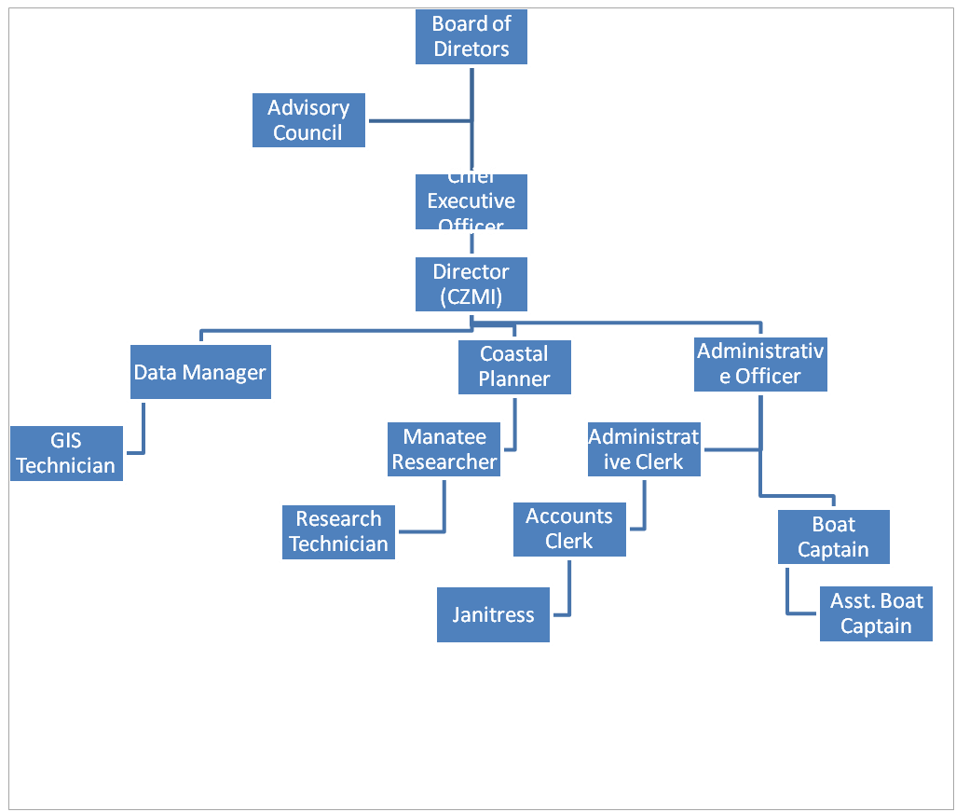

**Fig 3: CZMAI Organizational Structure**

**3.2.3 Legislation**

The legislation of record is the Coastal Zone Management Act which was enacted in 1998. The purpose of the Act is to provide for improvement in the management of Belize's coastal zone. It did this by establishing the "Authority" and the "Institute" and, a Board of Directors to control and manage the affairs of the Authority and Institute.

Relevant to this study is the creation of the only piece of regulation that emanated from the CZM Act; Statutory Instrument No 115 of 2009 which established sport fishing regulations which gave the CZMA the authority to issue licenses and collect fees from persons engaged in sport fishing activities and set conditions governing sport fishing.

**3.2.4 Plans and Policies**

The plans and policies of the CZMAI are focused on developing a lead organization that is engaged in promoting, directing, supporting and executing programs and actions that result in the sustainable use and planned development of Belize's coastal resources: a view that is cogently expressed in the Institution's Mission Statement. In this regard, the central pillar on which policies are built, is the Authority's National Integrated Coastal Zone Management Plan. This document was completed in 2013 and is expected to be accepted by the Legislature sometime in December, 2015.

In furthering the Plan and other policies, the CZMAI is preparing to develop and implement a "*Sport Fishery Management Plan and Accompanying Regulatory Framework*". This is but one of a series of six (6) Strategic Objectives and twenty (20) Specific Objectives identified in the CZMAI 2015-2030 Strategic Plan document (CZMAI, Draft Strategic Plan:2015-2030).

3.3 **Tourism**

**3.3.1 Tourism Governance Structure**

Belize’s tourism governance framework is ordered amongst a set of stakeholders from the public, private and civil sector, which are active in undertaking several tourism development initiative (see Table 8). Fundamental to this, is the Ministry of Tourism which is the policy making body that is also responsible for legislation, coordination, implementation and enforcement of policies (Belize Tourism Policy 2005).

**Table 8: Belize Key Tourism Stakeholders by Sector\***

|  |  |  |
| --- | --- | --- |
| **Public** | **Private** | **Civil (Social & NGO)** |
| Ministry of Tourism and Civil Aviation  Ministry of Natural Resources and the  Environment  Ministry of Forestry, Fisheries and Sustainable Development  Ministry of Works  Belize Tourism Board  National Institute of Culture and History  Coastal Zone Management Authority  Forest Department  Protected Areas Conservation Trust  Belize Trade and Investment Development Service | Belize Tourism Industry Association  Belize Chamber of Commerce and Industry  Belize Hotel Association  Belize Cruise Industry Association  Belize National Tour Operator Association  Belize Tour Guide Association | Belize Audubon Society  Southern Environmental  Association  Programme for Belize  Green Reef  Healthy Reefs  APAMO  National Garifuna Council |

* Adapted from National sustainable-Belize tourism master plan 2030

**3.3.2 Structure and function of Belize Tourism Board**

The Belize Tourism Board (BTB) is a body appointed by the Minister of Tourism that is responsible for planning, developing and marketing the tourism industry of Belize. As described in the National Sustainable Tourism Master Plan (GOB, 2011), the Board creates programmes to increase tourist traffic to Belize and encourages the development and promotion of capacity building programmes for those employed in the industry. The Board also works closely with its sister agencies which include the Ministry of Tourism & Culture, National Institute of Culture & History (NICH) and Border Management Agency.

The Board of Directors of the BTB is comprised of ten members, nine of whom belong to the private sector including the Belize Tourism Industry Associating (BTIA) and the Belize Hotel Association(BHA). The Minister of Tourism is the Chairman of the Board.

**3.3.3 Plans and Policies**

The plans and policies of Belize’s Tourism are formulated to improve the quality of life of the local population, satisfy the need of the tourist and fostering a positive environment for the industry. Strong local participation is promoted ensuring that planning and management are based on partnership and collaboration agreements.

The policies and strategies are summarized and classified in the following documents:

* + A Tourism Strategy Plan for Belize (1998)
  + Belize Tourism Policy (2005)
  + Belize Cruise Tourism Policy
  + Belize Tourism Board Action Plan (2009/2010**)**

**3.3.4 Legislation**

The governing legislations supporting the tourism industry are summarized below.

* + **Belize** **Tourism Board Act (2000)**

This Act created the Board and outlines its composition, powers and responsibilities.

* + **Belize Times Share Act (2007)**

This Act describes the laws that monitor the time shares used for tourism accommodations

* + **Belize Hotels and Tourist Accommodation Act (2000)**

The registration process for accommodations, standard applicable, and the legal stipulations for adhering to the guidelines are describe here

* + **Belize Hotels and Tourist Accommodation Act Subsidiary Laws(2003 revised)**

These provide a supplement to the primary act, specifying the requirements for various types of tourist accommodations

**4.0 Challenges to Development**

4.1 Although both Capture Fishery and Aquaculture industries form a significant part of the national economy, there are a range of challenges that needs to be surmounted for continued growth and development to be realized. These challenges are as follows:

**4.1.1** There is a paucity of data (range of species and product form, quantum and value) on the consumption of fishery products by the tourism subsector (See Table 3).

**4.1.2** There is the need for the sustained monitoring and assessment of the quality of seafood purchased at establishments catering to tourism sector (See Fig. 1). This is especially relevant to ‘Open markets’ and ‘Landing Sites’(See Fig. 1) and to fishery products from Capture Fishery sources (See Fig. 1).

**4.1. 3** The absence of any feasibility assessment for certification and eco-labelling of seafood and in general fishery products that would be destined for the tourism market. The ‘Certification’ and ‘Labelling’ of seafood has implications for pricing. Some effort has been expended by the Aquaculture Certification Council (ACC) and the World Wildlife Fund (WWF) in regards to some of the shrimp farms in Belize.

**4.1.4** The need to capitalize on all potential sources of seafood demand including exploring the potentials of sourcing seafood from Belizean producers by the Cruise Tourism Sector.

**4.1.5** There are a range of opportunities that would increase revenues for the Belizean seafood industry; particularly for value-added production and processing.

One shrimp farm in Belize produces a wide range of value-added product forms that include:

* Heads on – shell on
* Headless – shell on
* Peeled Pull Vein
* Ez-Peeled
* Peeled

This farm is located in the south of the country but the overwhelming majority of the production is destined for the export market. There is no definitive marketing strategy by the farm to attract greater participation of the Belizean market, particularly in regards to the tourism economies.

**4.1.6** Any attempt to introduce and strengthen ‘Certification’ and ‘Labeling’ initiatives should be accompanied by adjustments in legislation. The Fisheries Act and Regulations would therefore need to be amended to accommodate any proposed ‘Certification’ and ‘Eco-labeling’ response contemplated.

**4.1.7** The impacts of Climate Change and Climate Variability (CCCV) will prove to be increasingly pervasive and macroscopic. These impacts are expected to accrue on two fronts: Firstly the infrastructure supporting the production systems and secondly the stocks themselves.

In regards to the Capture Fishery Industry – both the fishing tackle immediately associated with the capture and landing of fish will be impacted, as will the standing support infrastructure. The latter entails largely fishing camps, piers, potable water repository and store houses. The fishing tackle ranges from boats, to traps to anchored seines, and buoyed horizontal and vertical long-lines. The standing fishing infrastructure in Belize also includes the super-efficient ‘Beach Trap’.

These impacts are created largely by hurricanes, tropical storms and strong winds independent of these systems. In the case of the latter, there has been much displacement and loss of lobster traps associated with the Cold Fronts or ‘Northerlies’ which impacts Belize generally from October to March. The south-easterlies are also characterized by relatively strong winds that blow for a couple days uninterruptedly and even a week and beyond in extreme cases. The effect of these south-easterlies on fishing activity has been documented (Mahon, 2002) as displacing and transporting traps to areas where they become lost to fishers. Apart from the loss of fishery production to fishers, these traps continue to fish in a phenomenon known as ‘Ghost Fishing’, which has negative implications for stock depletion and in general biodiversity.

Apart from the immediate fish stocks themselves, the habitats and ecosystems supporting commercial species and populations are also impacted. These include the big three tropical ecosystems: mangroves, seagrass beds and coral reefs. The mangrove ecosystems are most severely affected with heavy sedimentation of their root systems, defoliation and consequent die-off (Mahon 2002).

The impacts of CCCV on coral reefs are more cumulative and long-term. These include bleaching events and diseases associated with elevated water temperatures (Mahon 2002). Much of the habitat and species associated will however, adapt over time to the gradual changes in environmental conditions associated with CCCV (Mahon 2002). This however does not obviate the scope for impacts to some finfish and macro-invertebrate species that are of commercial importance to fisheries and tourism development.

The impacts of CCCV to fishlife include influence on spawning events, migration patterns, maturation and survivorship.

The impacts of CCCV are similar on aquaculture. Both the support infrastructure and species have been and will continue to be impacted. The standing infrastructure includes hatcheries, larvae-culture and on-growing containment facilities such as tanks, raceways and ponds.

The impacts on captive stocks are expected to be as pervasive and significant as they are on wild stocks. These impacts are not all negative: For example the increase in water temperature predicted for CCCV has positive implications for both farmed fin-fishes and invertebrate stocks.

Given the foregoing it would thus be imperative to assess and monitor the effect of CCCV on the life history, distribution, behavior and abundance of commercially important snapper and grouper species (See Table 10 below).

**4.1.8** It has been suggested that the poorer classes of society are more vulnerable, in relation to their livelihood and the place where they live, to the effects of Climate Change and Climate Variability (CCCV).

The poor often live in areas, usually low-lying areas, that are prone to flooding, and/or exposed to the ravages to winds and waves, where they are disproportionately exposed to the effects CCCV.

Much of the poor are involved in with economic activities, such as agriculture, forestry and fishing, for their livelihood. These activities are to be increasingly impacted by CCCV as time progresses. A 2012 CRFM sponsored study on the incidence of poverty among fishers in the Caribbean has showed that poverty is widespread among fishers in Belize.

Thus from a vulnerability perspective there would need for some intervention to alert fishers to the existence of CCCV and build capacity among fishers and to invest them with the knowledge to adapt and cope with the impacts of Climate Change and Climate Variability.

**4.1.9** Over the last two (2) decades a number of unsuccessful attempts have been made to generate a comprehensive national policy to guide the development of a national fishery. Such a document should in principle address the connections and synergies between the fishing industry and tourism in regards to the question of seafood availability. This document could contribute to the national policy initiative to provide a rational framework for the development of the industry.

**4.2 Sports Fishing**

**4.2.1 Branding and Certification**

With the importance given to the economic value of the industry and the strong conservation ethics employed by sport fishers and managers, consideration should be given to expanding its scope and value through an application for "Branding" Belize as a prime sport fishing destination. This would be especially relevant to the capture of Bonefish, Permit and Tarpon as relatively strong management is instituted through the FD, and the CZMA. Importantly, stakeholders at every level have bought into applying best fishing practices, principally Catch and Release (C&R). Strong Collaboration with the Ministry of Tourism, BTB , FD, CZMAI, Belize Sport Fishing Association (BSFA) and the International Game Fish Association (IGFA) would greatly enhance a successful outcome of this venture. Certification of sport fishing lodges and tour operators who vigorously practice C&R is an option that should be considered.

**4.2.2 Enforcement**

**Sports Fishing Sub-Sector**

The Fisheries Department (FD) , under the Fisheries Act and through S.I 114 of 2009, has the responsibility for the allocation and protection of the targeted species and enforcement of the regulations. The Coastal Zone Management Authority, through S.I.115 of 2009, is responsible for issuing licenses and collection of fees. Service providers are also required to comply with several other formal rules including guides requiring a national tour-guide license or a national fly-fishing license, or a tour -operator license issued by the BTB. Boat Captains license and boat registration license, administered and issued by the Belize Port Authority are also required. Additionally, there are codes of conduct and ethics, which are information and guidelines given by the service providers and practiced by the recreational sport fishers.

In spite of this, enforcement is notoriously difficult. And, while service providers report that there was surveillance by FD and Belize Defense Force /Coast Guards, one study has at least shown that there is no statistically significant difference between those who claimed they had some interaction with enforcement agencies and those who don't (Perez, Cobb *et al*., 2014) There is clearly a need to expand on surveillance patrols and compliance within the industry.

**4.2.3 Impacts of Climate Change**

Belize is highly vulnerable to the effects of climate change. Projected impacts for Belize include a 7-8% decrease in the length of the rainy season, a 6-8% increase in the length of the dry season and a 20% in the intensity of rainfall. Other expected impacts include increased erosion and inundation of coastal areas, increased sea temperature and sea level rise, flooding and an increase in the intensity of and occurrence of hurricanes (NCRIP, 2013). It is further anticipated that there will be significant beach and land loss particularly in the northern part of the country, including Ambergris Caye and Caye Caulker (CARIBSAVE2012).

**4.2.3.1 Impacts of Climate Change on recreational-sport Fisheries sub-sector**

Most habitats, including coral reefs, sea grass beds, mangroves and littoral forest are vulnerable to climate change events including sea-level-rise (SLR) and increases in water temperature. SLR will impact fish production if coastal wetlands and other habitats that serve as nurseries are lost. Shallow water areas, including the "Sand Flats' along the coast and around the cayes, would vanish or be diminished. SLR would also exacerbate the process of coastal erosion and salinization of aquifers, increase flooding risk and the impact of severe storms along the coast.

4.2.3.2 **Climate change impacts on infrastructure and sport fishing activities**

Significantly, service providers within the sector live largely within coastal communities; 50% of the Belizean population reside near the coast. They therefore depend heavily on the road network to bring in supplies and "clients" to them. Severe flooding in 2008 and Hurricane Richard in 2010 had, among other things, isolated many coastal communities, destroyed roads and generally gave rise to an economic slowdown, negatively impacting growth and development in the country.

**4.2.3.3 Climate Change impacts on fish behavior (spawning, migration)**

Warm waters are a primary cause of coral bleaching. The loss of coral impacts fish diversity and fish population size. Warm water and changing ocean circulation alters the time of spawning which could also lead to higher fish mortalities. Evidence also suggests that fish species are migrating pole-ward as sea temperatures rises (Nurse, 2011).

**4.2.3.4 Impacts of Climate Change on the Tourism Sector**

Tourism is one of the most important industries in Belize contributing significantly to tax revenues, foreign exchange earnings and, the overall economic growth of the country. The Belize National Tourism Master Plan-2030 records that in 2008 tourist arrivals, including overnight and cruise ship visitors, was about 845,000 persons, contributing Bz$563 million to the Belize economy (GOB, 2011). In 2014, at least one million tourists entered the country (BTB, 2014). Most of Belize's tourism is marine based; 70% of hotels are located in the coastal zone. Reef based activities attract more than 80 % of tourist who want to visit the cayes and reefs for snorkeling, diving or fishing. Evidently any decline in marine tourism will have a direct impact on the economy of the country.

The vulnerability of coral reefs is among the most significant threat to the tourism sector. This vulnerability is directly related to rising sea levels, increasing temperatures (and coral bleaching), and the increasing frequency and intensity of tropical storms (R. B. Richardson 2007). Several other impacts have been linked with the forces of climate change, including loss of coastal land, coral reef mortality (or coral bleaching), ocean acidification, changes in the productivity of agriculture and forestry, risks to human health, and risks to physical infrastructure.

An assessment of the economic impact of climate change on Belize‘s tourism sector has been done and estimated at BZ$48.3 million, which included the effects of reduced tourism demand and the loss of facilities (from sea level rise), beaches (from coastal erosion) and reef-based ecotourism (GOB, 2013 in: *National Climate Resilience Investment Plan [NCRIP]*)

Given tourism's emphasis on marine related products and activities, environmental change, for example along cayes, reefs, or in river valleys affecting fishing and boating activities could be highly damaging to local communities. This outcome has been fully documented by Allen Perry (2004) in his paper "Sports, Tourisms and Climate Variability". Belize and other Caribbean Island States for example are experiencing an epidemic wherein large accumulations of *Sargassum* have invaded ocean areas, many beaches and coastal lands. A condition attributed to climate change induced shifting ocean currents and rising sea temperatures.

Shown in Table 9 below is a summary of the major implications for tourism destinations. It is highly likely that some of these direct effect of climate change, and their subsequent indirect effects, would have an impact on Belize.

**Table 9: Main Impacts of Climate Change and their Implications for Tourism\***

|  |  |
| --- | --- |
| **Impact** | **Implications for Tourism** |
| Warmer temperatures | Altered seasonality, heat stress for tourists, cooling costs, changes in: plant-wildlife-insect populations and distribution range, infectious disease ranges |
| Increasing frequency and  intensity of extreme storms | Risk for tourism facilities, increased insurance costs/loss of insurability, business interruption costs |
| Reduced precipitation and  increased evaporation in some  regions | Water shortages, competition over water between tourism and other sectors, desertification, increased wildfires threatening infrastructure and affecting demand |
| Increased frequency of heavy  precipitation in some regions | Flooding damage to historic architectural and cultural assets, damage to tourism infrastructure, altered seasonality (beaches, biodiversity, river flow, spawning aggregations) |
| Sea level rise | Coastal erosion, loss of beach area, higher costs to protect and maintain property, waterfronts and sea defenses |
| Sea surface temperature rise | Increased coral bleaching and marine resource and aesthetic degradation in dive, snorkel and fishing destinations |
| Changes in terrestrial and  marine biodiversity | Loss of natural attractions and species from destinations, higher risk of diseases. |
| Soil changes (such as moisture  levels, erosion and acidity) | Loss of assets and other natural resources, with impacts on destination attractions |

**\* Source: Adapted from Sandra Sookram (2009) The impact of climate change on tourism n selected Caribbean countries.**

**5.0 Potential Project Areas**

There are a range of possibilities arising from the TOR for this undertaking. These span issues immediately related to food production and indirectly to management and conservation of bio-diversity. The issues as outlined earlier, relate to capture fishery, aquaculture production plus sport and recreational fishing.

**5.1 Capture Fishery**

This relates to capturing wild-caught fish for immediate human consumption. There are a range of potential project areas which includes the following:

**5.1.1** The scope for improving data collection, analysis and reporting with respect to consumption, use and value of fishery products. This should bridge the challenge identified in Section 4.0 above regarding the paucity and absence of data and information. It would additionally, better position management to make informed decisions relating to the connections between capture fishery production on the supply side and tourism on the demand side (See Table 10 No. x).

**Table 10: Feasibility assessment of potential project ideas – Capture Fishery food consumption**

|  |  |  |  |  |  |  |
| --- | --- | --- | --- | --- | --- | --- |
| **Project Ideas** | **Feasibility Criteria** | | | | | **Cumulative Score** |
| **Cost** | **Time-frame** | **Complxty** | **Stkhldr Support** | **Policy**  **Priority** |
| (i) Assess and monitor volume, value and range of seafood consumed by tourists | 2 | 2 | 1 | 3 | 3 | **11** |
| (ii) Assessment of volume and value of imported vs. domestically produced fishery products | 2 | 2 | 2 | 2 | 2 | **10** |
| (iii) Quality assessments of seafood at establishments catering to tourism sector | 1 | 1 | 1 | 3 | 3 | **9** |
| (iv) Feasibility assessment for certification and eco-labelling of seafood for tourism market | 1 | 2 | 1 | 2 | 2 | **8** |
| (v) Assessment of scope for sourcing seafood in Belize for Cruise Tourism Sub-Sector | 3 | 3 | 3 | 2 | 2 | **13** |
| (vi) Feasibility assessment of scope for value-added production for tourism market | 2 | 2 | 2 | 1 | 2 | **9** |
| (vii) Legislative amendment of Fisheries Act and Regulations to accommodate Certification and Eco-labelling provisions | 2 | 1 | 2 | 2 | 2 | **9** |
| (viii) Monitor effect of climate change on life history, distribution, behavior, abundance of snapper and grouper species | 1 | 1 | 1 | 1 | 2 | **6** |
| (ix) Assess impacts of hurricanes and extreme weather events on income and livelihood of fishers | 2 | 1 | 1 | 2 | 1 | **7** |
| (x) Build capacity among fishers to cope with the impacts of Climate Change and Climate Variability | 2 | 2 | 2 | 2 | 2 | **10** |

**Key:** 1 = Least favorable; 2 = Moderately favorable; 3 = Most favorable.  **n.b.** Complxty = Complexity; Stkhldr = Stakeholder

This thrust for improved data should also include statistical material on the quantity of seafood imported for the tourism market (See Table 10 No. ii).

**5.1.2** The need for sustained monitoring and assessments of the quality of seafood purchased at establishments catering to the tourism sector (See Table 10 No. iii and Fig. 1).

**5.1.3** A feasibility assessment for certification and eco-labeling of fishery product for the tourism market (See Table 10 No. iii). The Capture Fishery Industry in Belize is largely managed within the context of ‘Sustainable Stewardship’. The added values that may accrue to fishery produce from ‘Certification’ and ‘Environmental Labelling’ schemes have not been explored in Belize.

**5.1.4** The need to explore the potential of sourcing seafood from Belizean producers by the Cruise Tourism Sector (See Table 10 No. v): The Fishing Cooperatives are ideally positioned to take advantage of such a market, if there is buy-in from the Cruise Tourism side.

**5.1.5** The need for value-added product forms in regards to pre-cooked and package-friendly presentations (See Table 10, No. vi). Much of Belizean seafood is retailed fresh, or fresh-frozen ( See PL 1,3,4,5,6,&13). The intervention of ‘Easy to Prepare’ value-added preparations needs to be fully investigated (See Fig. 1).

**5.1.6** Legislative amendment in regards to the Fisheries Act and Regulations to accommodate Certification and Eco-labelling provisions (See Table 10, No. vii). Any measure directed at development and implementation of ‘Certification’ and ‘Eco-Labelling’ would need to be supported by appropriate legislation.

**5.1.7** Monitor the effect of climate change on the life history, distribution, behavior, abundance of snapper (Lutjanidae) and grouper (Serranidae) species (See Table 10, No. viii): These are prime finfish species that are in high demand by the tourist market.

**5.1.8** Assess the impacts of hurricanes and extreme weather events on the income and livelihood of fishers (See Table 9, No. ix). Predictions are that as hurricanes and tropical cyclonic systems become more frequent and severe, fishers and fishery production are expected to be impacted. This relates to both the loss of fishing opportunity in terms of days or weeks worked, as well as to the loss of fishing tackle, boats and infrastructure such as fishing camp and piers.

**5.1.9** Build capacity among fishers to cope with the impacts of Climate Change and Climate Variability (See Table 10, No. x). Fishers are within that strata of society that may be significantly impacted by Climate Change and Climate Variability (CCCV).

**5.2 Sports Fishing**

**5.2.1 Strengthen coordination between Fisheries Department and CZMA to improve enforcement in regards to sports fishing**

Of the several actions that can be taken, the most outstanding is co-ordination of Fisheries Department's and Coastal Zone Authority's surveillance and enforcement programmes. The coordination of compliance efforts would result in reduced surveillance cost and, better compliance.

**Table 11: Feasibility assessment of potential project ideas – Sport Fishing**

|  |  |  |  |  |  |  |
| --- | --- | --- | --- | --- | --- | --- |
| **Project Ideas** | **Feasibility Criteria** | | | | | **Cumulative Score** |
| **Cost** | **Time-frame** | **Complxty** | **Stkhldr Support** | **Policy**  **Priority** |
| Strengthen coordination between Fisheries Department and CZMA to improve enforcement in regards to sports fishing | 3 | 3 | 3 | 1 | 1 | **11** |
| Scope for marketing campaign based on highlighting sustainable Fisheries management framework | 1 | 1 | 2 | 1 | 3 | **8** |
| Assess and monitor effects of Climate Change on four main species viz: Tarpon, Bonefish, Permit and Common Snook | 1 | 1 | 1 | 1 | 2 | **6** |
| Monitor the effects of Hurricanes and other extreme weather events on income, livelihood of tour guides and fishing lodges | 1 | 2 | 1 | 1 | 2 | **7** |

**Key:** 1 = Least favorable; 2 = Moderately favorable; 3 = Most favorable. **n.b.** Complxty = Complexity; Stkhldr = Stakeholder

**5.2.2 Scope for marketing campaign highlighting the sustainable Fisheries management framework**

Generally the fisheries sector operates within a succinct sustainable management framework. The Coastal Zone Authority's management is also conservation based. These are important policy statements which can be used to support a marketing campaign directed at enhancing and expanding the social and economic benefits of the recreational-sport fishery.

**5.2.3 Assess and monitor the effects of Climate Change and Climate Variability on three main Sports Fishing Species viz**.**, Tarpon, Bonefish, Permit and Common Snook**

Given that sport fishers, particularly "anglers" target the Tarpon (*Megalops atlanticus*), Bonefish (*Albula vulpes*)and Permit (*Trachinotus falcatus*) and to a lesser though increasing extent the Snook (Centropomus spp.) and, given that these fish species frequent, at various stages of their development critical habitats that are considerably vulnerable to climate change and climate variability and, given the economic value of the fishery and the number of Belizeans who are dependent upon it for their livelihood, priority efforts should be directed at assessing and monitoring the effect of climate change and climate variability on these four species such that relevant adaptation or mitigation measures could be considered. Furthermore, an assessment of the economic vulnerability of the fishery should be undertaken to consider the exposure of the tourism system to the hazards of climate change as well as the adaptive capacity of communities to overcome them.

**5.2.4 Assess and monitor the effects of Hurricanes and other extreme weather events associated with Climate Change and Climate Variability**

These are long term and probably continuous programs. Ideally however, they may be undertaken under the country's National Tourism Vulnerability and Capacity Assessment Programme or Coastal Zone's National Integrated Coastal Management Plan.

**5.3 Aquaculture**

There are a number of project ideas that are pertinent to the Aquaculture Sub-Sector in the context of the TOR currently being attended. These are as follows:

**5.3.1** Development of National Policy and legislation to guide the course of development of the industry (See Table 12, No. i). There is no overarching policy guiding the development of aquaculture in Belize. Furthermore, no legislation guides the development of the industry. An aquaculture policy should now identify the opportunities presented by the significant tourists inflows to Belize.

**Table 12: Feasibility assessment of potential project ideas – Aquaculture production consumption**

|  |  |  |  |  |  |  |
| --- | --- | --- | --- | --- | --- | --- |
| **Project Ideas** | **Feasibility Criteria** | | | | | **Cumulative Score** |
| **Cost** | **Time-frame** | **Complxty** | **Stkhldr Support** | **Policy**  **Priority** |
| (i) Development of National Policy and legislation to guide course of development of the industry | 1 | 1 | 2 | 1 | 3 | **8** |
| (ii) Evaluating scope for eco-labeling of aquaculture produce | 2 | 2 | 2 | 1 | 2 | **9** |
| (iii) Feasibility study on expanding aquaculture certification from a few production locations to all the shrimp farms and fish farms | 3 | 3 | 3 | 1 | 2 | **12** |
| (iv) Strengthening data collection systems specific to aquaculture production information | 2 | 2 | 2 | 2 | 3 | **11** |
| (v) Aquaculture suitability survey to identify sites for small scale aquaculture production for the local market | 1 | 1 | 1 | 2 | 1 | **6** |
| (vi) Disaster Preparedness Plan for the sector as a proactive measure to cope with the impacts of Climate Change | 2 | 2 | 3 | 1 | 2 | **10** |
| (vii) Industry research on local feed ingredients to lower feed costs for small scale fish farmers | 1 | 1 | 1 | 3 | 3 | **9** |

**5.3.2** Evaluating the scope for Green Labelling of aquaculture produce (See Table 12, No. ii). Generally, the production systems employed tend towards the ‘greener’ end of the production spectrum. This is so for both penaeid shrimp culture as well as Tilapia husbandry.

**5.3.3** Feasibility study on expanding aquaculture certification from a few production locations to all shrimp farms and fish farms (See Table 12, No. iii). This would entail the expansion of the Aquaculture Certification Council (ACC) and the World Wildlife Fund (WWF) Eco-Certification programme from the current eight shrimp farms to the remaining five operations (See Table 13).

**Table 13: Status of Shrimp Farm Certification**

|  |  |  |
| --- | --- | --- |
| **Farm** | **Operational Status**  (As of Dec.31, 2014) | **ASC Certification**  (As of Dec. 31, 2015) |
| Aqua-Mar Shrimp Farm | √ | √ |
| Aqua-Sur | √ |  |
| Bel-Euro Aquaculture Ltd | √ | √ |
| Belize Aquaculture Ltd | √ | √ |
| Cardelli Farms Ltd | √ | √ |
| Destiny Aquaculture Ltd | √ |  |
| Four Hands Aquaculture Ltd | √ |  |
| Haney Farm | √ |  |
| Paradise Shrimp Farm Ltd | √ | √ |
| Royal Mayan Shrimp Farm Ltd | √ | √ |
| Tex-Mar Shrimp Farm Ltd (North) | √ | √ |
| Tex-Mar Shrimp Farm Ltd (South) | √ | √ |
| Tropical Aquaculture Investment Ltd (TAIL) | √ |  |

**5.3.4** Strengthening data collection systems specific to aquaculture production information (See Table 12, No. iv). Data is invaluable in providing the information necessary to inform and guide policy formulation and legislation in identifying a path linking the fisheries and tourism sub-sector.

**5.3.5** Aquaculture suitability survey to identify sites for small scale aquaculture production for the local market (See Table 12, No. v). This would impact positively on the volume and range of species being farmed and, the working class Belizean in terms of employment and income generation.

**5.3.6** Disaster Preparedness Plan for the sector as a proactive measure to improve resilience in regards to the impacts of Climate Change (See Table 12, No. vi). This would relate to the standing infrastructure which supports the aquaculture production process and, the potential loss of farmed stocks in low-lying flood prone areas.

**5.3.7** Industry research on local feed ingredients to lower feed costs for small scale fish farmers [See Table 12, No. (vii)]: This is an imperative if small-scale producers are to become relevant servicing the Tourism Market for aquaculture produce.

**5.4 Tourism**

**5.4.1 Coordinate promotional efforts with the BTB and Ministry of Tourism to ‘Buy in Belize’, including Belizean seafood that are eco-labeled**

The Fisheries sector could buy into the vast experiences of the BTB to collaborate on and develop a project to "Brand" Belize as a recreational-sport fishing destination. A sub-component of such a proposal would include a "Buy in Belize" element that would promote and encourage tourists to purchase "eco-labeled" Belizean seafood.

**Table 14: Feasibility assessment of potential project ideas – Tourism**

|  |  |  |  |  |  |  |
| --- | --- | --- | --- | --- | --- | --- |
| **Project Ideas** | **Feasibility Criteria** | | | | | **Cumulative Score** |
| **Cost** | **Time-frame** | **Complxty** | **Stkhldr Support** | **Policy**  **Priority** |
| Develop and implement coordinated promotional efforts between the BTB and Fisheries Dept. to ‘Buy in Belize’ for fishery products | 1 | 2 | 2 | 2 | 2 | **9** |
| Develop Certification Programme for Catch-and-Release species, viz: Tarpon, Bonefish and Permit | 2 | 1 | 2 | 1 | 2 | **8** |
| Develop project for data sharing between BTB and Fisheries Dept. in regards to the quantum and range of seafood consumed by tourists | 3 | 3 | 3 | 1 | 2 | **12** |
| Build capacity among tour guides, tour operators and hoteliers in regards to the linkages between Fisheries and Tourism | 2 | 2 | 2 | 2 | 2 | **10** |
| Develop and implement public awareness programme in regards to linkages between conservation of biodiversity and tourism | 2 | 2 | 2 | 1 | 2 | **9** |

**Key:**  1 = Least favorable; 2 = Moderately favorable; 3 = Most favorable.  **n.b.** Complxty = Complexity; Stkhldr = Stakeholder.

**5.4.2 Develop Certification Programme for Catch-and-Release species focused on Tour Guides**

Service providers in the sport-recreational fishery have bought into the conservation principles driving the catch and release practice legislated. The economics of this practice is also largely understood. These principles can be further enhanced through the development of a certification programme for the fishing lodge operator, tour operator and tour guide who is exceptional in promoting and enforcing the catch-and -release-fishing practice.

**5.4.3 Develop project to assess the viability of supplying the Cruise Tourism Sub-Sector with locally produced food**

Cruise ship companies are anxious to enter into partnership with local suppliers providing that they are able to meet market demands and produce products of high quality. The fisheries sector working with the Ministry of Tourism, the BTB and the Fishing Cooperatives, should develop a project to assess the viability of supplying the cruise ship companies with locally produced seafood.

**5.4.4 Develop project for data sharing between BTB and Fisheries Dept. in regards to the quantum and range of seafood consumed by tourists**

There is currently no data which unequivocally sites the amount of sea-food consumed by tourists. A project must be formulated, between the BTB and the FD, relating to tourist visitors and the quantum, price and range of seafood consumed.

**6.0 Project Selection for Case Study**

**6.1 Develop project selection framework to identify more viable projects**

The range of project possibilities needs to be prioritized within the context of the TOR. The general approach taken is to generate a simple Project Feasibility Matrix in the various topical areas described in Secs. 5.1, 5.2 , 5.3, & 5.4 above. These matrices are outlined as Tables 10, 11, 12 & 14. From these matrices the two more viable projects identified under each of the topical areas are as follows:

* Capture Fishery Subsector – Food Consumption
* Assessment of scope for sourcing seafood in Belize for Cruise Tourism Sub-Sector
* Assess and monitor volume, value and range of seafood consumed by tourists
* Aquaculture Sub-Sector – Food Consumption
* Feasibility study on expanding aquaculture certification to all the shrimp farms and fish farms
* Disaster Preparedness Plan for the sector as a proactive measure to cope with the impacts of Climate Change
* Sports Fishing Subsector
* Strengthen coordination between Fisheries Department and CZMA to improve enforcement in regards to sports fishing
* Scope for marketing campaign based on highlighting sustainable Fisheries management framework
* Tourism Sector
* Develop project for data sharing between BTB and Fisheries Dept. in regards to the quantum and range of seafood consumed by tourists
* Build capacity among tour guides, tour operators and hoteliers in regards to the linkages between Fisheries and Tourism

**6.2 Specific Case Study Project**

As seen from Sec. 6.1 above, there are eight potential projects that would be most feasible under the four subject areas. The project that has been selected, within the context of the TOR, is: ***‘Assess and monitor volume, value and range of seafood consumed by tourists’.*** This project is a component of the Capture Fishery Subsector and has been chosen because it is felt that it would get greater political buy-in at the Ministry Level. Also, it is felt that the project would be more congruent with the needs and policy orientation of both the Capture Fishery and the Tourism Sectors.

**6.3 Project Design**

Given the general lack of data and information across the board for the various project ideas ( See tables 10, 11, 12, & 14), it is important to design a project that would yield the information required and should explicitly be reflected in the project identified. The project identified as: ‘Assess and monitor volume, value and range of seafood consumed by tourists’ should do so. Traditional components such as purpose, operational objectives, methodology, time-frame, results and resources to execute this project would be further elaborated in term of project design, which, it is supposed, has been captured in the proposed project log frame presented in Table 15 below.

**Table 15: Proposed Project Log Frame**

**Project Title:** Qualify and Quantify Tourism Seafood Consumption **Target Area:** National Scope

**Duration:** Apr.. 2016 – Sep. 2016

|  |  |  |  |
| --- | --- | --- | --- |
| **Narrative Summary** | **Objectively Verifiable Indicators** | **Means of Verification** | **Assumptions** |
| **Goal:** ‘Assess and monitor volume, value and range of seafood consumed by tourists’ | Volume and value of fishery products consumed by tourists known | Final Project Report | MFFSD and Min. Tourism committed to effecting public policy on issue |
| **Purpose:** Evaluate amount of fishery product consumed by tourists to effect synergies between Fisheries Sector and Tourism | Improved cooperation and coordination between Fisheries and Tourism Sectors | Monthly reports verifying MOUs on data sharing between the sectors | Improving synergies between the sectors are a priority for senior management |
| **Outputs:**  (i)Evaluate total amt. fishery product consumed by tourist on annual basis  (ii) Determine amt. imported fishery product consumed vs. that produced in Belize  (iii) Assess types of fishery products  (iv) Determine importance and range of retail outlets  (v) Determine Marketing strategy | (i) Poundage fishery products consumed by tourists  (ii) Value and quantum seafood imported  (iii) Identification range fishery products  (iv) Identification diversity retail outlets  (v) Qualified marketing strategies | (i) GST Returns Hotels & Resorts  (ii) Customs Entry Log  (iii) Project specific survey report  (iv) Project specific survey report  (v) Project specific survey report | - Cooperation and support by stakeholders to accommodate very surveys, esp. hotels and resorts, Customs and GST Offices and supermarkets  - Stakeholder can be assured that sharing of sensitive and confidential data and info will not pose any problems |
| **Activities:**  (i) Survey of tourism establishments and retail outlets to determine tourism consumption  (ii) Canvas Customs Dept. and Importers to determine range and volume of imports  (iii) Survey of fishers, Fishing Coops and Fish Farms to determine volume and value of domestic seafood production and consumption  (iv) Sample survey of establishments and individuals marketing seafood to accurately qualify range of marketing strategies | **(Budget Bz$)**  Travel and Subsistence $ 6,500  Office Expenses $ 2,100  Report Production $ 1,200  Consultant Rate $45,000  Contingency $ 980  **Budget Total $55,780**  **-** | | Project would be supported in part by Foreign Donor as part of MFFSD Cap IIIB Budget submission |
| **Precondition:** Political buy-in and support by HODs, CEOs and Ministers of MFFSD and Min. of Tourism |

**7.0 Conclusion**

Both the tourism and the Fisheries sectors expect that they will experience further growth following decade of success. Neither sector has however, expressed any desire to join forces, to create an alignment that would market fishery products for the tourism market. There is no strategic marketing arrangement to produce fishery products directly for tourist consumption. Nor is there any definitive marketing strategy to attract greater participation of the Belizean fishery product producers the tourism economies. Evidently, there is a paucity of knowledge about the existing opportunities and how best to take advantage of them.

This exercise concludes with the recommendation that a project entitled ***‘****Assess and monitor volume, value and range of seafood consumed by tourists’* be developed and implemented. Such a project will produce data highlighting the value of directly addressing fish consumption demands of the tourist. It is very likely that a project of this would persuade leaders within the fisheries and tourism sectors to form partnerships (linkages) to capitalize on any opportunity that would further advance their sector's continued success.

**References**

Belize Fisheries Act: Chapter 210 of the Laws of Belize - Revised Edition 2000. Showing the Law as at 31st December 2000.

B.T.B. 2014. Overnight visitors to Belize 2014.

B.T.B. 2015. Tourism Statistics 2015.

Centre on Ecotourism and Sustainable Development (CESD). 2006. Cruise Tourism in Belize: Perceptions of Economic, Social & Environmental Impact .

Coastal Zone Management Act: Chapter 329 of the laws of Belize- Revised Edition 2000.

Coastal Zone Management Authority and Institute (CZMAI) 2015. Belize integrated Coastal Zone Management Plan 2015.

Coastal Zone Management Authority and Institute (CZMAI) 2015. Draft CZMAI Strategic Plan: 2015-2030

European Commission. 2004. Aid Delivery Methods: Project Cycle Management Guidelines – Volume 1.

FAO. 2005. National Aquaculture Sector Overview. Belize. National Aquaculture Sector Overview FACT sheets. Text by Myvett, G. In : FAO Fisheries and Aquaculture Department. Rome.

Felder, A. J. and Craig Hayes. 2008. Economic Impact of recreational Fishing for Bonefish, Permit and Tarpon in Belize for 2007. G.O.B. 2013. National Climate Resilience Investment Plan (NCRIP).

G.O.B. 2012. National Sustainable Master Plan 2030.

G.O.B. 2005. Belize Tourism Policy. Prepared by Launchpad Consulting in Collaboration with David M. Russel for the Belize Tourism Board.

Gongora, M. 2012. Status of the Fishing Industry. In: State of the Coastal Zone Summit-2012

Grimshaw, T., M. Paz and E. Quiroz. 2010. Sport Fish Distribution and Conservation in Belize

Kehr, A. , Craig Bessermin and Owen Segerstrom. 2007. Aquaculture in Belize: Directed Study – January 2009. Monterey Institute of International Studies.

Mahon R., 2002. Adaptation of Fisheries and Fishing Communities to the Impacts of Climate Change in the CARICOM Region. Issues paper prepared for the CARICOM Fisheries Unit, Belize City, Belize, as input to the planning process for the project Mainstreaming Adaptation to Climate Change (MACC) of the Caribbean Centre for Climate Change (CCCC)**.**

Nurse, L. 2011. The implications of Global Climate Change for fisheries Management in the Caribbean.

Perez, A.U., A. Minerva, M. Garcia-Ortega, M. Valdez-Moreno and J. Azueta. 2014. Artisanal Recreational Fisheries: Using a combined approach to fishing assessment aimed at providing insight for fishery management

Perez-Cobb, A.U. 2012. Characterization of Recreational- Sport fishing in Belize.

Richardson, R. R. 2007. Tourism in Belize: Vulnerability and Capacity Assessment.

Statistical Institutes of Belize (SIB). 2015. Gross Domestic Product, February 2015.

Statutory Instrument 114. 2009. Belize Fisheries Act, chapter 210 of the Substantive Laws of Belize. Revised Edition 2000-2003.

Statutory Instrument 115. 2009. Coastal Zone Management Act, chapter 322 of the Substantive Laws of Belize. Revised Edition 2000-2003.

Wade, B. A. 2010. Belize Fishery Country Profile and Information – FAO Digital Atlas.

Wikipedia 2015. The Economy of Belize. http.//en.wikipedia/wiki/Economy_of_Belize)

**Appendix A**

Plates 1 to 14 (PL!-PL!4)

An assortment of locally produced and imported fish products

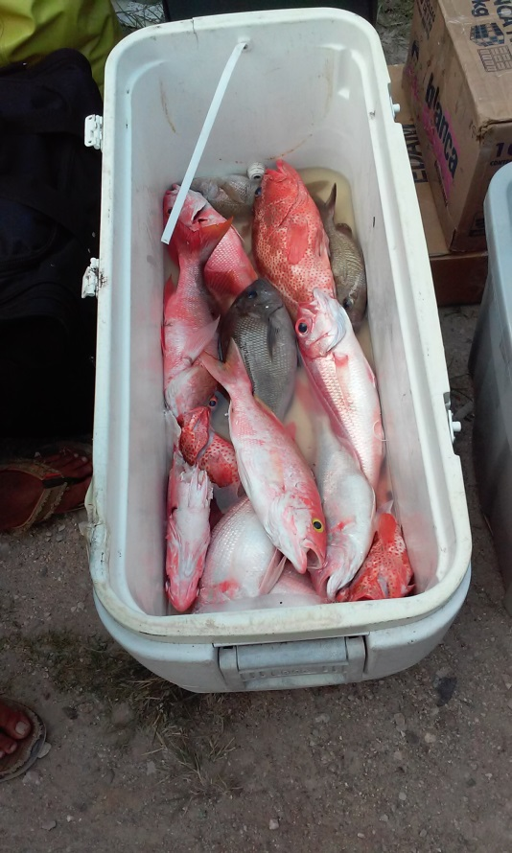 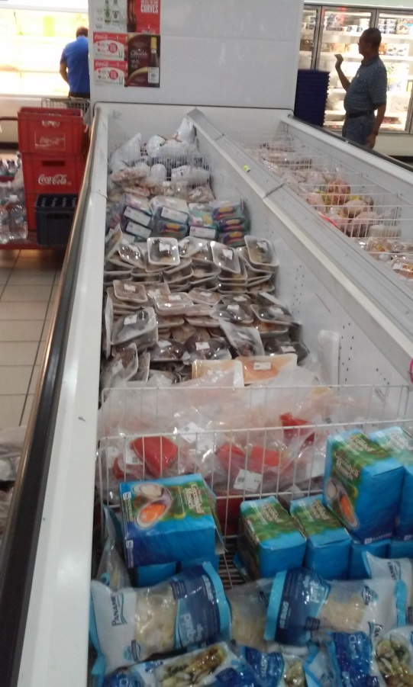

**PL1:** Assortment of Red Snapper and **PL2:** Panoramic view of seafood display

and Deep Sea Black Snapper destined in supermarket freezer in Belize City

For Fish Landing Site in Belize City

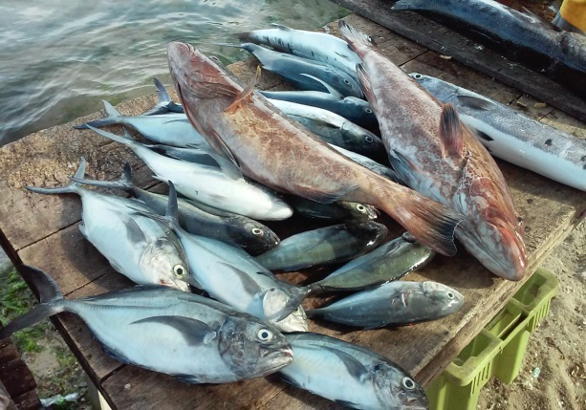 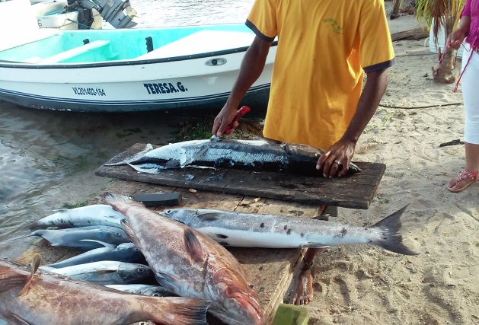

**PL3:** Assortment of jacks, groupers and **PL4:** Barracuda being scaled and gutted for

Barracuda at fish landing site in hotel client in Placencia Village in southern Belize

Placencia Village southern Belize

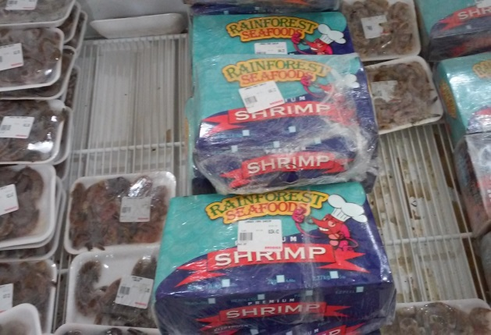 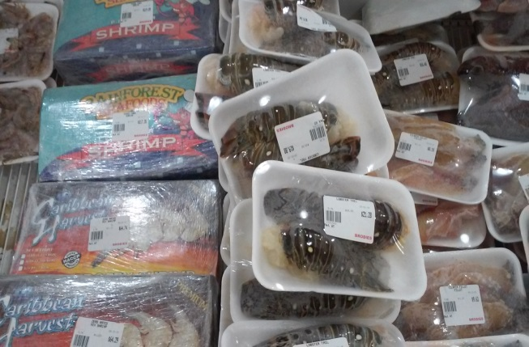

**PL5:** Locally produced and package shrimp in **PL6:** Packaged lobster tails in freezer produced

freezer at center and left and right of frame by local Fishing Cooperative

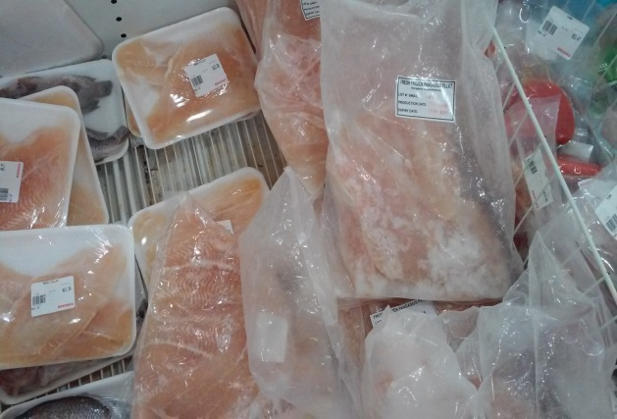 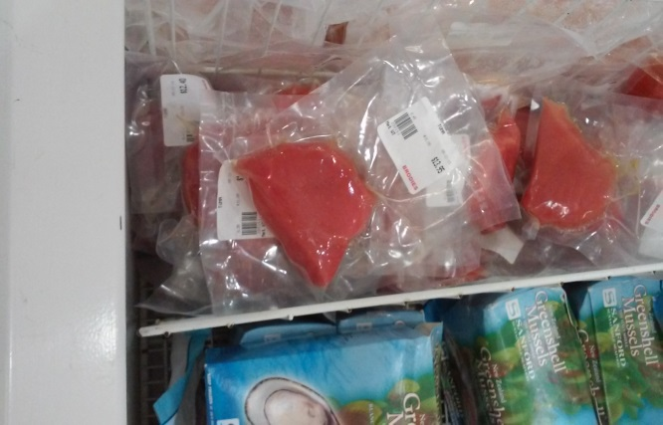

**PL7:** Imported and packaged ‘Bassa’ fillets in **PL8:** Imported Tuna cuts packaged and on display

freezer – Note: ‘Bassa’ is colloquial name for in freezer

Pangasid Catfish from Vietnam

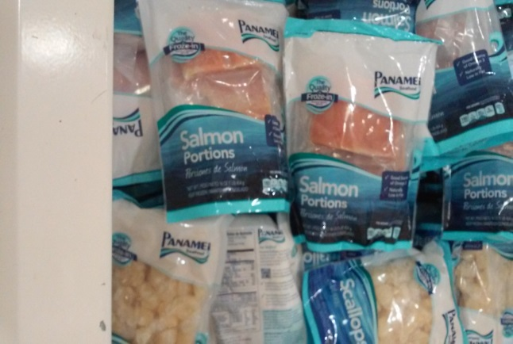 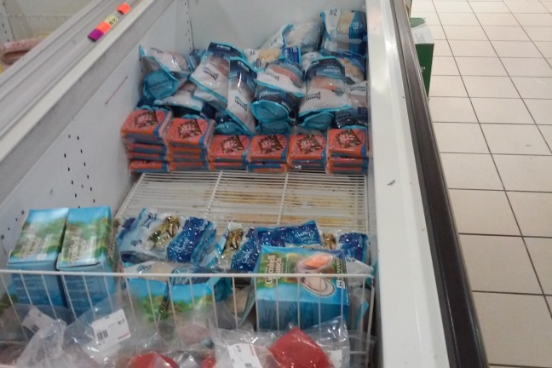

**PL9:** Imported salmon cuts in upper portion of **PL10:** Imported seafood at distal end of freezer

frame and imported scallops in lower portion in Belize City supermarket

On display in Belize City supermarket freezer

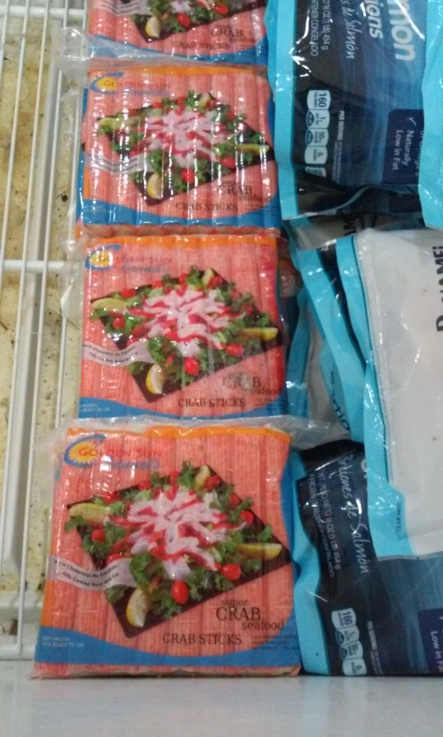 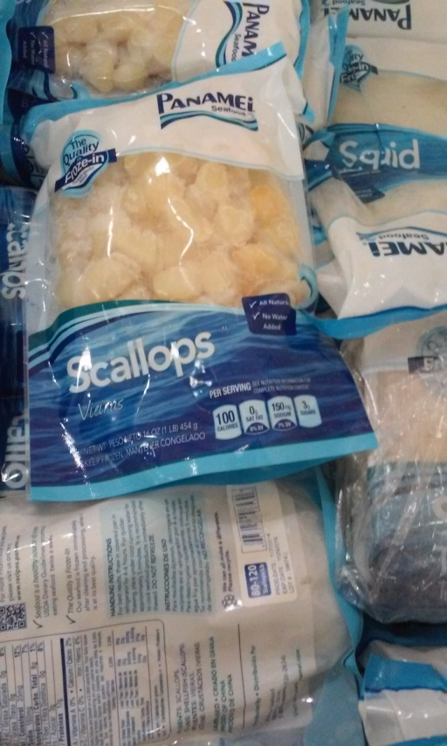

**PL11:** Imported Crab Sticks on display **PL12:** Imported scallops on display in

In freezer of Belize City supermarket freezer of Belize City supermarket

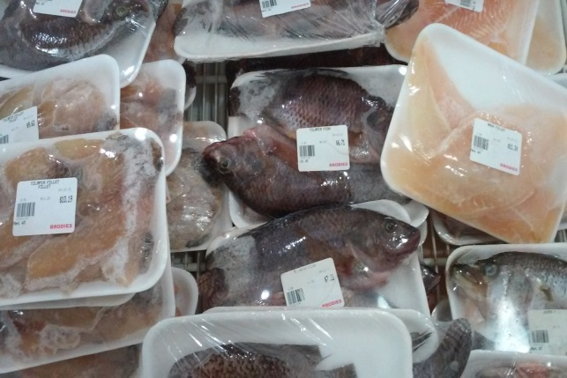 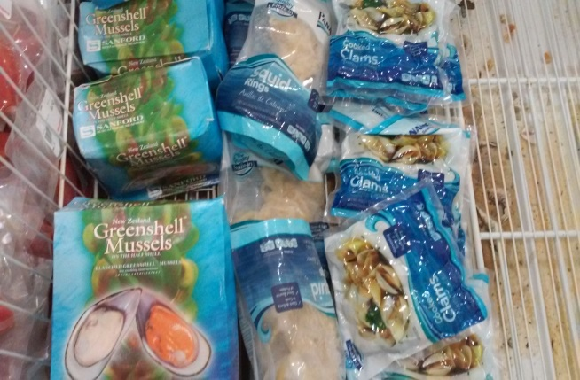

**PL13:** Locally harvested and packaged Tilapia **PL14:** Imported green mussels, squid and clams

In center of frame flanked by imported ‘Bassa’ on display in Belize City supermarket freezer

fillets at left and right of frame