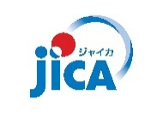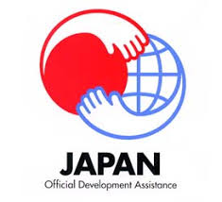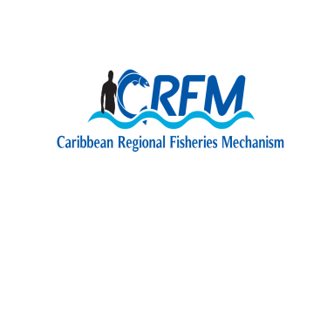

**Government of Saint Lucia**

**CRFM / CARIFICO REGIONAL SEMINAR:**

**STRENGTHENING FISHERIES CO-MANAGEMENT IN THE REGION**

**30 NOVEMBER – 1 DECEMBER 2017**

**SAINT LUCIA**

|  |  |  |  |
| --- | --- | --- | --- |
| **DAY 1 – 30 November 2017**  **Theme: Fisheries Co-Management Today: Activities and Outputs from the CARIFICO Project** | | | |
| **Time** | **Contents** | **Presenters** | |
| **OPENING CEREMONY** | | | |
| 09:00 | Opening Prayer |  | |
| 09:05 | Welcome Remarks | Mr. John Calixte, Permanent Secretary, Department of Agriculture, Fisheries, Natural Resources and Cooperatives, Saint Lucia | |
| 09:10 | Remarks | Mr. Milton Haughton, Executive Director, CRFM | |
| 09:15 | Remarks | Mr. Ichiro Mimura, Director, Rural Development Department, JICA | |
| 09:20 | Feature Address | Hon. Herod Stanislas, Minister in the Ministry of Agriculture, Fisheries, Physical Planning, Natural Resources and Cooperatives, Saint Lucia | |
| 09:35 | Vote of Thanks | Ms. Sarita Williams-Peter, Chief Fisheries Officer, Saint Lucia | |
| 09:45 | **COFFEE BREAK & PRESS CONFERENCE** | | |
| **TECHNICAL SESSION** | | | |
| 10:15 | Introduction to Participants |  | |
| 10:20 | Overview of CARIFICO | Mr. Minoru Tamura, JICA Expert | |
| 10:35 | Activities and Outputs of CARIFICO:  Co-Management of FAD Fisheries | Mr. Kharim Saddler, Department of Marine Resources, St. Kitts and Nevis | |
| 10:50 | Ditto | Mr. Hilroy Simon, Fisheries Division, Antigua and Barbuda | |
| 11:05 | Ditto | Mr. Jullan Defoe, Fisheries Division, Dominica | |
| 11:20 | Ditto | Ms. Margaret Harrison, Department of Fisheries, Saint Lucia | |
| 11:35 | Ditto | Mr. Trovan Ferary, Fisheries Division, St. Vincent and the Grenadines | |
| 11:50 | Ditto | Mr. Francis Calliste, Fisheries Division, Grenada | |
| 12:05 | Activities and Outputs from CARIFICO:  Co-Management of Fish Pot | Mr. George Looby, Fisheries Division, Antigua and Barbuda | |
| 12:20 | Activities and Outputs from CARIFICO:  Co-Management of Conch Fisheries | Ms. Petronila Polius, Department of Fisheries, Saint Lucia | |
| 12:35 | **LUNCH** | | |
| 13:30 | Socio-Economic Analysis of Offshore Fishers | Dr. Nancy Montes, University of Florida, Florida Sea Grant | |
| 14:00 | Common Technical Outputs from CARIFICO | Mr. Mitsuhiro Ishida, JICA Expert | |
| 14:15 | Discussion about the Outputs from CARIFICO | Saint Lucia / CRFM / JICA | |
| 15:00 | Resource Person Database and Appreciation for Master Fishers | Mr. Mitsuhiro Ishida, JICA Expert | |
| 15:10 | Speech from Fisher | Mr. Royan Isaac, President of Grenville FAD Fishers Organisation, Grenada | |
| 15:15 | Speech from Fisher | Mr. Bertley Carrette, Master Fisher, Dominica | |
| 15:20 | Closing Remarks | CRFM | |
| 15:30 | End |  | |
|  |  |  | |
| **DAY 2 – 1 DECEMBER 2017**  **Theme: Fisheries Co-Management in the Future: Dissemination of Outputs from the CARIFICO Project** | | | |
| **Technical Session (Cont’d)** | | | |
| 09:00 | Opportunities to Strengthen Co-Management of Caribbean Offshore FAD Fisheries | | Dr. Charles Sidman, Florida Sea Grant, University of Florida |
| 09:15 | Guidelines for Fisheries Co-Management | | Mr. Minoru Tamura, JICA Expert |
| 09:30 | Continuation and Future Activities of Fisheries Co-Management | | Mr. Kharim Saddler, Department of Marine Resources, St. Kitts and Nevis |
| 09:40 | Ditto | | Mr. Hilroy Simon, Fisheries Division, Antigua and Barbuda |
| 09:50 | Ditto | | Mr. Jullan Defoe, Fisheries Division, Dominica |
| 10:00 | Ditto | | Ms. Margaret Harrison, Department of Fisheries, Saint Lucia |
| 10:10 | Ditto | | Mr. Trovan Ferary, Fisheries Division, St. Vincent and the Grenadines |
| 10:20 | Ditto | | Mr. Francis Calliste, Fisheries Division, Grenada |
| 10:30 | **COFFEE BREAK** | | |
| 10:45 | CARIFICO-CRFM Joint Statement on Fisheries Co-Management | | CRFM |
| 11:00 | Discussion about the Future Direction of Fisheries Co-Management and the Statement | | Saint Lucia / CRFM / JICA |
| 11:30 | Endorsement of CARIFICO-CRFM Joint Statement | | CRFM |
| 11:45 | The Results from Final Evaluation | | Mr. Satoshi Chikami (Dr. Hideaki Higashino)  JICA Senior Advisor (RECS International Inc.) |
| 12:15 | Closing Remarks | | Ms. Sarita William-Peter, Chief Fisheries Officer, Saint Lucia |
| 12:20 | Closing Remarks | | Mr. Milton Haughton, Executive Director, CRFM |
| 12:25 | Closing Remarks | | Mr. Tetsuhiro Ike, Resident Representative, JICA Saint Lucia Office |
| 12:30 | Closing Remarks | | Mr. Masaru Honda, JICA Chief Advisor |
| 12:35 | End | |  |