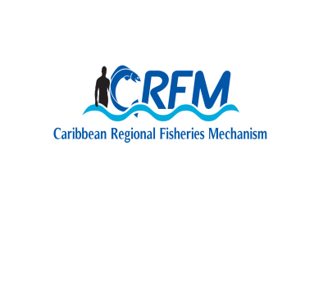

*Towards Sustainable Development of Fisheries for the People of the Caribbean*

<http://www.crfm.int>



<http://www.youtube.com/TheCRFM>



<http://www.facebook.com/CarFisheries>



<https://twitter.com/CaribFisheries>

Funded by the Government of Japan



***The Government of Saint Lucia***

**OPENING CEREMONY**

**CRFM-CARIFICO Regional Seminar: Strengthening Fisheries Co-management in the Region**

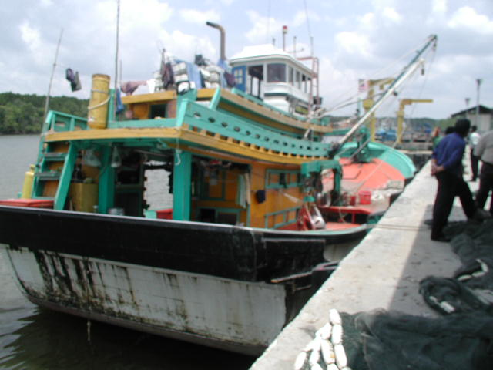

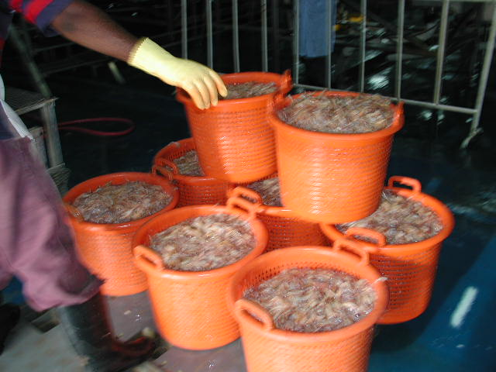

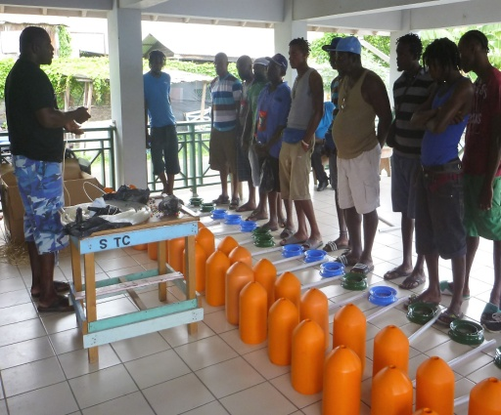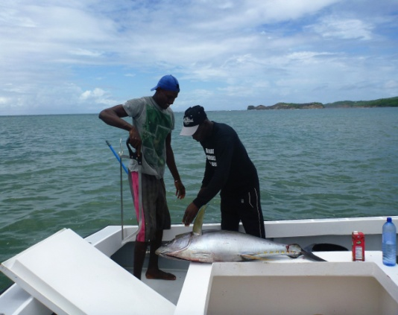

**30 November 2017**

**Saint Lucia**

**NATIONAL ANTHEM**

**Sons and Daughters of Saint Lucia**

Sons and daughters of Saint Lucia,

love the land that gave us birth.

Land of beaches, hills and valleys,

fairest isle of all the earth!

Wheresoever you may roam,

love oh love, our island home.

Gone the times when nations battled

for this 'Helen of the West'.

Gone the days when strife and discord

dimmed her children's toil and rest.

Dawns at last a brighter day,

stretches out a glad new way.

May the good Lord bless our island,

guard her sons from woe and harm.

May our people live united,

strong in soul and strong in arm.

Justice, Truth and Charity,

our ideal forever be!

### PROGRAMME

***Chairperson:-*** Mr. John Calixte

Permanent Secretary

Department of Agriculture, Fisheries,

Natural Resources and Co-operatives

***National Anthem***

***9:00 a.m. – 9:05a.m. Opening Prayer***

***9:05 a.m. – 9:10a.m. Welcome Remarks***

Mr. John Calixte

Permanent Secretary

Department of Agriculture, Fisheries,

Natural Resources and Co-operatives

***9:10 a.m. – 9:15a.m. Remarks***

Mr. Milton Haughton

Executive Director

CRFM Secretariat

***9:15a.m. – 9:20a.m. Remarks***

Mr. Ichiro Mimura

Director, Rural Development

Department, JICA

***9:20a.m. – 9:35a.m.*** ***Feature Address***

Hon. Herod Stanislas

Minister in the **Ministry of Agriculture, Fisheries, Physical Planning, Natural Resources and Co-operatives**

***9:35a.m. – 9:40a.m***. **Vote of Thanks**

Mrs. Sarita Williams-Peter

Chief Fisheries Officer