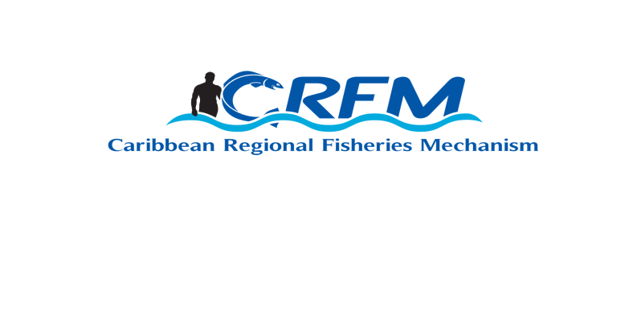
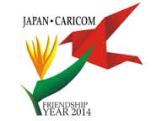

CARICOM-JAPAN FRIENDSHIP YEAR CJF 2014/ 01

Port of Spain, Trinidad and Tobago
4-5 December 2014 Document Date: 27 November 2014

ANNOTATED PROGRAMME

CRFM CARICOM-Japan Friendship Year Regional Fisheries Workshop
Thursday, 4 December 2014

 |  | Registration of participants | 0830 - 0900
ITEM1 |  | Opening ceremony  Special delegates have been invited address the Regional Workshop during a formal opening ceremony. | 0900 – 0945
 |  | COFFEE BREAK | 0945 – 1000
ITEM 2 |  | Highlights of 20 years of CARICOM-Japan Cooperation in fisheries  A 15-minute powerpoint presentation by the CRFM Secretariat will reflect on the major achievements of CARICOM-JAPAN relations over the past 20 years. | 1000 - 1015
ITEM 3 |  | Review of Japan fisheries projects: national / bilateral experiences
3.1 |  | Belize Seminar report  A 10-minute powerpoint presentation by the representative from Belize will summarise the review, findings, conclusions and recommendations of the country seminar. | 1015 – 1030
3.2 |  | St. Kitts and Nevis Seminar report  A 10-minute powerpoint presentation by the representative from St. Kitts and Nevis will summarise the review, findings, conclusions and recommendations of the country seminar | 1030 – 1045
 |  | COFFEE BREAK | 1045 – 1100
3.3 |  | Suriname Seminar report  A 10-minute powerpoint presentation by the representative from Suriname will summarise the review, findings, conclusions and recommendations of the country seminar | 1100 – 1115
3.4 |  | St. Vincent and the Grenadines Seminar report  A 25-minute powerpoint presentation by the representative from St. Vincent and the Grenadines will summarise the review, findings, conclusions and recommendations of the country seminar | 1115 – 1145
3.5 |  | Jamaica Seminar report  A 10-minute powerpoint presentation by the representative from Jamaica will summarise the review, findings, conclusions and recommendations of the country seminar | 1145 – 1200
3.6 |  | Dominica Seminar report  A 10-minute powerpoint presentation by the representative from Dominica will summarise the review, findings, conclusions and recommendations of the country seminar | 1200 – 1215
 |  | LUNCH | 1215 – 1315
ITEM 4 |  | Review of Japan fisheries projects: CARICOM-wide experiences
4.1 |  | Grant aid Cooperation  A 15-minute presentation by a representative of the Embassy of Japan will review the aims and achievements of CARICOM-Japan cooperation in respect of the Grant Aid Cooperation programme | 1315 – 1335
4.2 |  | Cooperation with the Caribbean Fisheries Training and Development Institute (CFTDI)  A 15-minute powerpoint presentation by the representative from CFTDI will review the aims and achievements of cooperation between Japan and CFTDI | 1335 – 1355
4.3 |  | Cooperation with the CRFM – Master Plan Study  A 15-minute powerpoint presentation by the CRFM Secretariat will review the aims and achievements of cooperation between Japan and CRFM in respect of the Master Plan Study, including recommendations on the way forward | 1355 – 1415
4.4 |  | Technical Cooperation (training and capacity-building)  A 15-minute presentation by a representative of the JICA Dominican Republic Office will review the aims and achievements of CARICOM-Japan cooperation in respect of training, and use of experts and volunteers for capacity building in countries | 1415 – 1435
4.5 |  | Cooperation with the CRFM –CARIFICO project  A 15-minute powerpoint presentation by an expert from JICA will review the aims and achievements to date of cooperation between Japan and CRFM in respect of the CARIFICO project, including recommendations on the way forward | 1435 – 1455
ITEM 5 |  | Scope for new interventions - emerging and future issues, and priority areas consistent with the Caribbean Community Common Fisheries Policy and the CARICOM Strategic Plan  The Workshop Chairperson will facilitate a panel discussion, intended to consider the achievements, advantages, and challenges of CARICOM-Japan cooperation in the area of fisheries. The panel will consist of representatives from: Trinidad and Tobago Fisheries Division, Caribbean Fisheries Forum, CRFM Secretariat, Caribbean Network of Fisherfolk Organizations (CNFO), and JICA. | 1455 – 1515
 |  | COFFEE BREAK | 1515 – 1530
ITEM 5 - cont’d |  | Scope for new interventions - emerging and future issues, and priority areas consistent with the Caribbean Community Common Fisheries Policy and the CARICOM Strategic Plan  The Workshop Chairperson will facilitate a panel discussion, intended to consider current and emerging issues, challenges and opportunities for sustainable use of marine living resources and possibilities for future CARICOM / Japanese cooperation in fisheries. The panel will consist of representatives from: Trinidad and Tobago Fisheries Division, Caribbean Fisheries Forum, CRFM Secretariat, Caribbean Network of Fisherfolk Organizations (CNFO), and JICA. Each panellist will make a brief (2-3 minutes) presentation followed by a moderated discussion with questions and comments from participants. | 1530 – 1615
ITEM 6 |  | The Way Forward  The Workshop Chairperson will facilitate review, discussion and development of an agreed ‘Draft Statement on the issue of cooperation in fisheries, identifying broad areas for future cooperation’ | 1615 - 1700
ITEM 7 |  | Workshop Closure  The Workshop Chairperson will invite any closing remarks | 1700 - 1715
CRFM CARIFICO Regional Workshop on FAD management
Friday, 5 December 2014

ITEM 1 |  | CARIFICO Project - Review
1.1 |  | Regional review  A 30-minute powerpoint presentation by a regional JICA expert will provide details of the project’s aims and achievements to date | 0900 – 0930
1.2 |  | Selected country presentations  A 5-minute powerpoint presentation by 1-2 country representatives will provide further details of the progress of country-level CARIFICO project activities, achievements and challenges | 0930 – 0950
ITEM 2 |  | MAGDELESA Project - Review  A 20-minute powerpoint presentation by a representative from IFREMER will provide details of the project’s aims and achievements | 0950 – 1010
ITEM 3 |  | University of Florida - Project Review  A 20-minute powerpoint presentation by a representative from the University of Florida will provide details of the project’s aims and achievements | 1010 – 1030
ITEM 4 |  | FAO/ UWI - Activity Review  A 20-minute powerpoint presentation by a representative from UWI will provide a review of the activity titled ‘ FAO Workshop on Strengthening Organizations and Collective Action in Fisheries: Towards the Formulation of a Capacity Development Programme’. | 1030 – 1050
 |  | COFFEE BREAK | 1050 – 1105
ITEM 5 |  | CANARI - Activity Review  A 20-minute powerpoint presentation by a representative from CANARI will provide a review of CANARI’s activities on building the capacity of regional and national fisherfolk organization networks to participate in fisheries governance and management. | 1105 - 1125
ITEM 6 |  | CRFM – Activity Review
6.1 |  | CRFM Activities in support of FAD Fisheries Management  A 20-minute presentation by a representative of the CRFM Secretariat will provide a review of CRFM’s inputs into the CARIFICO project (administration, regional coordination, PWG activities including support for improved FAD monitoring and logbook development), highlighting achievements and challenges | 1125 – 1145
6.2 |  | The ICCAT Connection  A 20-minute presentation by a representative of the CRFM Secretariat will provide a review of the status and recommendations on FAD fisheries management, with emphasis on developments by ICCAT | 1145 – 1205
6.3 |  | CRFM Cooperation with other regional fisheries bodies and entities on FAD fisheries management  A 20-minute presentation by a representative of the CRFM Secretariat will provide a review on the status of this activity | 1205 – 1225
ITEM 7 |  | Way forward  To formulate agreed conclusions and recommendations on the way forward, the Workshop Chairperson will facilitate general discussions on the presentations received, with emphasis on the participatory (co-management) approach, taking into account the experiences gained so far especially in the area of FAD fisheries management. | 1225 – 1250
ITEM 8 |  | Workshop Closure  The Workshop Chairperson will invite any closing remarks | 1250 – 1300

