### :advantage brochure images:42-16922719.jpg:advantage brochure images:42-18138061.jpg:advantage brochure images:42-17840257.jpg Contents

Dominican Republic

+

Abstract

This report outlines mission activities and research findings for Trinidad and Tobago.

Mission Report

+

Mission Summary 4

Key Observations 4

Appendix 1 | Meeting Notes 5

Fisheries Department 5

National Consultation 5

TNINT 7

Appendix 2 | Presentations 9

Appendix 3 | List of Documents 10

Appendix 4 | Photographs 11

# Mission Summary

# 

# Key Observations

# Appendix 1 | Meeting Notes

## Meeting with CODOPESCA, 11 May

Introduction of mission team

The meeting commenced at 09:57 a.m.

Present were:

* Chris Hedley (Legal KE & Team Leader), PAM (CRFM Sec)
* Mr. Milton Ginebra, Executive Director, CODOPESCA; Jeannette Mateo (Director of Marine Resources; also served as interpreter);
* Milton Ginebra Morales, Director Ejecutivo
* Jeannette Mateo, Directora de Recursos Pesqueros
* Rodolfo Herasme, Consultor Jurídico
* José Infante, Enc. Pesca de Captura
* Raúl González, Enc. Regulación Pesquera
* Eligio Mateo, Enc. Estación Santo Domingo
* Julio Cesar Tejeda Soto, Enc. Estación Baní
* Héctor De La Cruz, Técnico
* Tarsis Alcántara, Técnico
* Marcia Beltré, Técnico
* Idelfonso De Los Ángeles, Técnico
* Ángela González, Abogada

Introduction to the Project and consultancy (PowerPoint presentation available from C. Hedley under separate cover)

* ToRs for consultancy (overall objective; purposes of current component/consultancy; results to be achieved, outputs)
  + Why are we doing this?
    - Supporting and developing international trade
    - Promoting competitiveness
    - Ensuring/increasing market access
    - Improving national food safety
    - Supporting the fishing industry
* Issues/challenges and related Main SPS programme activities
  + More food safety conscious world
    - Where project fits in with overall need to improve food safety in fisheries
      * Accessing international markets – EU example
        + Policy
        + Capacity building
        + Regulation
  + Technical expertise and physical capacity
  + Management woes
  + Environmental concerns
* Indicative stakeholder “map”

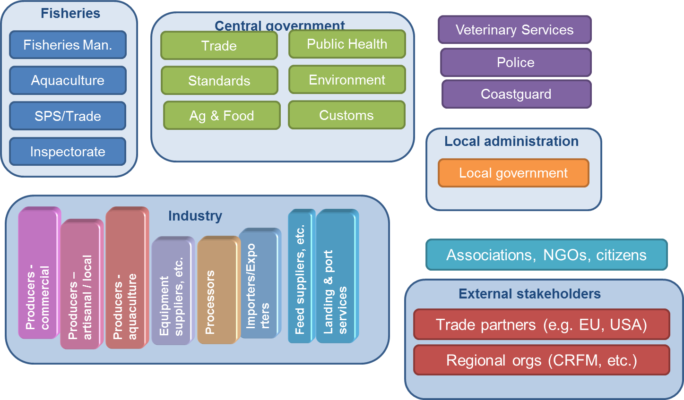

* Approach to consultancy including anticipated timeline
* Discussion:
  + draft policy (in Spanish) prepared by ACP FISH II project also draft regulations for SPS, related to fisheries products done in conjunction with Min of Health (in Spanish)
  + Executive Director thanked everyone especially team for coming and apologised for being late, noting that this was due to his having a medical appointment. Thought presence of team is very important and will serve DR well. Wants team to ensure that recommendations are well based on sound technical advice. Has to depart for another appointment but will be with team for a short time tomorrow.
  + Concern whether MS would be obliged to utilise the models – assured that this is not the case and Countries would be free to utilise as they see fit, whichever aspects/parts they consider relevant
  + Concern that the fisheries component links with the wider project being coordinated by IICA. Disabused of that
  + Concern that standards (for EU) may be (too?) high to be effectively managed
  + No single reference/certified laboratory but have a number that are certified for individual tests. Been working on the possibility of a single lab but too expensive. Considering use of local veterinary lab which is certified for a number of tests, though not overall. May be worth considering the development of (sub-)regional provision of certified services. A good start would be to establish good practices at the primary (fish landing and/or farm) level. Italian funded project did not given Fisheries a report on the status of labs this was given directly to the labs
  + Only exports to EU are a problem at this time: the view appears to be that there is need for Fisheries to become competent authority, pointed out that Fisheries does not necessarily have to be competent authority for all things, once the legislation speaks to the issue in some way
  + Noted tat whiel EU may currently be the biggest challenge to meet standards, other countries may in the coming years adhere to similar standards as EU.
  + Collaborating with Public Health and they are giving Fisheries authority to inspect on behalf of Public Health for fishery products; also working with National CODEX committee to adapt (species specific?) standards to DR reality. Six or seven draft standards for fisheries inspection are almost ready for publication/promulgation. E-copies to be provided later today or tomorrow.
  + Aquaculture is primarily done at the community level rather than “commercial” for export. Export from the latter go mainly to US. There are some problems with exports from the capture fisheries because there are no standards or difficult to manage given that the fleets are small scale and mainly artisanal; thus posing problems with sanitary and quality control.
  + Apparently two companies are exporting small amounts of lobster and parrotfish to the US (HACCP compliant) and a few Caribbean countries.
  + No residue monitoring for aquaculture.
  + While fisheries legislation has no specific SPS mention, currently regulations are being developed on how to interpret the fisheries law and this will speak to SPS issues as part of application of fisheries law.
  + Currently Fisheries has to approve export of fishery products; what is done operationally is that Fisheries will not give this approval unless the exporter shows that Animal Health division of Ministry of Agriculture has given written (by the head) approval.

Identification of key stakeholders and institutions

* No objection to indicative stakeholder map
* CODEPESCA
* Public Health
* Animal Health
* Agriculture Commercial Department
* INDOCAL (standards agency also responsible for CODEX)
* Customs
* Environment Department (some of fisheries production may take place in protected areas)
* In theory, a number of agencies are part of the management council of CODEPESCA but this is often not practically implemented though good relations obtain at the directorial level

Logistical Arrangements for meetings with key stakeholders and institutions (individual meetings/national consultation/ site visits/ etc.)

* Tomorrow (09:30 pick-up at hotel) team will be taken to see a processing plant in SD (Mr. Gomez, the owner is also president of association of fisheries entrepreneurs); though “not the best”, other plants are too far to be visited in one day.
* Attempts to arrange meeting with the Director of the Office of Agricultural Trade Agreements (Oficina de Tratodos Comerciales Agricolas: OTCA - focal point for SPS project) at whose offices the current meeting is being held. Meeting set for after lunch (actual project coordinator is on travel duty).

Close

The meeting adjourned at 12:20 p.m. and was followed by lunch

## National Consultation

## TNINT

# Appendix 2 | Presentations

# Appendix 3 | List of Documents

# Appendix 4 | Photographs

(1) Meeting Notes

(2) Photographs

(3) Consultation Documents (Agenda – Presentation)

# Appendices

+

+

lorem ipsum

[Street Address]  
[City], [State][Postal Code]

[Web Address]