Conch data collection and research activities for saint lucia

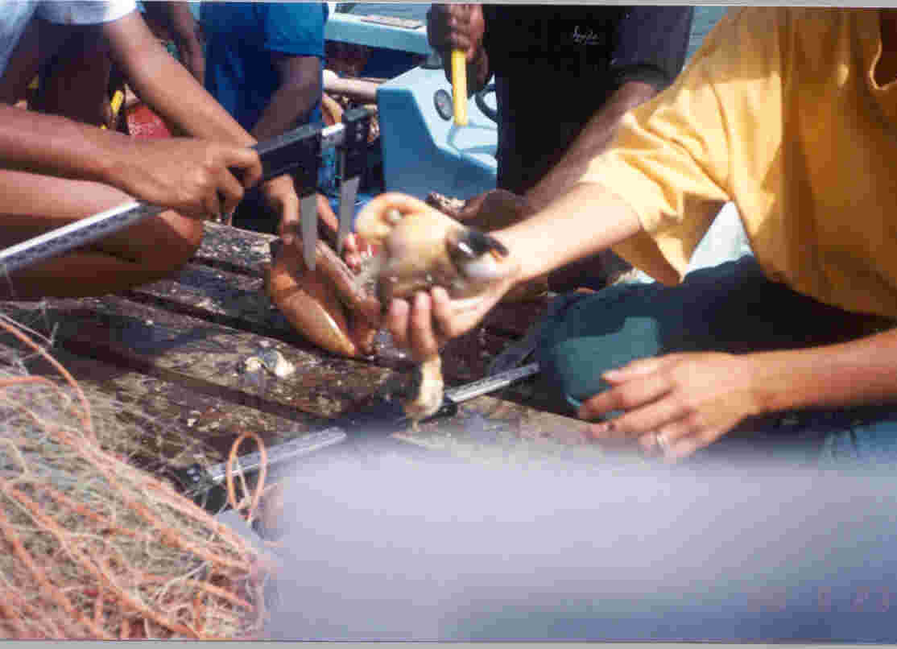

2001
Prepared
By
Williana Joseph
Fisheries Biologist
Department of Fisheries
Ministry of Agriculture, Forestry and Fisheries
NIS Building, Castries St. Lucia

1. Introduction

Saint Lucia is situated between latitude 13° and 14° north and longitude 60° and 61° west, and occupies a central position among the windward islands group of islands in the Lesser Antilles (Figure 1). The island has a total land area of 620 km² with maximum dimension of 42 km long and 22 km wide surrounded by a coastal shelf area of 522 km² and coastline which extends for 158 km.
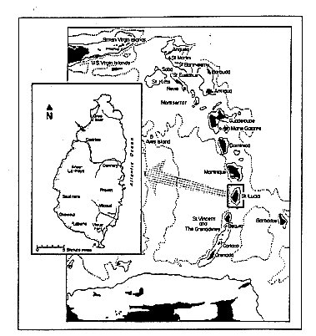
Figure 1. Map of St. Lucia showing its position in relation to the other islands of the Eastern Caribbean
(Murray, 1996).

The most productive economic sectors, in terms of contribution to national GDP comprise: transport and communication; construction; hotel and restaurants; wholesale and retail trade. The agriculture sector although not a top contributor to the GDP contributed at least 104.65 EC$ million (at current prices) in 2000 which accounted for 8.53 % of the total GDP (Government Statistics Department). The fishing sector provides a small but growing contribution and in 2000 contributed in excess of 15 million dollars which represented an increase of just over twice its contribution to the national GDP for 1995 (Government Statistics Department).
.
The major fisheries resources of St. Lucia comprise demersal, coastal pelagic and offshore pelagic fisheries. Although there is some year to year variability in transition in terms of time, the fishing year of St. Lucia can be divided into two seasons: a “high’ season which extends from December to May when significant landings of offshore migratory pelagics occur and a “low” season which extends from June to November when large quantities of demersal fishes are landed.

The offshore pelagic fisheries contribute over 73% of the annual landings by weight (Department of Fisheries, 2000) which is made up of a number of migratory species including dolphinfish (Coryphaena hippurus); mackerel (Stromberomorus spp.); Wahoo (Acanthocybium solandri); blackfin tuna (Thunnas atlanticus); yellowfin tuna (Thunnus albacares); Skipjack tuna (Katsuwonus pelamis); sharks (various families); billfishes (Istiophoridae, Xiphiidae) and flying fish (Hirundichthys affinis)(Figure 2). The total landings have fluctuated but with a general increase in annual production from 1990 to 2000 (Figure 3).

Figure 2. Contribution of species groups to annual landings 1993 – 2000

Description of the Conch Fishery

The Queen conch, Strombus gigas (Linaeus, 1758) is one of the single species nearshore fisheries of Saint Lucia. Near shore stocks have been over exploited thus most fishers harvest at deeper depths with SCUBA gear. However, conch is still harvested with gill nets and by free diving in areas along the west and southwest coasts (Rambally, 1999). Although this species is thought to be distributed around the island, only two significant populations have been identified, one to the north and the other to the south of the island (Nicholas & Jennings-Clark, 1994). The northern population is thought to have been more heavily exploited than the southern population.

Conch is exploited commercially all year by over by 40 fishers in depths ranging from 11 m to 43 m. They operate out of open wooden and fiberglass pirogues ranging in length from 7.02 – 8.45 m powered by outboard engines of 115 – 250 hp (Appendix 1). Fishers of this resource can be divided into part-time and full-time. Full-time fishers conduct dives on average four times each week alternating harvesting and rest days whilst part-time fishers operate twice each week (DOF- Conch divers’ survey, 1999). Approximately 300 – 700 individual conch are landed per trip. Subsistence exploitation in shallower areas occurs but the extent is unknown.

Due to the nature of the fishery, the marketing system, in addition to an informal policy of the Department of Fisheries the majority of conch harvested are landed whole (live) and then stored in wire-meshed cages in shallow areas close to shore until sale is obtained.

Previous to 1993, legal exportation of conch was not permitted but a study on conch consumption in Martinique revealed that illegal exports in the late 80’s were in the region of 5 tons. From 1993, export to this neighbouring territory had then been permitted controlled under the Convention on International Trade in Endangered Species of Wild Fauna and Flora (CITES) (Department of Fisheries, 2001). Under this system vessels were required to export whole animals and were only allowed to operate through procedures stipulated by CITES and only after careful examination of the product. But in 1997, due to the implementation of trade restrictions by the EU with regards to health and sanitary controls for fishery products exported to the EU coupled with the re-opening of the conch fishery of Martinique legal export to this island ceased. This has therefore resulted in a thriving illegal trade of this resource between St. Lucia and Martinique.

Fisheries regulations in place since1994 provide protection for this resource by prohibiting the harvesting of conch of less than 180 mm total shell length, less than 1 kg total weight and less than 280g meat weight not including digestive glands. In addition, these regulations restrict harvesting of immature conch defined as individuals without a flared lip. However, enforcement focuses on only one of these regulations - the harvesting of individuals with flared lips due to the ease of enforcement and implementation in the field. The Fisheries Regulations also make provisions for a closed season but to date, this management measure has not been implemented.

Conch Data Collection Programme

3.1 Catch and Effort Data Collection Programme

3.1.1 Catch and Effort Sampling Plan

The first fisheries data collection system for the island was implemented in 1979. Since then the system has undergone considerable refinement and revision in an effort to satisfy the information required for decision- making and sound management advice, whilst responding to the numerous changes in the fisheries sector, in addition to human resource and financial limitations (W B. Joseph, unpublished a). Over the past decade, very little information on major single species fisheries such as conch has been collected on a consistent basis. Therefore, other collection programmes were implemented to obtain necessary information for assessing the status of these stocks.

The main aim of the data collection system is to monitor the status of the stocks that are being exploited. However, due to the nature of different fisheries, fishermen’s perceptions or behaviour and both national and global economic issues, strategies implemented to gather necessary information require constant modification in order to capture in a timely manner the changes occurring in the fishery. But, due to administrative, financial and human resource constraints there is a time lag in modification of these strategies and therefore there can be instances of loss of important data to guide management decisions.

Overall, current fisheries data collection system includes several components such as gathering of catch, effort and biological data, registration of fishermen and vessels, SCUBA diving establishments, sports fishing vessels and spear gun fishers, in addition to registration and licensing data of fisher and fishing vessels. The catch and effort data collection plan is based on a stratified random sampling regime of three major strata: primary, secondary and tertiary landing sites, based on the number of vessel operating, the fishery types and the volume of fish landed (W.B. Joseph, unpublished b). Of the 23 landing sites out from which the fisheries operate, catch and effort data are collected from eight on a permanent basis (Figure 3). Under this sampling plan conch landings are captured for Gros Islet in the north only, where the majority of conch are landed. Earlier this year, the sampling plan was revised to include two other sites in the southwest where fishers from one of these sites are also known to target conch. This revision would improve the information base for this species.

Limitations and Strengths

Limitations

Due to traditional practices in the fishery, collection of adequate data on landings of this resource has been challenging. However, during the jointly CFRAMP and Government of Saint Lucia funded conch biological data collection programme, sufficient data were collected and many lessons were learnt. One of which is, that it is essential that data collection for this fishery be undertaken with in a collaborative framework with fishers. Another limitation identified is that the sampling strategy is not flexible enough to respond to the impact of national and external policy measures.

With the termination of the funded biological data collection programme and the discontinuation of biological data collection for this resource, the situation has reverted to its original state. Complicating the issue further is the loss the legal trade to Martinique and competition from cheaper imported conch resources from neighbouring island of St. Vincent.

Strengths

Data are collected on a regular basis

The fishery is operated by a small number of fishers therefore facilitating close interaction between key players and the management authority.

Recommendations

Although the collection of conch data is integrated into the catch and effort data collection plan, the nature of the fishing practices justifies a separate catch and effort data collection plan designed in close collaboration with the fishers. Without this strategy, adequate catch data may be collected but effort in addition to biological information will be challenging to collect since before sale conch are stock piled into cages and cannot later be distinguished by trip or by area fished.

Biological Data Collection Programme

Biological Data Collection Programme

Although biological data have been collected in the past for this species, the collection of such data has not been sustained after the termination of externally funded projects.

Recommendations

In the management of any fishery it is fundamental that adequate and reliable data guide management decisions. Therefore, in order to monitor and assess the status of this resource at least basic biological data such as lip thickness, shell length and weight should be collected consistently over a prolong period. Mechanisms for funding and integrating collection of biological data into the catch and effort programme for this resource must be sought.

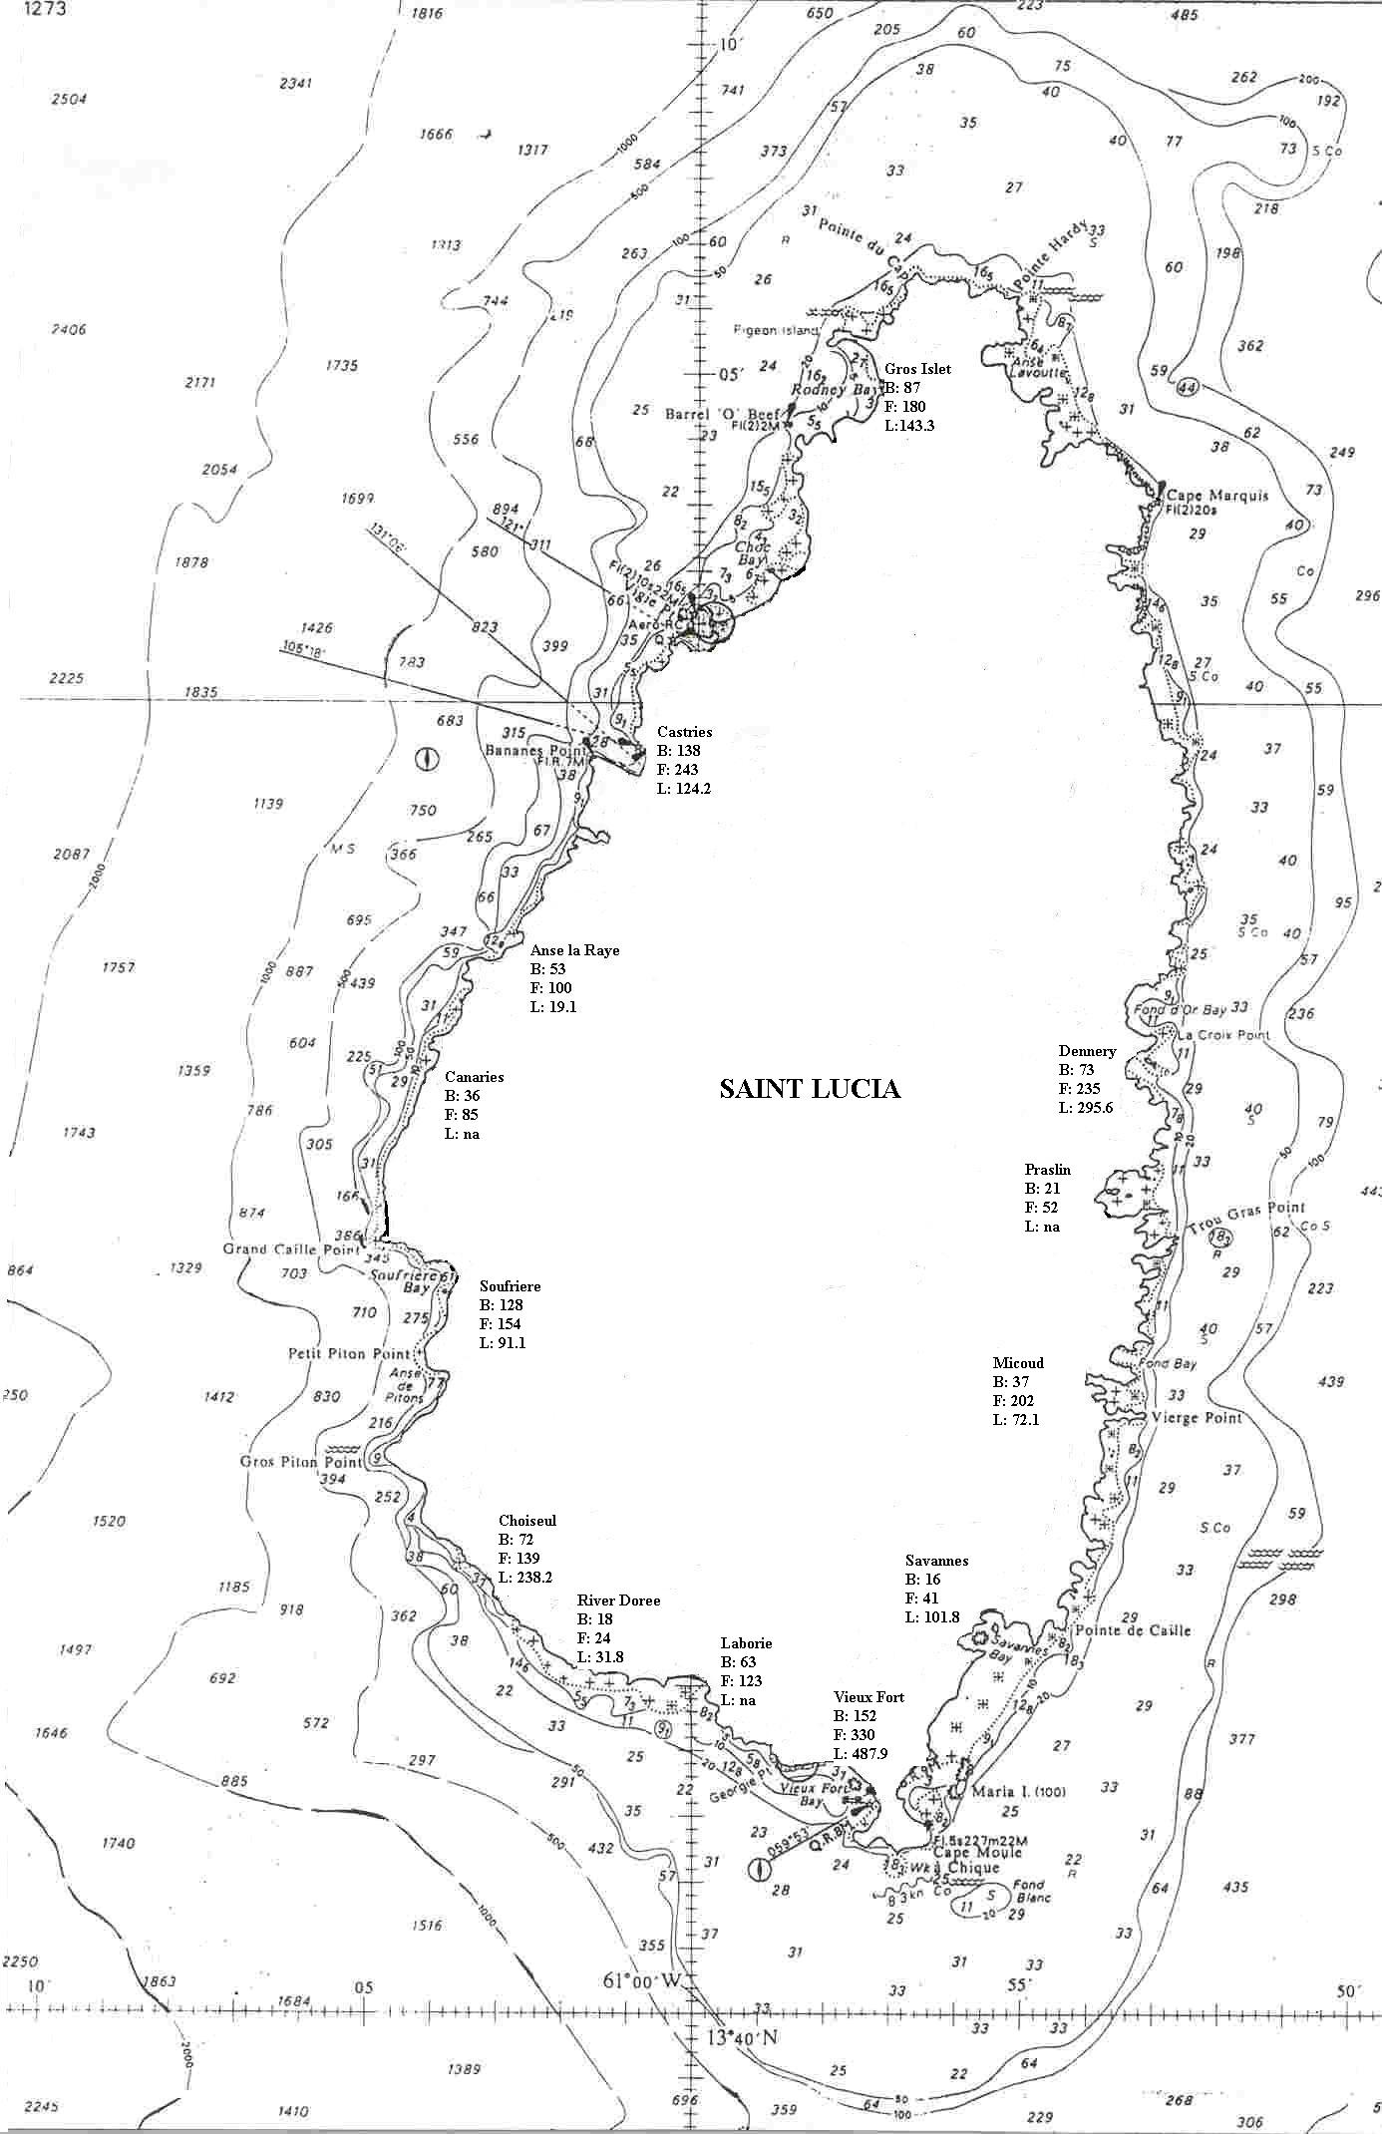
Southern fishing ground
Northern fishing ground

Figure 3. Major landing sites in St. Lucia and the number of fishers and vessels at each
site. Depths in m. (Source: Department of Fisheries, St Lucia - 2000) - Fish landing data collection sites. Key: B: number of boats L: Landings (tons) F: number of fishers na: not available

Other (economic, social) collection programme

Recently the Department, in response to the increased accidents/injury resulting from unsafe diving practices during harvesting of conch, administered a questionnaire to collect information for implementation of a training programme in safe harvesting practices. Information gathered has been used in the preparation and delivery of training. It has also been used for justification of the need to support a proposal for the provision of a grant for replacement of SCUBA gear of fisher of which the majority is unsafe but yet continue to be used in the fishery.

Data Management

For all catch and effort data, integrity checks are carried out both prior and preceding data entry. Prior to data entry, data sheets are checked for errors and omissions with the data collectors whilst subsequent to data entry into Trip Interview Programme (TIP) data are validated and verified for errors and omissions also.

Data are backed up and stored on diskettes using WINZIP at regular intervals throughout the year. A copy is made when the last batch of data are entered for the calendar year. Data are stored on site as well as off location.

Data Analysis

Catch and effort data are analyzed quarterly using a raising factor function based on the fishing activity (total number of vessels and number of fishing days) and effort of collectors based on a stratified sampling plan (days and vessels sampled by collectors).

In 2000, the conch fishery only accounted for only 2.2% of the total annual landing. However, this contribution has been steadily increasing from 1996 (Figure 3).

Figure 3. Annual total landings and Strombus gigas landings for 1993 - 2000

Management Options and Actions

Two management objectives have been defined for this resource and are articulated in the Plan for Managing the Fisheries of Saint Lucia. They include rebuilding the near shore stocks and ensuring sustainable use of this resource. Options identified for attaining these objectives include initiating a flared lip thickness restriction, controlling effort through a licensing system, implementing closed areas or seasons and co-management arrangements with resource users.

In an effort to effectively manage this resource, steps have been taken to implement a limited entry system by licensing all fishers operating in the fishery. To this end, the Department has held training sessions in proper and safe diving practices. Through this training workshop several traditional divers have been certified in SCUBA diving. The next step, the replacement of unfit SCUBA gear has been delayed due to the unavailability of a financing avenue accessible to the conch fishers. Therefore, the Department has not been able to implement unless vessels and gear pass inspection.

6. Fisheries Independent Studies

6.1 Introduction

A conch biological data collection initiative jointly funded by CFRAMP and the Government of St. Lucia commenced in 1996 and was for a period of two years. The main aim of this initiative was to gather information in order to assess the status of the conch resources of the island, to guide management decisions. Previous to this data collection exercise, the fishery was severely under recorded and information required to conduct basic monitoring of the resources was unavailable and in some cases had never been collected.

Methodology

Strombus gigas harvested by commercial fishers from fishing areas in the north and south (Figure 3) were sampled. Note that fishers involved in the study were asked to land all sizes of conch. The locations of fishing grounds were determined using a Global Positioning System (GPS). Harvesting was done using SCUBA gear only.

Data collected included shell length, lip thickness for adults, sex, state of maturity (adult /juvenile), total weight and wet-meat weight. State of maturity was approximated by the presence of a flared lip and immaturity the absence of a flared lip. All length measurements were measured to the nearest millimeter with calipers. Total shell length was the maximum length measured from the tip of the spire to the edge of the siphonal canal whilst lip thickness was measured in the mid-lateral region approximately 35 mm from the edge of the shell. Weights were measured to the nearest gram for one sample for each site. Total weight was determined by weighing the whole animal including the shell however, meat weight that is wet-meat weight, was determined by weighing the animal excluding the shell but including the viscera. Sex of the conch was determined when the meats weights were taken, once they were shelled.

All data were stored and summarized in Trip Interview Programme (TIP) and EXCEL
For analyses, data were grouped into northern and southern areas.

Results and Discussion
The results presented here are preliminary. An indepth analysis has not yet been conducted.

A total of 4390 conch were sampled 3114 from the northern fishing ground and 1276 from the southern fishing ground (Fig. 3). 7.4 % of the sampled conch were immature, that is, did not have a flared lip. Sex was determined for a total of 317 conchs of which just over 45 % were female. For both areas, lip thickness showed a predominance of conch in the 15 –27 mm size classes with the greatest percentage in the 24 – 26mm size classes. Very few conch with lip thickness less than 5mm were landed (Figure 4).
Figure 4. Lip thickness composition of queen conch sampled in the northern and southern fishing areas.

For both fishing areas, the majority of conch were found in the 200 – 280 mm size classes. But peaks were obtained in the 260 mm – 279 mm range for the south and 220 –239 mm range for the north. The majority of conch found in the south was of larger total shell length compared to those from the north (Figure 5.). Over 99% of the total conch harvested had shell lengths greater than 180mm, the minimum size limit.
Minimum size regulations

Figure 5. Shell length composition of queen conch sampled in the northern and southern fishing areas.
The mean shell length, lip thickness, total weight and meat weight were larger in the south compared to the north (Table 1).

Table 1: Summary Statistics for length, weight and lip thickness by sampling area.
N= Number of individuals, S.D.= standard Deviation, F = Females, M = Males

Area | Shell Length (mm) |  |  | Meat Weight (g) |  |  | Lip Thickness (mm)
 | N | Mean | S.D | N | Mean | S.D | N | Mean | S.D
North
All | 3114 | 239.44 | 26.95 | 149 | 283.28 | 100.31 | 3114 | 19.19 | 8.42
M | 72 | 225.26 | 13.65 | 78 | 295.51 | 102.07 | 77 | 22.58 | 7.91
F | 77 | 230.99 | 718.89 | 71 | 270.07 | 96.80 | 72 | 23.51 | 7.51
South
All | 1276 | 246.25 | 27.03 | 49* | 331.63 | 132.50 | 1276 | 21.37 | 8.27
M | 73 | 233.53 | 13.87 | 13 | 370.17 | 146.18 | 73 | 28.32 | 9.64
F | 96 | 238.59 | 24.92 | 34 | 322.68 | 84.64 | 96 | 28.33 | 10.01

*Sex was not determined for 3 conch in the sample.

Preliminary analyses revealed that although less than 10% of the conch sampled were immature, (without a flared lip), less than 0.5 % were less than 180mm total length meaning that the majority of conch landed are above the minimum size limit as articulated in the Fisheries Regulations No 10 of 1994. This supports the conclusion drawn from the crude method adopted previously where monitoring landings was done by examining stock piles of discarded conch shells and indicated that the fishery was targeting mainly adults since juvenile landings were negligible. Stocks are thought to be sustaining the current level of fishing, although shallow water stocks have been over exploited.

Conch matures at about 2.5 – 3 years when shell lip has completely formed and thickens to 5mm (Appeldorn, 1994). From preliminary analyses the majority of conch appear to be older than 3 years.

6.4 Recommendations
- An indepth analysis of biological data collected during the two-year period should be carried out. This would provide much need information to guide management decisions.

Conclusions and recommendations for management and future activities
  - Although stocks are thought to be sustaining the current level of fishing pressure, fishers have moved from the near shore depleted resources to resources offshore. Therefore it is essential that measures are put in place to contain the level of effort for the sustainability of the fishery. Effort to commence the recovery of the near shore stocks by closing these areas to fishing for conch should be investigated.
  - Mapping of the conch habitats should be considered followed by a detailed baseline study of conch density within these areas. This would enable the management authority to manage the resource more effectively through zonation and declaring closed areas if necessary (eg. To protect major breeding areas).
  - Collaboration for regional management of this resource in the form of harmonized regulations.
  - Biological data collection for this resource should be integrated for any data collection strategy for monitoring the populations.
  - Collaborative arrangements between fishers and management authority in the collection necessary biological, catch and effort information.
  - Implementation of a minimum lip thickness criteron which is, a better indicator of maturity than total shell length since at maturity growth in shell ceases.

References

Appeldorn, R. (1994), Status of Queen Conch Fishery in the Caribbean Queen, In:R.S. Appledorn & B. Rodriquez (Ed.) Conch Biology, Fisheries and Mariculture Fundacion Cientifica Los Roquez, Caracas, Ven.

Department of Fisheries (2001) Plan for Managing the Marine Resources of St. Lucia Department of Fisheries St. Lucia 54pp

Joseph, W (unpublished a) Fisheries Data Collection System for Saint Lucia

Joseph, W (unpublished b) Conch Fishery Resources of Saint Lucia

Nichols K., and Jennings-Clarke, (1994) An overview of the Conch Industry in St. Lucia, West Indies In:R.S. Appledorn & B. Rodriquez (Ed.) Conch Biology, Fisheries and Mariculture Fundacion Cientifica Los Roquez, Caracas, Ven.

Rambally J. (1999) An overview of the Conch Fishery of St. Lucia.

Appendix 1

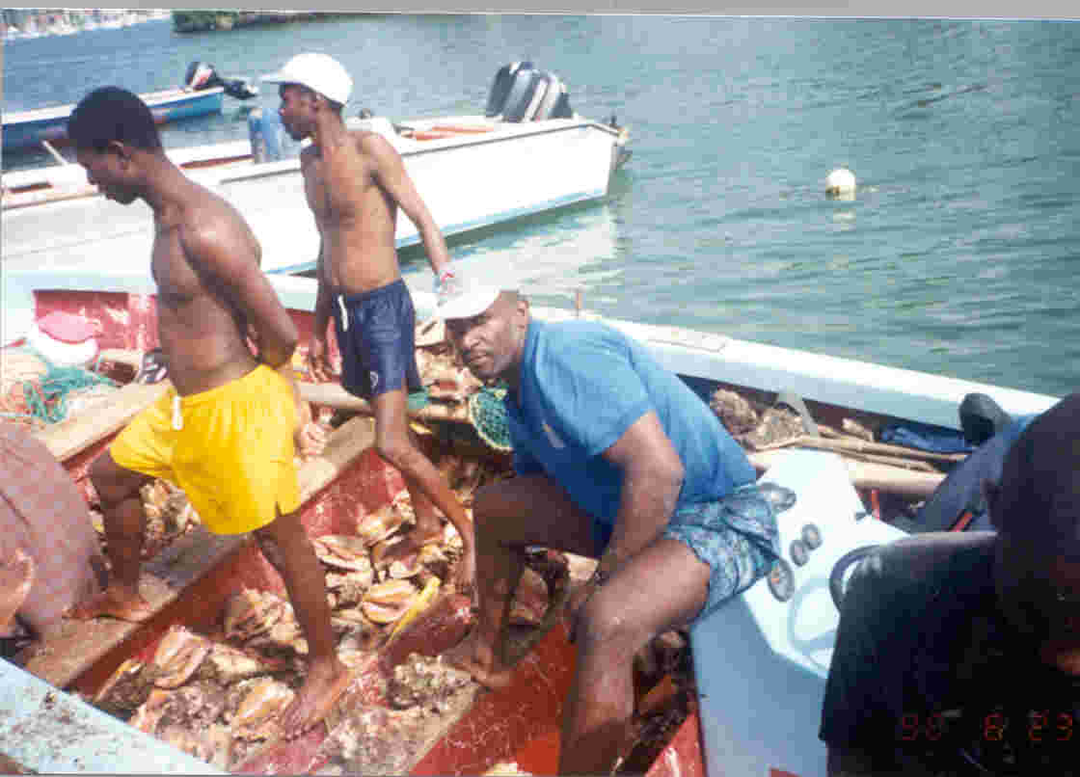

Plate 1. Fisher returning from a conch-harvesting trip.
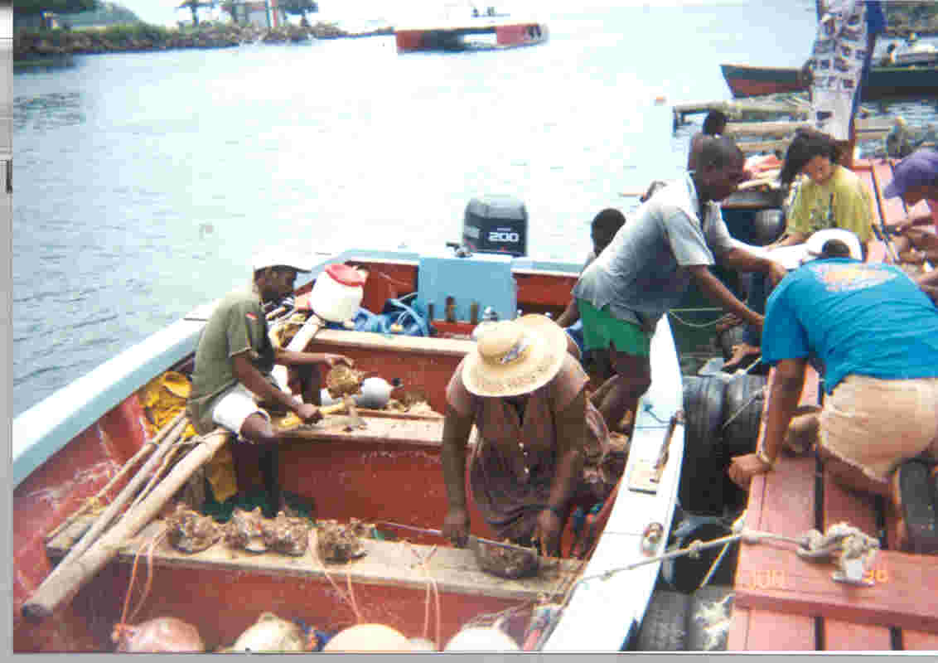
Plate 2.Biological sampling of conch

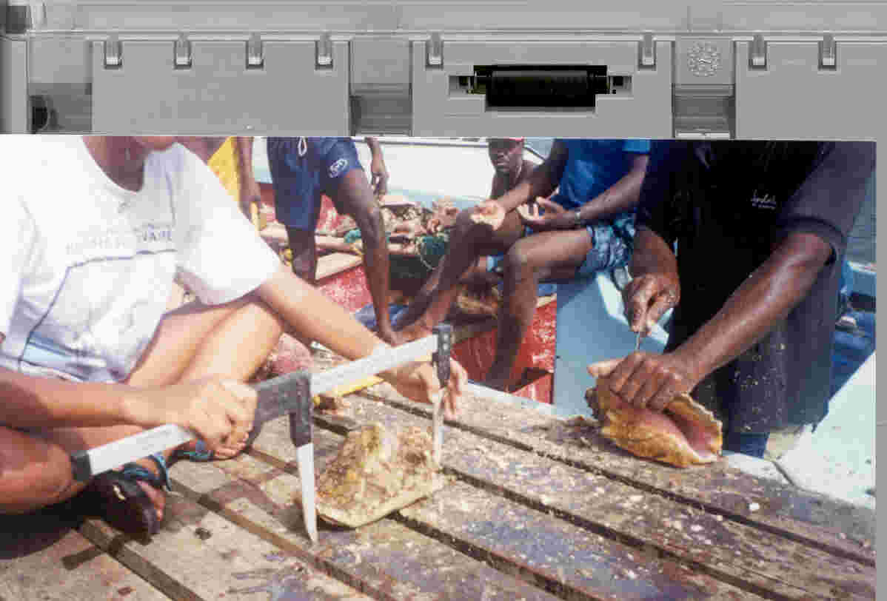
Plate 3. Measuring a conch shell.

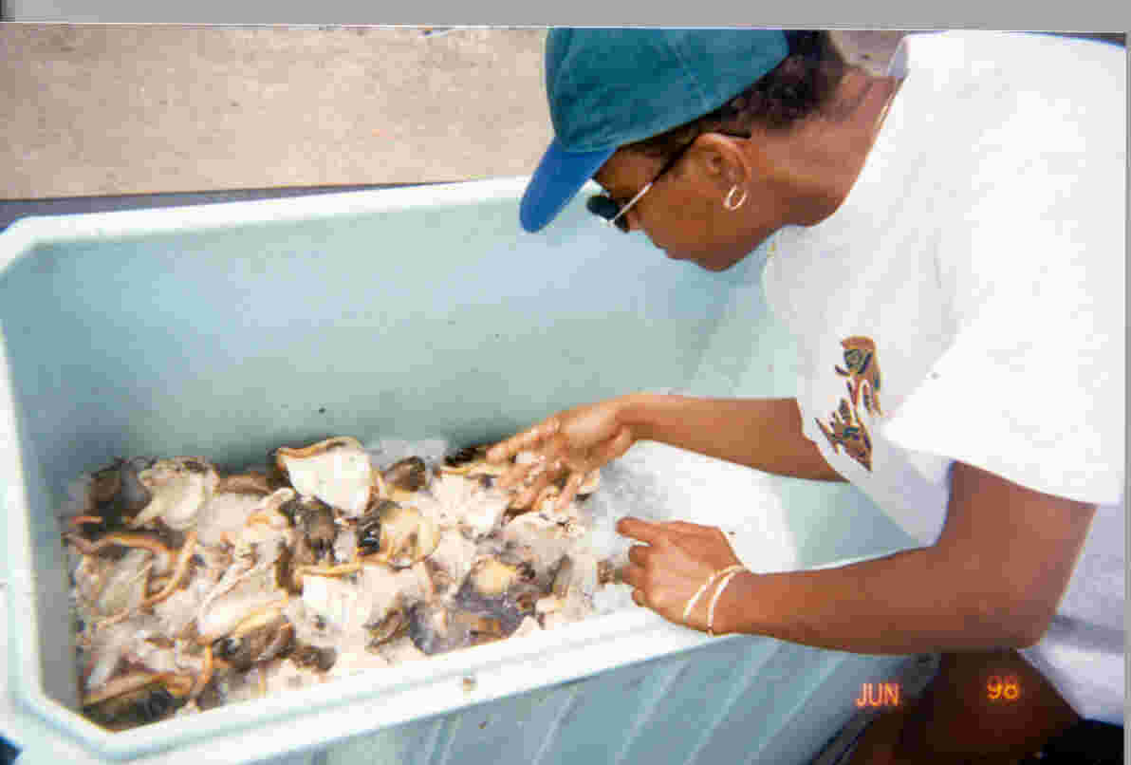
Plate 4 : Conch meat preserved before sale

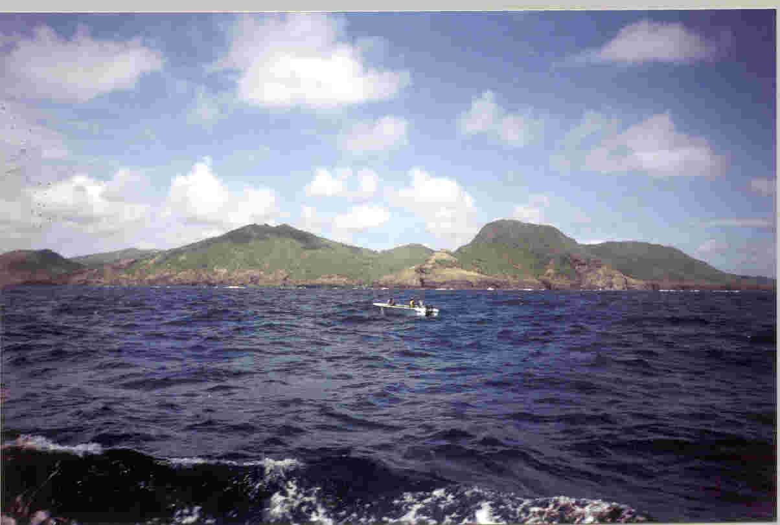Plate 5. Conch harvesting site in the north.

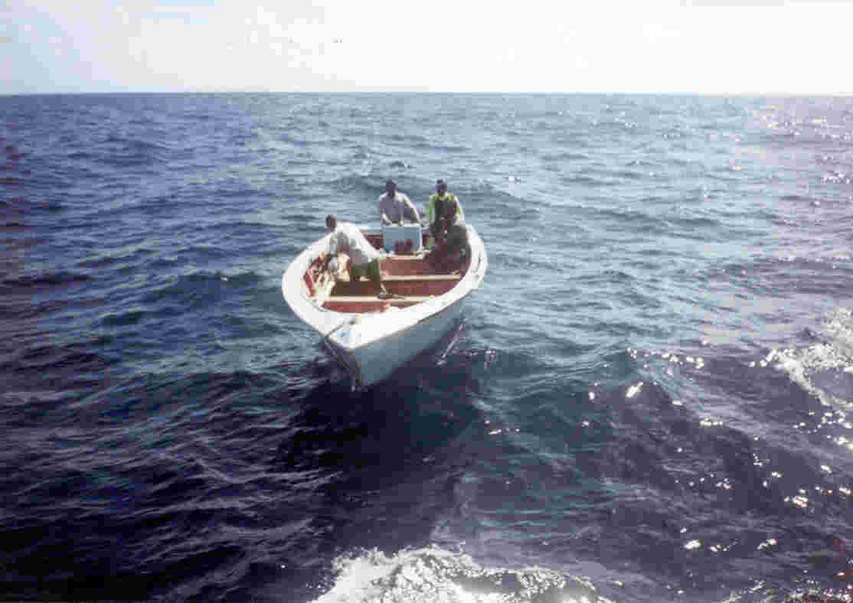
Plate 6. Open fibreglass pirogue vessel used to in the fishery
.

