Saint Lucia Conch Assessment and management Activities Report for 2nd Lobster and conch working group meeting

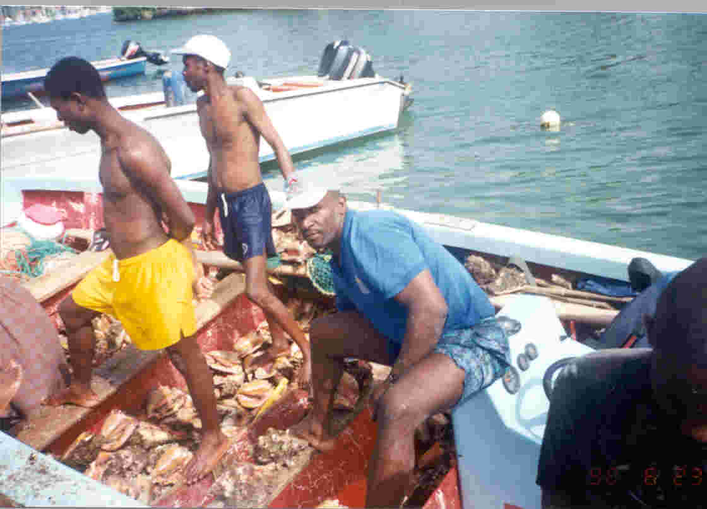

Revised, 2003
Data Collection and Research Activities for Saint Lucia, 2001
Prepared

By
Williana Joseph
Fisheries Biologist
Department of Fisheries
Ministry of Agriculture, Forestry and Fisheries
Sir Stanislaus James Building, Castries St. Lucia

1. Introduction

Saint Lucia is situated between latitude 13° and 14° north and longitude 60° and 61° west, and occupies a central position among the windward islands in the Lesser Antilles (Figure 1). The island has a total land area of 620 km², with maximum dimension of 42 km long and 22 km wide, surrounded by a coastal shelf area of 522 km² and a coastline which extends for 158 km.
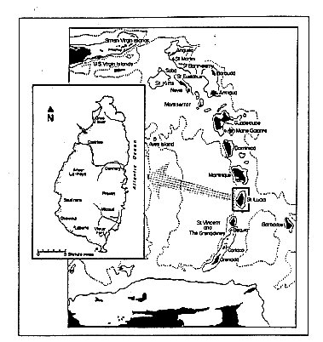
Figure 1. Map of Saint Lucia showing its position in relation to the other islands of the Eastern Caribbean (Murray, 1996).

The most productive economic sectors, in terms of contribution to national GDP comprise: transport and communication; construction; hotel and restaurants; wholesale and retail trade. The agriculture sector, although not a top contributor to the GDP, contributed at least 97.62 EC$ million (at current prices) in 2002, which accounted for 6.45% of the total GDP (Government Statistics Department). The fishing sector provides a small but growing contribution and in 2002 contributed in excess of 24 million EC dollars which represented an increase of over twice its contribution to the national GDP for 1995 (Government Statistics Department).
.
The major fisheries resources of Saint Lucia consist of demersal, coastal pelagic and offshore pelagic fisheries. Although there is some year to year variability in transition in terms of time, the fishing year of Saint Lucia can be divided into two seasons: a “high’ season which extends from December to May when significant landings of offshore migratory pelagics occur and a “low” season which extends from June to November when large quantities of demersal fishes are landed.

The offshore pelagic fisheries contribute over 75% of the annual landings by weight (Department of Fisheries, 2002) which is made up of a number of migratory species, including dolphinfish (Coryphaena hippurus); mackerel (Stromberomorus spp.); Wahoo (Acanthocybium solandri); blackfin tuna (Thunnas atlanticus); yellowfin tuna (Thunnus albacares); Skipjack tuna (Katsuwonus pelamis); sharks (various families); billfishes (Istiophoridae, Xiphiidae) and flying fish (Hirundichthys affinis). The total landings have fluctuated but with a general increase in annual production from 1993 to 2002 (Figure 2).

Figure 2. Estimated annual landings of Strombus gigas for 1993 - 2002
Data for 2002 are preliminary

Description of the Conch Fishery

The Queen conch, Strombus gigas (Linaeus, 1758) is one of the single species nearshore fisheries of Saint Lucia. Presently, near shore stocks have been over exploited, thus most fishers harvest at deeper depths with SCUBA gear. However, conch is still harvested with gill nets and by free diving in areas along the west and southwest coasts (Rambally, 1999). Although this species is thought to be distributed around the island, only two significant populations have been identified, one to the north and the other to the south of the island (Nicholas & Jennings-Clark, 1994). Information obtained from a recent survey of vessels targeting conch resources (Walker, 2003) indicated that divers harvest conch regularly from various areas off Cas en Bas, Esperance, Grand Anse, Gros Islet, Mennard and Marisule in the north; Vieux Fort and Caille Bleu in the south; and Dennery on the east coast. Conch vessels target, on average, three areas on a rotational basis. At this point the northern population is thought to be more heavily exploited than the southern population.

Conch is exploited commercially all year by over 40 fishers in depths ranging from 11 m to 43 m. Fishers operate mainly out of fiberglass pirogues ranging in length from 7.02 – 8.45 m, powered by outboard engines of 115 – 250 hp (Appendix 1). Walker, (2003), reported that whilst conch is targeted commercially by some fishers throughout the year, others fishers focus their efforts on this resource during the low period for “offshore” pelagic species, for, on average, five months. Fishers of this resource can be divided into part-time and full-time. Full-time fishers conduct dives on an average of four times each week alternating harvesting and rest days, whilst part-time fishers operate twice each week (DOF- Conch divers’ survey, 1999). Walker, (2003), reported that the majority of divers conduct greater than three dives per trip and approximately 100 – 500 individual conch are landed per trip. The quantity of conch landed is dependent on the number of divers and the number of dives conducted during the trip. Subsistence exploitation in shallower areas occurs but the extent is unknown.

Due to the nature of the fishery, the marketing system and an informal policy of the Department of Fisheries, the majority of conch harvested are landed whole (live) and then sold immediately or stored in wire-meshed cages in shallow areas close to shore until sale is obtained.

3. Trade Statistics, Trends and Issues

Export and Import quantities and values for past 5-10 years or more

Previous to 1993, exportation of conch was not permitted, but a study on conch consumption in Martinique revealed that illegal exports in the late 80s were in the region of 5 tons. From 1993, export to this neighbouring territory was then permitted and controlled under the Convention on International Trade in Endangered Species of Wild Fauna and Flora (CITES) (Department of Fisheries, 2001). Under this system, vessels were required to export whole animals and were only allowed to operate through procedures stipulated by CITES and only after careful examination of the product. But at the end of 1997, due to the implementation of trade restrictions by the EU with regards to health and sanitary controls for fishery products exported to the EU coupled with the re-opening of the conch fishery of Martinique, legal export to this island ceased. In 1997, approximately 6,900 conch (live) were exported to Martinique (records of DOF). In addition, in 1999, CITES Standing Committee recommended the suspension of imports of conch products from Saint Lucia. These decisions therefore resulted in an apparent thriving illegal trade of this resource between Saint Lucia and Martinique.

In April, 2002, at the 46th meeting of CITES, the Standing Committee withdrew its recommendations to Parties to suspend imports of conch from Saint Lucia. However, trade between Martinique and Saint Lucia has not resumed after the lifting of trade restrictions since Saint Lucia has not satisfied the EU health and sanitary control requirements. From 2002, for reasons unknown, the unauthorized trade by fishing vessels of this resource appears to have almost ceased.

Conch shell, a by-product of the fishery is cleaned and polished then sold as a souvenir to visitors. Records of the Department indicate that at least 30 souvenir conch shells were exported between 1997 and 2002.

Conch is also imported to satisfy the local demand of the local tourism industry and in 2001, 5,045 kg of frozen conch meat was imported mostly from neighbouring Saint Vincent and the Grenadines and the US. Information on the quantity of conch imported is not readily available since the data resides with the Department of Customs and Excise. Recently, the Department of Fisheries has held dialogue with the Department Customs and Excise in developing a mechanism which would enable copies of records of the importation of conch meat available to the Department.

Product description and processing plants (numbers, capacity, private sector, cooperatives etc).

Generally, conch meat is removed from the shell and sold by fishers without further processing. However, at the Saint Lucia Fish Marketing Corporation, the meat is 100% processed before it is packaged and sold.

Markets (USA, Canada, Europe, tourist trade etc), market access issues

Currently, the major market for conch meat is the local market, which serves both the tourism sector and nationals. Over the past three years, there has been a growing demand for conch meat as a result of activities such as seafood festivals, developed in several communities to stimulate economic development in these communities. To date, these festivals take place weekly in four major communities namely, Gros Islet, Dennery, Anse la Raye and Vieux Fort.

Walker, (2003), reports that seven out of nine conch entities responded to having both local and foreign markets for conch whilst only two had only local markets. The local markets identified were the Saint Lucia Fish Marketing Co-operation, hotels, restaurants, seafood festival vendors and the public. The majority of respondents indicated that there is a daily demand for the product, unlike in the past when conch had to be enclosed in nearshore pens until sale was obtained.

Government subsidies and incentives (type, quantities)

Subsidies and incentives in this sub-sector are not different to the subsidies obtained in the overall fishing sector and include, refund of duty on fuel, duty free concession and consumption tax exemption on fishing gear and equipment.

Other trade issues including CITES –

In 2002, the Standing Committee of CITES withdrew recommendations to suspend imports of conch from Saint Lucia and COP 12 agreed that shells of the Queen conch would qualify as exempt from the provision of Articles III, IV and V of the Convention under the category of personal and household effect. Under Resolution, Conf. 12.9 “Queen conch (Strombus gigas) shell – up to three per person do not require export or import permits, or re-export certificates, for personal or household effects for the dead specimens, parts and derivates.”

The more affluent market prices obtained in neighbouring Martinique is a continual driving force for trade from Saint Lucia therefore enforcement by Martinique is essential to regulate trade.

4. Conch Data Collection Programme

4.1 Catch and Effort Data Collection Programme

4.1.1 Catch and Effort Sampling Plan

The first fisheries data collection system for the island was implemented in 1979. Since then, the system has undergone considerable refinement and revision, in an effort to satisfy the information required for decision- making and sound management advice, whilst responding to numerous changes in the fisheries sector, in recognition of human resource and financial limitations (W B. Joseph, unpublished a). Over the past decade, very little information on major single species fisheries such as conch has been collected on a consistent basis. Therefore, other collection programmes were implemented to obtain necessary information for assessing the status of these stocks.

The main aim of the data collection system is to monitor the status of the stocks that are being exploited. However, due to the nature of different fisheries, fishermen’s perceptions or behaviour and both national and global economic issues, strategies implemented to gather necessary information require constant modification, in order to capture in a timely manner, the changes occurring in the fishery. Nonetheless, due to administrative, financial and human resource constraints ,there is often a time lag in modification of these strategies and therefore there can be instances of lack of current specific data to guide particular management decisions.

Overall, current fisheries data collection systems include several components such as gathering of data on catch, effort, registration of fishermen and vessels, SCUBA diving and snorkeling establishments, sports fishing vessels and spear gun fishers, in addition to licensing data of fishers and fishing vessels, dive and snorkel leaders. The catch and effort data collection plan is based on a stratified random sampling regime of three major strata: primary, secondary and tertiary landing sites, based on the number of vessels operating, the fishery types and the volume of fish landed (W.B. Joseph, unpublished b). Of the 23 landing sites from which the fisheries operate, catch and effort data are collected from eight on a permanent basis (Figure 3). Under this sampling plan, conch landings were only captured for Gros Islet in the north, where the majority of conch were landed. In 2001, the sampling plan was revised to include two other sites in the southwest, where fishers from one of these sites are also known to target conch. This revision has improved the information base for this species. Analysis of the 2002 data shows that conch is now landed at four landing sites: Gros Islet, Castries, Laborie and Vieux Fort.

4.1.2 Limitations and Strengths

Limitations

Due to traditional practices in the fishery, collection of adequate data on landings of this resource has been challenging. However, during the jointly funded CFRAMP and Government of Saint Lucia funded conch biological data collection programme, sufficient data were collected and many lessons learnt. One such lesson is, that it is essential that data collection for this fishery be undertaken as part of a collaborative framework with fishers. One limitation identified is that the sampling strategy is not flexible enough to respond to the impact of national and external policy measures.

With the termination of the biological data collection programme and the discontinuation of biological data collection for this resource due to lack of funds, the situation has reverted to its original state. Complicating the issue further was the loss of the legal trade to Martinique and competition from cheaper imported conch resources from neighbouring island of Saint Vincent and the Grenadines.

Strengths

The fishery is operated by a small number of fishers, therefore facilitating close interaction between key players and the management authority. Thus, additional information to augment data collected at the landing sites can be easily obtained by the administration of a questionnaire.

Fisheries data are collected on a regular basis at eight landing sites, four of which capture conch landings.

Recommendations

Previously, it was recommended that although the collection of conch data is integrated into the catch and effort data collection plan, the nature of the conch fishing practices justifies a separate catch and effort data collection plan designed in close collaboration with the fishers. Without this strategy, adequate catch data may be collected but effort, in addition to biological information, will be challenging to collect since before sale, conch are stock piled into cages and cannot later be distinguished by trip or by area fished.

Biological Data Collection Programme

Biological Data Collection Programme

Although biological data have been collected in the past for this species, the collection of such data has not been sustained after the termination of externally funded projects.

Recommendations

In the management of any fishery, it is fundamental that adequate and reliable data guide management decisions. Therefore, in order to monitor and assess the status of this resource, at least basic biological data such as, lip thickness, shell length and meat weight should be collected consistently over a prolonged period. Mechanisms for sourcing funding and integrating collection of biological data into the catch and effort programme for this resource must be sought.

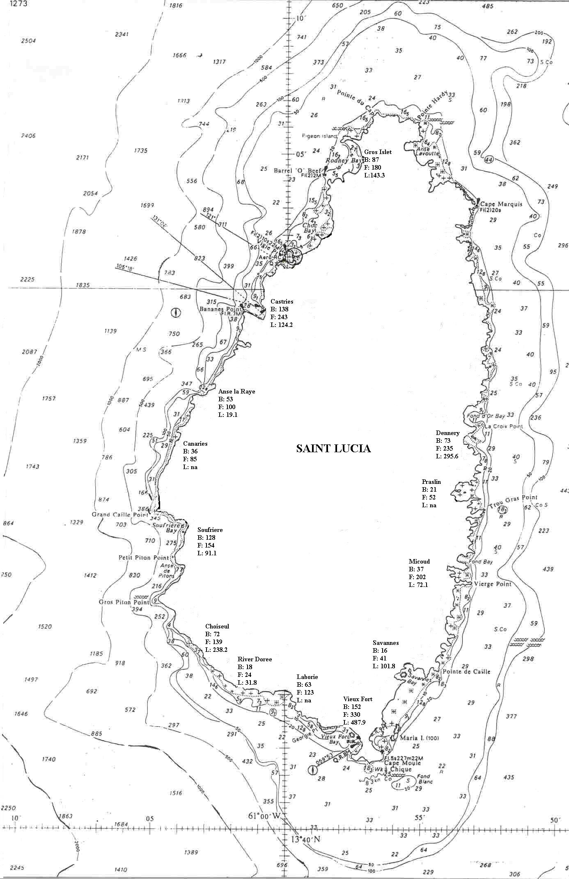
Southern fishing ground
Northern fishing ground

Figure 3. Major landing sites in Saint Lucia and the number of fishers and vessels at each
site. Depths in m. (Source: Department of Fisheries, Saint Lucia - 2000) - Fish landing data collection sites. Key: B: number of boats; L: Landings (tons); F: number of fishers na: not available

Other (economic, social) collection programme

In 2000, the Department of Fisheries, in response to the increased accidents/injury resulting from unsafe diving practices during harvesting of conch, administered a questionnaire to collect information for implementation of a training programme in safe harvesting practices. Information gathered has been used in the preparation and delivery of training. It has also been used for justification of the need to support a proposal for the provision of a grant for replacement of SCUBA gear of fishers of which the majority is unsafe, but yet continue to be used in the fishery.

Data Management

For all catch and effort data, integrity checks are carried out both prior and preceding data entry. Prior to data entry, data sheets are checked for errors and omissions with the data collectors whilst subsequent to data entry into Trip Interview Programme (TIP) data are also validated and verified for errors and omissions.

Data are backed up and stored on diskettes at regular intervals throughout the year using WINZIP. A copy is made when the last batch of data are entered for the calendar year. Data are stored on site as well as off location.

Data collected by the administration of questionnaires are stored in an electronic form. All data sheets are filed using the Data Management Unit filing system.

Data Analysis

Catch and effort data are analyzed quarterly using a raising factor function, based on the fishing activity (total number of vessels and number of fishing days) and effort of collectors based on a stratified sampling plan (days and vessels sampled by collectors).

In 2002, the conch fishery accounted for only 1.94% of the total annual landing. However, this contribution has been steadily increasing from 1996 with decreases in 1997 and 2002 (Figure 2).

Legal and Regulatory Framework for Management

Two management objectives have been defined for this resource and are articulated in the Plan for Managing the Fisheries of Saint Lucia (2001- 2005). They include rebuilding the near shore stocks and ensuring sustainable use of this resource. Options identified for attaining these objectives include initiating a flared lip thickness restriction, controlling effort through a licensing system, implementing closed areas or seasons and co-management arrangements with resource users.

In an effort to effectively manage this resource, steps have been taken to implement a limited entry system by licensing all fishers operating in the fishery. To this end, the Department of Fisheries has held training sessions in proper and safe diving practices. Through this training workshop, several traditional divers have been certified in SCUBA diving. The next step, the replacement of unfit SCUBA gear, has been delayed due to the unavailability of a financing avenue accessible to the conch fishers. Therefore, the Department has not been able to implement the limited unless vessels and gear pass inspection.

At the national level, Fisheries Regulations, in place since 1994, provide protection for this resource by prohibiting the harvesting of conch of less than 180 mm total shell length, less than 1 kg total weight and less than 280 g meat weight, not including digestive glands. In addition, these Regulations restrict harvesting of immature conch, defined as individuals without a flared lip. However due to financial and manpower limitations, enforcement focuses on only one of these Regulations - the harvesting of individuals with flared lips due to the ease of implementation in the field. The Fisheries Regulations also make provisions for a closed season but, to date, this management measure has not been implemented.

In 2000, the Department of Fisheries with assistance from FAO, embarked on an initiative to revise the fisheries legislation. The following are amendments regarding conch proposed in revised fisheries legislation, which should be in enacted by the end of 2003 :

(1) No person shall -
I. take from the fishery waters, sell, purchase, or at any time have in his possession any immature conch; or
II take from the fishery waters, expose for sale, purchase or at any time have in his possession any conch during the closed season for conch or taken from a closed area for conch as specified by the Minister by notice published in the Gazette and in a newspaper which is printed or circulated in the State
III. take from the fishery waters, have on board any fishing vessel or land any conch out of its shell.

(2) In this Regulation -

- “conch” includes the whole or any part of any conch;
- “immature conch” means a conch with -
  - a shell with a lip thickness of less than 5 millimetres;
  - a total weight of less than one kilogramme or
  - a shell which does not have a flared lip.

7. Fisheries Independent Studies

7.1 Introduction

A conch biological data collection initiative jointly funded by CFRAMP and the Government of Saint Lucia commenced in 1996 and was for a period of two years. The main aim of this initiative was to gather information in order to assess the status of the conch resources of the island so as to guide management decisions. Previous to this data collection exercise, the fishery was severely under recorded and information required to conduct basic monitoring of the resources was unavailable and in some cases had never been collected.

Methodology

Strombus gigas harvested by commercial fishers from fishing areas in the north and south (Figure 3) were sampled. Fishers involved in the study were asked to land all sizes of conch. The locations of fishing grounds were determined using a Global Positioning System (GPS). Harvesting was done using SCUBA gear only.

Data collected included shell length, lip thickness for adults, sex, state of maturity(adult /juvenile), total weight and wet-meat weight. State of maturity was approximated by the presence of a flared lip and immaturity by the absence of a flared lip. All length measurements were measured to the nearest millimeter with calipers. Total shell length was the maximum length measured from the tip of the spire to the edge of the siphonal canal, whilst lip thickness was measured in the mid-lateral region, approximately 35 mm from the edge of the shell. Weights were measured to the nearest gram for one sample for each site. Total weight was determined by weighing the whole animal, including the shell; however, meat weight, that is, wet-meat weight, was determined by weighing the animal, excluding the shell but including the viscera. Sex of the conch was determined when the meat weights were taken, once they were shelled.

All data were stored and summarized in Trip Interview Programme (TIP) and EXCEL.
For analyses, data were grouped into northern and southern areas.

Results and Discussion

The results presented here are preliminary. An indepth analysis has not yet been conducted.

A total of 4,390 conch were sampled 3114 from the northern fishing ground and 1276 from the southern fishing ground (Fig. 3). Less than eight percent (7.4 %) of the sampled conch were immature, that is, did not have a flared lip. Sex was determined for a total of 317 conchs of which just over 45 % were female. For both areas, lip thickness showed a predominance of conch in the 15 –27 mm size classes, with the greatest percentage in the 24 – 26 mm size classes. Very few conch with lip thickness less than 5 mm were landed (Figure 4).

Figure 4. Lip thickness composition of queen conch sampled in the northern and southern fishing areas.

For both fishing areas, the majority of conch were found in the 200 – 280 mm size classes. But peaks were obtained in the 260 mm – 279 mm range for the south and 220 –239 mm range for the north. The majority of conch found in the south were of a larger total shell length compared to those from the north (Figure 5). Over 99% of the total conch harvested had shell lengths greater than 180 mm, that is, the minimum size limit.
Minimum size regulations

Figure 5. Shell length composition of queen conch sampled in the northern and southern fishing areas.

The mean shell length, lip thickness, total weight and meat weight were larger in the south compared to the north (Table 1).

Table 1: Summary Statistics for length, weight and lip thickness by sampling area.
N= Number of individuals; S.D.= standard Deviation; F = Females, M = Males

Area | Shell Length (mm) |  |  | Meat Weight (g) |  |  | Lip Thickness (mm)
 | N | Mean | S.D | N | Mean | S.D | N | Mean | S.D
North
All | 3114 | 239.44 | 26.95 | 149 | 283.28 | 100.31 | 3114 | 19.19 | 8.42
M | 72 | 225.26 | 13.65 | 78 | 295.51 | 102.07 | 77 | 22.58 | 7.91
F | 77 | 230.99 | 718.89 | 71 | 270.07 | 96.80 | 72 | 23.51 | 7.51
South
All | 1276 | 246.25 | 27.03 | 49* | 331.63 | 132.50 | 1276 | 21.37 | 8.27
M | 73 | 233.53 | 13.87 | 13 | 370.17 | 146.18 | 73 | 28.32 | 9.64
F | 96 | 238.59 | 24.92 | 34 | 322.68 | 84.64 | 96 | 28.33 | 10.01

*Sex was not determined for three conch in the sample.

Preliminary analyses revealed that although less than 10% of the conch sampled were immature, (without a flared lip), less than 0.5 % were less than 180 mm total length, meaning that the majority of conch landed are above the minimum size limit articulated in the Fisheries Regulations No. 10 of 1994. This supports the conclusion drawn from the crude method adopted previously, where monitoring landings was done by examining stock-piles of discarded conch shells and indicated that the fishery was targeting mainly adults since juvenile landings were negligible. Stocks are thought to be sustaining the current level of fishing, although shallow water stocks have been over exploited.

Conch matures at about 2.5 – 3 years, when shell lip has completely formed and thickens to 5 mm (Appeldorn, 1994). From preliminary analyses, the majority of conch appear to be older than 3 years.

7.4 Recommendations

An in-depth analysis of biological data collected during the two-year period should be carried out. This would provide much need information to guide management decisions.

Conclusions and recommendations for management and future activities

The following recommendations are being considered by the Department of Fisheries:

  - Although stocks are thought to be sustaining the current level of fishing pressure, fishers have moved from the near shore depleted resources to resources offshore. Therefore, it is essential that measures are put in place to contain the level of effort for the sustainability of the fishery. Efforts to commence the recovery of the near shore stocks by closing these areas to fishing for conch should be investigated.
  - Mapping of the conch habitats should be considered, followed by a detailed baseline study of conch density within these areas. This would enable the management authority to manage the resource more effectively through zonation and declaring closed areas if necessary (eg. to protect major breeding areas).
  - Collaboration is needed for regional management of this resource in the form of harmonized regulations.
  - Biological data collection for this resource should be integrated with other fisheries data collection strategies.
  - Collaborative arrangements are needed between fishers and the management authority in the collection of necessary biological, catch and effort information.
  - Implementation of a minimum lip thickness criteron which is a better indicator of maturity than total shell length, since at maturity, growth in shell ceases.

References

Appeldorn, R. (1994), Status of Queen Conch Fishery in the Caribbean Queen, In:R.S. Appledorn & B. Rodriquez (Ed.) Conch Biology, Fisheries and Mariculture Fundacion Cientifica Los Roquez, Caracas, Ven.

Department of Fisheries (2001) Plan for Managing the Marine Resources of St. Lucia Department of Fisheries St. Lucia 54pp

Joseph, W (unpublished a) Fisheries Data Collection System for Saint Lucia

Joseph, W (unpublished b) Conch Fishery Resources of Saint Lucia

Nichols K., and Jennings-Clarke, (1994) An overview of the Conch Industry in St. Lucia, West Indies In:R.S. Appledorn & B. Rodriquez (Ed.) Conch Biology, Fisheries and Mariculture Fundacion Cientifica Los Roquez, Caracas, Ven.

Rambally J. (1999) An overview of the Conch Fishery of St. Lucia.

Walker, L. (2003, unpublished) Conch Fishery of Saint Lucia: analysis of questionnaires administered to boat owners.

Appendix 1

Plate 1: Fisher returning from a conch-harvesting trip.

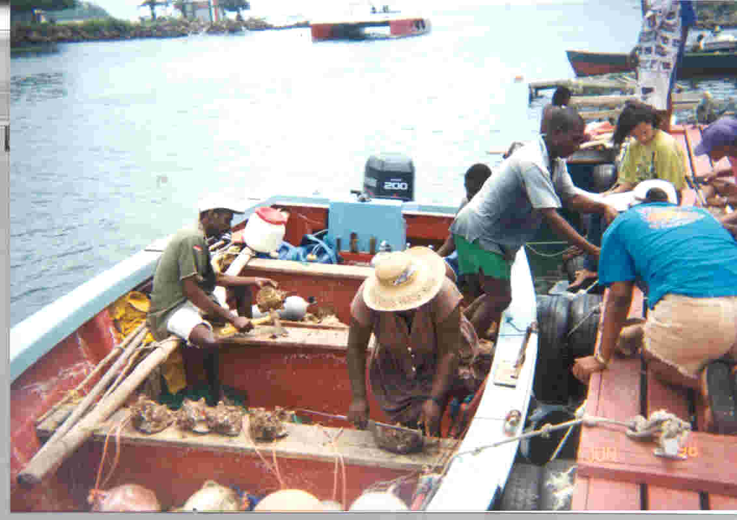

Plate 2: Biological sampling of conch

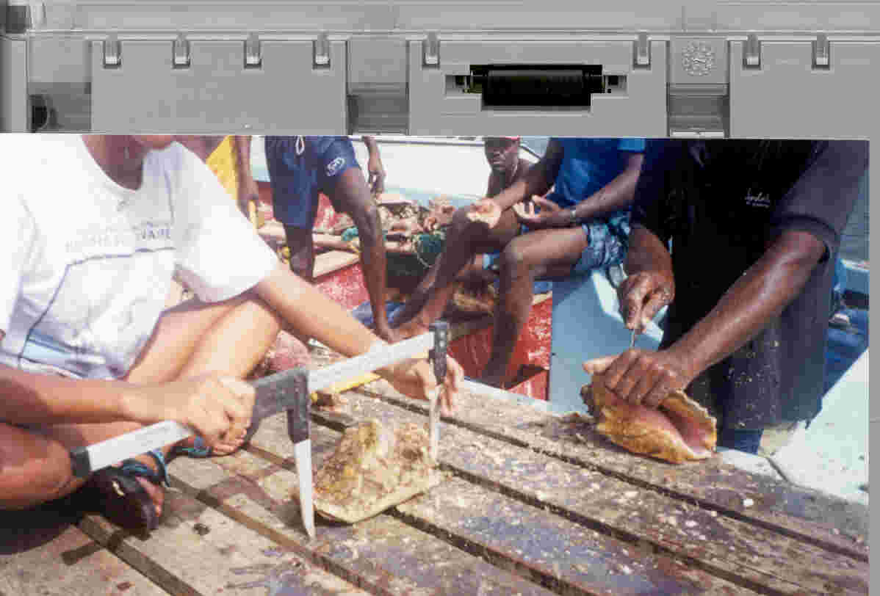
Plate 3: Measuring a conch shell.

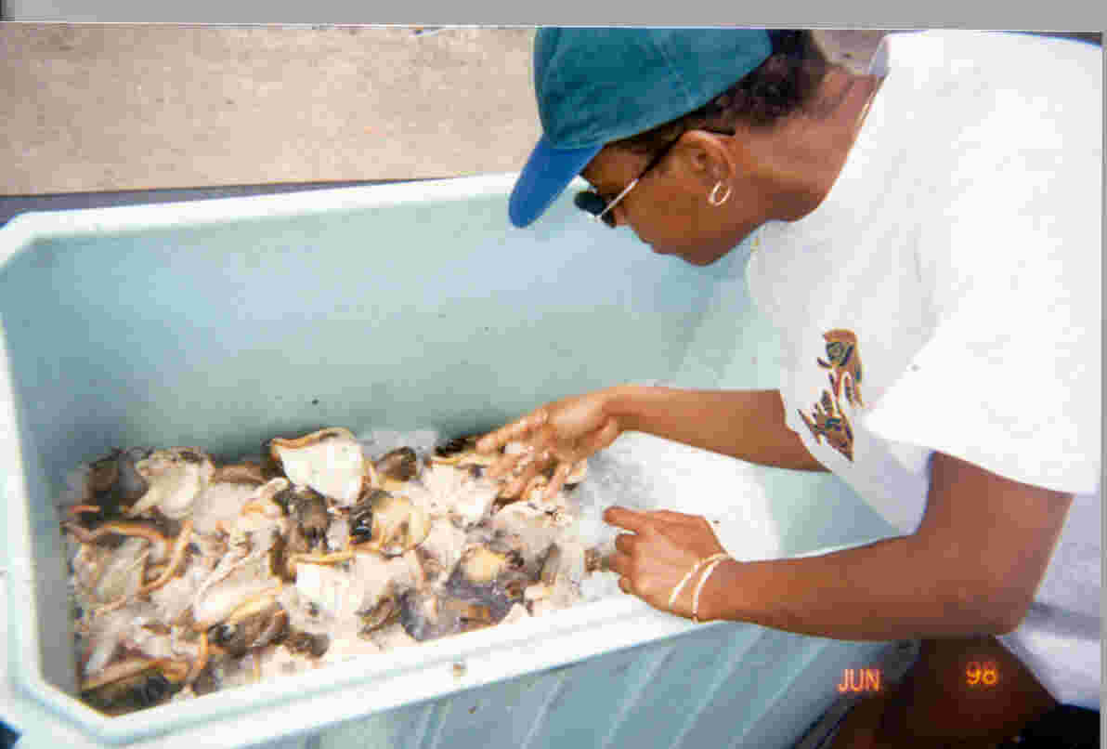

Plate 4 : Conch meat preserved before sale

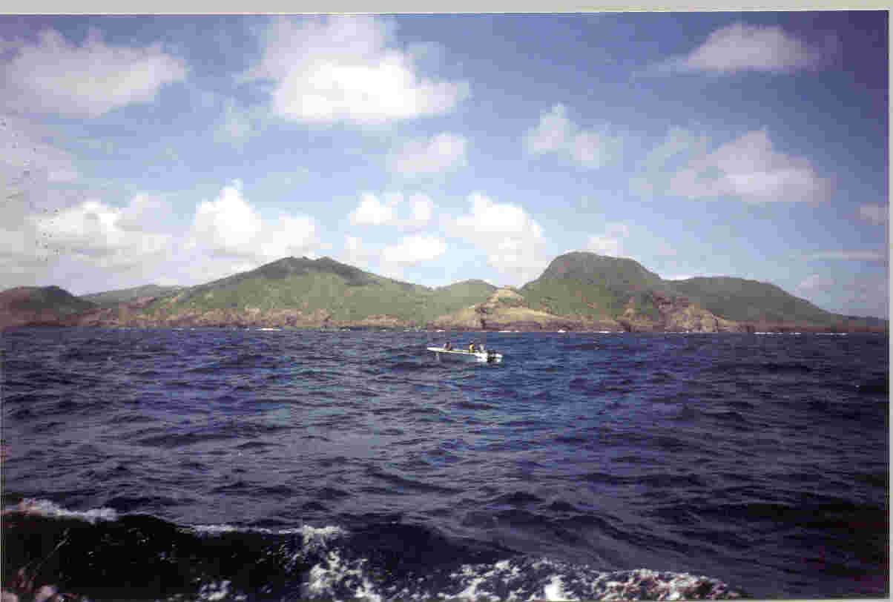

Plate 5: Conch harvesting site in the north.

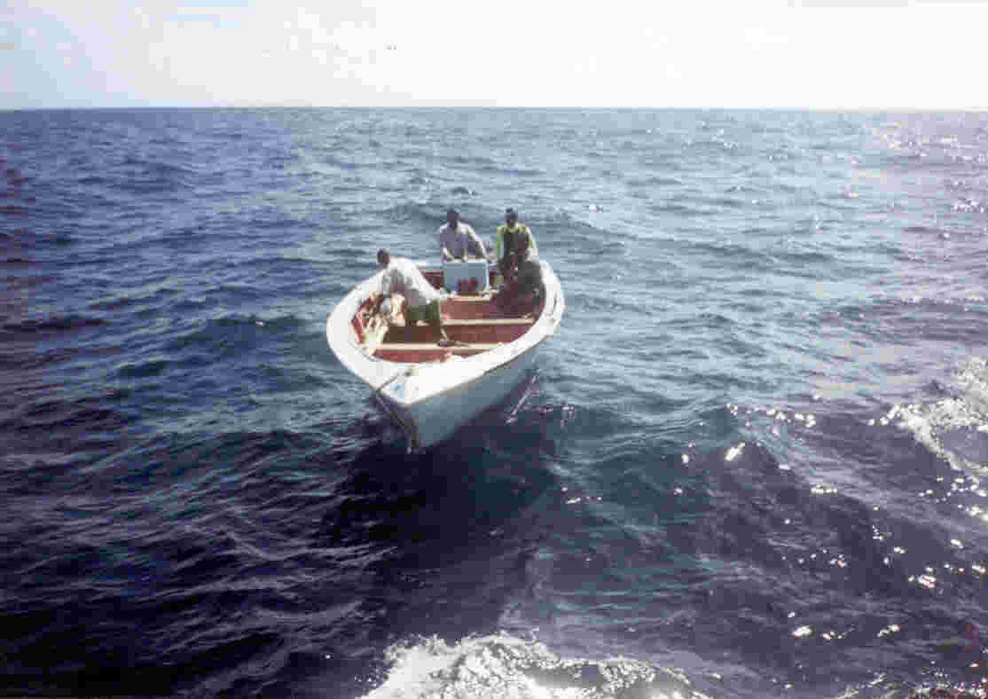
Plate 6: Open fibreglass pirogue vessel used in the fishery
.

Total export of conch in 1997 is being verified.

