

**Terminal Report**

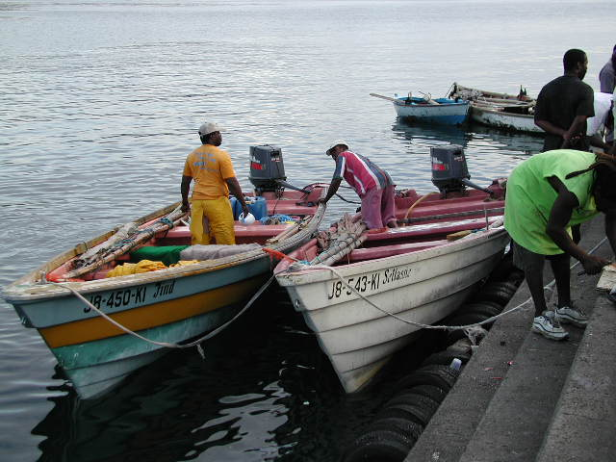**E-CONSULTATION ON THE IMPLEMENTATION AND MAINSTREAMING OF REGIONAL FISHERIES POLICIES INTO SMALL-SCALE FISHERIES GOVERNANCE ARRANGEMENTS IN THE CARIBBEAN**

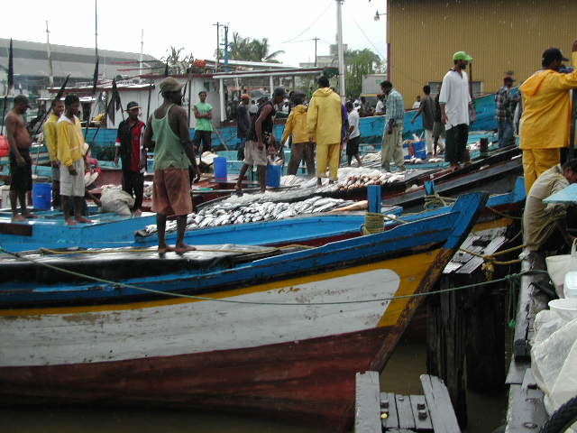

CRFM Secretariat

Belize

2013

Prepared by:

Julius P.A. Gittens, MA  
Media & Communications Specialist /Journalist

Barbados, [gittensj@freemotion.bb](mailto:gittensj@freemotion.bb), under contract to the Caribbean Regional Fisheries Mechanism (CRFM) Secretariat

*© CRFM 2013*

All rights reserved.

Reproduction, dissemination and use of material in this publication for educational or non-commercial purposes are authorised without prior written permission of the CRFM, provided the source is fully acknowledged. No part of this publication may be reproduced, disseminated on used for any commercial purposes or resold without the prior written permission of the CRFM.

Correct Citation:

Gittens, Julius P.A. Terminal Report – E-Consultation on the Implementation and Mainstreaming of Regional Fisheries Policies into Small-Scale Fisheries Governance Arrangements in the Caribbean. CRFM, Belize City. Pg27

Published by the Caribbean Regional Fisheries Mechanism Secretariat

Belize

This document has been produced with financial assistance of the Technical Centre for Agricultural and Rural Coordination (CTA) which funded the Consultancy. However, the views expressed herein are those of the author and CRFM Secretariat, and can therefore in no way be taken to reflect the official opinions of CTA.

## **Table of Contents**

* **Acronyms ii**
* **Introduction 1**
* **Original Query 3**
* **Results and Reporting 3**
* **Summary of Responses 4**
* **Responses in Full 6**
* **List of e-Consultation Contacts 13**
* **Methodology: e-Consultation design and management 15**
* **Email invitation campaign details 17**
* **Lessons Learned 19**
* **Recommendations for Follow-up Action 20**
* **Bibliography 21**
* **Appendices 22**

## **Acronyms**

ACP African, Caribbean and Pacific states

CANARI Caribbean Natural Resources Institute

CaRAPN Caribbean Agricultural Policy Network

CARICOM Caribbean Community

CCA Climate Change Adaptation

CCCFP Caribbean Community Common Fisheries Policy

CERMES Centre for Resource Management and Environmental Studies

CIRP Caribbean ICT Research Programme

CLME Caribbean Large Marine Ecosystem

CNFO Caribbean Network of Fisherfolk Organisations

CRFM Caribbean Regional Fisheries Mechanism

CTA The Technical Centre for Agricultural and Rural Cooperation

DRM Disaster Risk Management

EAF Ecosystem Approach to Fisheries

FAO Food and Agriculture Organisation

GCFI Gulf and Caribbean Fisheries Institute

GRENCODA Grenada Community Development Agency

ICT Information and Communication Technology

IUU Illegal Unreported and Unregulated Fishing

SMS Short Message System

OSPECA Organisation for Central American Fisheries and Aquaculture

TTUFF Trinidad and Tobago United Fisher Folk

UWI University of the West Indies

WTO World Trade Organisation

## **INTRODUCTION**

Fisherfolk leaders in the Caribbean Community (CARICOM) have recognised the need to keep themselves informed as well as share information about current fisheries policy and related matters so as to be in a better position to make informed contributions to fisheries policy development at the national and regional levels.

Beginning in 2006, the Technical Centre for Agricultural and Rural Coordination (CTA) and the Caribbean Regional Fisheries Mechanism (CRFM) have been collaborating to support the integration of regional fisherfolk leaders. During the first phase of this collaboration, from 2006 to 2009, the potential for a regional network among fisherfolk groups was explored, national fisherfolk organisations were either established or formalised in order to create the backbone of a regional network, and fisherfolk leaders received training on network management, use of communication tools and advocacy work. In addition, fisherfolk leaders participated in workshops on policy influence and planning, leading to the creation of a strategy and work plan.

Organised as the Caribbean Network of Fisherfolk Organisations (CNFO), they have made direct contributions to the CRFM Ministerial Council Meeting (January 2009) and the CRFM’s Special Forum (April 2009) to develop a common fisheries policy for the CARICOM Member States, now referred to as the **Draft Caribbean Community Common Fisheries Policy**.

In addition, the CNFO has also participated in the CARICOM Consultations on the Implications of the WTO Doha Development Agenda Negotiations for Fisheries (May 2009); and the Gulf and Caribbean Fisheries Institute (GCFI) Meeting in Venezuela (November 2009).

In the latest phase of this process of building the capacity of fisherfolk leadership for contribution to policy formulation and advocacy, the CTA approved a project, **“Implementing the Caribbean Community Common Fisheries Policy: positioning and engaging fisherfolk organisations”**.

As part of this project and as a follow-up to the Guyana Consultation on the implementation and mainstreaming of regional fisheries policies into small-scale fisheries governance arrangements in the Caribbean, held from 25-28 February 2013, the CNFO, together with the CRFM and supported by the CTA, launched a moderated e-consultation from **November 4-14, 2013.**

The objective of the e-consultation was to capture additional views and share information among fisherfolk and stakeholders on **the mainstreaming of regional fisheries policies into small-scale fisheries governance arrangements in the Caribbean** to inform advocacy work.

In order to be in a better position to make informed contributions on issues and policy positions relevant to the implementation of regional fisheries policies, participants were invited via e-mail in a newsletter format to examine and comment on the following key documents available for download through the website:

·         **The**[**Draft Agreement Establishing the Caribbean Community Common Fisheries Policy**](http://www.caricom-fisheries.com/LinkClick.aspx?fileticket=FVQaSQ%2BDh68%3D&tabid=242)**[1] and**

·         **The**[**Castries Declaration on Illegal, Unreported and Unregulated (IUU) Fishing**](http://www.caricom-fisheries.com/LinkClick.aspx?fileticket=eeRVRXUBWGA%3D&tabid=37).**[2]**

To access the e-Consultation forum, participants were invited via email to visit the [website](http://www.dialogue-app.com/910)[3], where the original query was posted (see **Appendix 4**, page 29). They were further informed that the forum was for discussion purposes only, was strictly informal, and intended to be thought-provoking, with the sole intention of generating wide-ranging debate.  
  
They were also made aware that as the e-consultation forum was not an official document of the CRFM Secretariat, CNFO or CTA, participants were encouraged to feel entirely free to contribute to the e-consultation process unofficially and in their personal capacity, if they so desired.  
  
The e-Consultation process was a mixture of [questionnaire, website comments, and e-mail](http://www.dialogue-app.com/910)[4]. A discussion of the methodology begins with the section, ***Methodology: eConsultation design and management*** at page 18 of this report.

## **ORIGINAL QUERY**

The participants were asked to comment on the following [areas](http://www.dialogue-app.com/910/ideas/all-ideas)[5] during the e-consultation:   
  
**Topic 1:**  
**Taking into account the policy documents enclosed and the issues they raise, how can the various stakeholders (i.e. CARICOM member states, local communities, fisherfolk organisations, private sector, etc.) best contribute to the policy’s implementation?**  
  
**Topic 2:**  
**How would the policy impact on the following key policy areas:**  
**- Food and Nutrition Security**  
**- Climate Change**  
**- Disaster Risk Reduction**

## **Results and Reporting**

**Respondents**

There were **19 participants** in the forum.[6]Of this number, **four (4)** submitted a total of **11 comments** on **five (5) separate topics** or “ideas” in the forum. There was one idea contributed by a respondent on the last day of the consultation that received no additional posts. Ratings on the quality of an idea were allowed but only one of the ideas was rated by the manager in an effort to stimulate discussion. None of the individual ideas was rated by the participants. Posts were tagged with keywords by the moderator and by the participants to aid in searches, direct participants to posts and indicate which ideas dominated the discussion. There were 15 keywords, or “tags”, as follows:

|  |  |
| --- | --- |
| * Capacity Building * Climate Change * Data * Decision Making * Disaster Management * Ecosystem Approach * Fisherfolk | * Fisheries Contribution * ICT * License Fraud * Literacy * Stakeholder Ownership * Surveillance Capability * Training |

## **Summary of Responses**

The following responses summarise, in the main, the overarching consensus of the forum:

1. **Lobby CARICOM Heads for consensus on CCCFP:** ““Consensus is necessary to establish the policy, and boundaries among CARICOM and non-CARICOM members need to be established (Among the CARICOM countries a common area can be established).”

1. **The problem of cross-border management - a need for a regional fisheries management agency:** “The Executive Director of CRFM has to visit the different member states of CARICOM, especially the ones that have large rivers which provide for multi species of fish in the marine environment under their jurisdiction. I see also some problems with non-CARICOM states where there seems to be no boundaries in the marine environment. Dominica comes to mind with such a situation. These issues have to be resolved before the policy comes into force. However we need a Regional Body to manage the fisheries sector in the Region.”
2. **Barriers to fisherfolk to regional food and nutrition security:** “The voice of the fisherman is weak, fisheries’ true contributions, in particular, to rural coastal communities continue to be understated. The challenge is to convince the policy decision-makers and those who control the finances to prioritize fisheries from the viewpoint of food security and survival. The call for strength in speaking with one common voice, can we dispel the notion, that there is more to fishing activities than meets the eye. How does the region intend to deal with this real threat not only to food but also to national security as scarcity increases, livelihoods threatened and viable alternatives remain an illusion.”
3. **Ecosystem Approach to Fisheries (EAF) an ideal principle for marrying fisheries policies:** “Fishing behaviour influences risk exposure as well as the level of vulnerability of the fisher. For example, improvements in bait, gear (e.g. to reduce juvenile catch + by-catch), location selection can improve catch/unit effort and using ice chests can reduce market risks by preserving the quality of the catch. Both can improve the profitability of fishing (short + long term). Within the context of the EAF this could marry fishing regulations, fisher behaviour and the biological concerns of maximizing the use of the fisheries resource.
4. **CCCFP adequately covers Ecosystem Approach to Fisheries (EAF), Climate Change Adaptation (CCA) and Disaster Risk Management (DRM):** “This should be complemented by interventions articulated by the policy and supported by the partner organisations that would complement risk profiling and identifying reduction strategies. This would factor in the CCA and DRM issues that are outside the immediate control of the fisher (e.g. proper landing sites, storage facilities, marketing support, etc.).”

“I think that the CCCFP covers its bases well - Programme Areas #1, #2, #5, #6 and especially #8 clearly outline the thinking behind the approach to dealing with these issues.  
  
That said, the policy implementation strategy or action plan is where stakeholders need to talk about how best to do these things and to finance it.”

1. **The problem of enforcing licensing regimes and surveillance in the first [place] against IUU fishing:** “Given that the surveillance capability is in place, how do we deter fraudulence across the region in terms of licensing arrangements and have this information disseminated to those with the responsibility to arrest IUU activity when it is occurring or has occurred? Can we really expect that those now so engaged will abruptly discontinue when the CFP is effected? Do we have a database of those vessels anywhere in the region and what are affected countries doing about it?”
2. **Build fisheries data-gathering systems through Fisherfolk Cooperatives - a role for ICTs:** “mFisheries (<http://cirp.org.tt/mfisheries/>)[7] is a great example of the kind of ICT tools. We could make use of the data in a way that is useful to research as well as offers practical benefits to fisherfolk.

“There will be some initial challenges in getting buy-in and training. A lot of this can be worked out in the user-interface which means that fisherfolk should be vocal in how this looks and works based on their needs/interests.

## **Responses (Comments) in Full *(reproduced from forum website)***

# 1. Can the CARICOM Fisheries Policy Work?

*by*[*manager*](http://910.dialogue-app.com/author/manager)*on November 02, 2013 at 10:04PM*

**Taking into account the policy documents enclosed and the issues they raise, how can the various stakeholders (i.e. CARICOM member states, local communities, fisherfolk organisations, private sector, etc.) best contribute to the policy’s implementation?**

### Why the contribution is important

Every day that the CARICOM Fisheries Policy is not in force, the region is becoming more and more insecure in food and nutrition.

### Comments: (1)

1. ***Posted by***[***pixie***](http://910.dialogue-app.com/author/pixie)***November 15, 2013 at 17:19***

Apart from a few countries within the region with high-valued "fish" exports, one can consider our regional fisheries as relatively poor, fisheries contribution historically being reported in economic terms as a % GDP, even less significant in some instances as a % of Agriculture contribution to GDP. The voice of the fisherman is weak, fisheries’ true contribution, in particular, to rural coastal communities continues to be understated. The challenge is to convince the policy decision-makers and those who control the finances to prioritize fisheries from the viewpoint of food security, survival. The call for strength in speaking with one common voice, can we dispel the notion, that there is more to fishing activities than meets the eye. How does the region intend to deal with this real threat not only to food but also to national security as scarcity increases, livelihoods threatened and viable alternatives remain an illusion.

# 2. How can a CCCFP impact on, or be shaped by, An Ecosystem Approach to Fisheries, Adapting to Climate Change and Disaster Risk Reduction?

***by***[***manager***](http://910.dialogue-app.com/author/manager)***on November 03, 2013 at 01:40AM***

A wide range of issues currently stand in the way of implementing a common fisheries policy that integrates an **Ecosystem Approach to Fisheries** (EAF), **Climate Change Adaptation** (CCA) and **Disaster Risk Management (DRM)**.

·         The political will is simply lacking in order to effect change

·         There is not enough manpower, technical resources and money

·         Laws governing fisheries are outdated

·         Government policy on fisheries and aquaculture are out of step with these rapidly changing developments in the state of the marine ecosystem, climate change and natural/man-made disasters.

·         Fisheries authorities are weak, toothless tigers and fisherfolk organizations (FFOs) do not have the capacity to be effective self-regulators and watchdogs.

·         Many ministries and government agencies do not collaborate enough to coordinate policy and are often competing with each other for turf.

·         Fisherfolk are among the poorest in our society. It’s hard to adapt to change if your daily struggle is for survival.

·         Insurance is at best, inadequate, and at worst, non-existent, in the fisheries industry.

### Why the contribution is important

There may be other issues. Feel free to add but also discuss what can be done about them. What **needs** to be done? Join the discussion below. Feel free to address any or all of these three policy issues.

### Comments: (3)

1. ***Posted by***[***Brenttheo***](http://910.dialogue-app.com/author/Brenttheo)***November 06, 2013 at 21:16***

I think the common denominator across the EAF, CCA and DRM is in the fishing strategy/tactics adopted by the fisher as well as the extent to which provisions that economically reduce their risk are provided.

Fishing behaviour influences risk exposure as well as the level of vulnerability of the fisher. For example, improvements in bait, gear (e.g. to reduce juvenile catch + by-catch), location selection can improve catch/unit effort and using ice chests can reduce market risks by preserving the quality of the catch. Both can improve the profitability of fishing (short + long term). Within the context of the EAF this could marry fishing regulations, fisher behaviour and the biological concerns of maximizing the use of the fisheries resource.

This should be complemented by interventions articulated by the policy and supported by the partner organisations that would complement risk profiling and identifying reduction strategies. This would factor in the CCA and DRM issues that are outside the immediate control of the fisher (e.g. proper landing sites, storage facilities, marketing support, etc.).

These could also be supported by treating with indirect contributors such as non-fishing income, strategies/plans to use marine protected spaces for generating alternative revenues (that could be used to upgrade/maintain landing site facilities, etc.). Alternative sources reduce vulnerability and contribute to the revenue stream that is needed to indemnify against broad/systematic risks.

1. ***Posted by***[***manager***](http://910.dialogue-app.com/author/manager)***November 07, 2013 at 23:31***

EAF, CCA and DRA - a broad church, to be sure. Anything specific in the CCCFP that meets - or fails - the test, given what you have articulated?

1. ***Posted by [Brenttheo](http://910.dialogue-app.com/author/Brenttheo) November 12, 2013 at 23:06***

I think that the CCCFP covers its bases well - Programme Areas #1, #2, #5, #6 and especially #8 clearly outline the thinking behind the approach to dealing with these issues.  
  
That said, the policy implementation strategy or action plan is where stakeholders need to talk about how best to do these things and to finance it. Because many of the enterprise development aspects of fisheries necessitate treating with the kinds of risks we're talking about I think that that is the perspective from which the discussion should be taken: seeing the adoption of SPS measures, improving landing sites, better catch and handling practices, etc..as business development which is rewarded by a more competitive product and lucrative job.

# 3. Illegal, Unreported and Unregulated (IUU) Fishing: Is the Castries Declaration a game-changer?

***by***[***manager***](http://910.dialogue-app.com/author/manager)***on November 03, 2013 at 01:59AM***

It's estimated that between 17% to 20% of the annual catch in CARICOM is due to illegal, unreported and unregulated (IUU). The losses to fisherfolk, communities and nations are neither well known nor well documented, but various estimates put the costs at more than 100 million US dollars annually. Small wonder, then, that most CARICOM Member States see IUU fishing as one of the main threats to the sustainability and development of the region's fish stocks.

### Why the contribution is important

This is important because underlying the Castries Declaration on IUU Fishing and the CARICOM Common Fisheries Policy are the following key ideas:

* A common maritime authority to manage the resources, cooperate in research

and provide technical support for ongoing fisheries projects in the region;

* + - Licensing for operators in the fishery zone, with unlicensed operators to be declared illegal and punishable;
* Research to establish the allowable yearly sustainable catch;
* Quotas to guarantee sustainable harvesting;
* Recording of catches and landings;
* Standards for fishing gear, vessels and best practices;
  + A Policy for granting non-CARICOM access to fishing that is clear, transparent and closely monitored;
* Security procedures to require reporting by fishing vessels to Coast Guard, Customs and Immigration when entering and leaving national jurisdictions;
* A common approach and understanding on regional and international matters relating to fisheries management, governance, exploitation and surveillance.

### Comments: (2)

1. ***Posted by***[***pixie***](http://910.dialogue-app.com/author/pixie)***November 15, 2013 at 17:41***

The issues of mechanisms to be put in place to ensure timely and accurate reporting on catches and landings within the fishery zone, a repository for such data with accessibility and regional research capacity to undertake timely annual stock assessments to inform annual allowable quotas and monitoring of adherence to these quotas. There is need to establish closer linkages with relevant international regulatory bodies to ensure that IUU fishing within our waters is reported and appropriate trade sanctions imposed on the offending countries. Have we evaluated the region's monitoring and surveillance capability to take action when required?

1. ***Posted by***[***pixie***](http://910.dialogue-app.com/author/pixie)***November 15, 2013 at 17:57***

Given that the surveillance capability is in place, how do we deter fraudulence across the region in terms of licensing arrangements and have this information disseminated to those with the responsibility to arrest IUU activity when it is occurring or has occurred? Can we really expect that those now so engaged will abruptly discontinue when the CFP is effected? Do we have a database of those vessels anywhere in the region and what are affected countries doing about it?

# 4. Building fisheries data-gathering systems through Fisherfolk Cooperatives

***by***[***Brenttheo***](http://910.dialogue-app.com/author/Brenttheo)***on November 06, 2013 at 06:22PM***

Fisherfolk are the primary generators of fisheries data but this is not usually captured on a consistent basis.  However, by way of sustainable planning for fisheries development - which is data-intensive - fisherfolk are the primary beneficiaries.

Fisherfolk and fisherfolk organisations/cooperatives are the best-placed to capture, collate and store this data (e.g. through a web-based platform) and, with support, leverage this information as an asset for more effective management of the fisheries resource.

### Why the contribution is important

There is room for greater cooperation between development organisations (local and regional), fisherfolk organisations/cooperatives and the Government in improving the availability of and access to fisheries data to inform policy-making, resource management, resource mobilisation and regional collaboration on fisheries within the context of the Caribbean Community Common Fisheries Policy.

### Comments: (5)

1. ***Posted by***[***pixie***](http://910.dialogue-app.com/author/pixie)***November 06, 2013 at 19:51***

This comment is in no way intended to be pejorative but the collection and storage of fisheries data require proper training and regular monitoring under the guidance of an informed agency, whether government or non-governmental. One would have to assess the level of literacy, computer and otherwise within these fishing communities, cooperatives and organizations as well as their stability and longevity prior to making a determination as to whether the collection and storage of fisheries data crucial to effective fisheries management can be entrusted to regional   
fisherfolk organizations.

1. ***Posted by [Brenttheo](http://910.dialogue-app.com/author/Brenttheo) November 06, 2013 at 20:58***

I totally agree with the comment and think that you have spelt out critical areas for capacity-building of the fisherfolk. The intent is to empower and equip fisherfolk to do more for themselves and to support a process that is beneficial to a wide range of persons in the Caribbean community. I think it is definitely worth the effort and would be immensely beneficial to fisherfolk organisations by way of building their credibility and competence as partners in fisheries management.

1. ***Posted by***[***manager***](http://910.dialogue-app.com/author/manager)***November 07, 2013 at 23:28***

Interesting discussion worthy of further exploration. Surely, this, then, may be an issue in search of an ICT solution, no? As has been demonstrated elsewhere with farmers, even the use of SMS text messaging in mobile phones is a valuable tool for inputting and receiving market intelligence, for example(I assume this would be a valuable information for sellers as much as buyers, just to give an example). Even if you were to accept this suggestion, then, could anyone elaborate on this from an ICTperspective?   
  
I do believe fishers have the capacity to absorb ideas, concepts and technology if it means increasing their income or cutting costs. Speaking entirely on a personal empirical basis, I am not convinced that literacy/education attainment levels is as much a limitation as one might imagine.

1. ***Posted by [Brenttheo](http://910.dialogue-app.com/author/Brenttheo) November 12, 2013 at 22:50***

I agree. This is a great opportunity to build the capacity of fisherfolk and help with both managing and creating value from the data collection process.   
  
mFisheries (<http://cirp.org.tt/mfisheries/>)[8] is a great example of the kind of ICT tools we could make use of the data in a way that is useful to research as well as offers practical benefits to fisherfolk.

Yes there will be some initial challenges in getting buy-in and training. A lot of this can be worked out in the user-interface which means that fisherfolk should be vocal in how this looks and works based on their needs/interests.  
  
Also, there is the issue of getting fisherfolk to see the kinds of benefits they could create for themselves by recording and sharing the data. It's also an opportunity for them to learn about ICT's and how they can be used, to develop and employ new skills (learning about surveys/data capture tools, collation, analysis, etc.) that can also be used outside of fishing and to showcase a different side of 'fishing' to youth. Interest and investment are motivated by sophistication and this could be a start along that path.

1. ***Posted by***[***pixie***](http://910.dialogue-app.com/author/pixie)***November 15, 2013 at 16:30***

There is need to examine the existing/proposed legislative framework governing fisheries management and the expected involvement of fishers and fisherfolk organizations in the implementation of fisheries management plans. Given the multi-species, multi-gear nature of our fisheries should we anticipate that cooperation, buy-in, a sense of ownership of the resource from these primary stakeholders would emerge as even more critical to successful implementation. The promotion of greater buy-in through outreach educational programmes, wean the main beneficiaries away from the individualistic approach. The goal [is] sustainability of our fisheries resources and ultimately livelihoods.

# 5. Lobby the Heads of Caricom to arrive at a consensus

***by***[***Joslee***](http://910.dialogue-app.com/author/Joslee)***on November 17, 2013 at 04:19AM***

The Executive Director of CRFM has to visit the different member states of CARICOM especially the ones that have large rivers which provide for multi species of fish in the marine environment under their jurisdiction. I see also some problems with non-CARICOM states where there seems to be no boundaries in the marine environment. Dominica comes to mind with such a situation. These issues have to be resolved before the policy comes into force. However we need some Regional Body to manage the fisheries sector in the Region.

### Why the contribution is important

Consensus is necessary to establish the policy and boundaries among CARICOM and non-CARICOM members need to be established (Among the CARICOM countries a common area can be established).

### Comments: (0)

## **List of e-Consultation Contacts[9]**

1. Mitchell Lay, Antigua and Barbuda Fishers Alliance
2. Adrian LaRoda, Bahamas Commercial Fishers Alliance
3. Vernel Nicholls, Barbados National Union of Fisherfolk Organizations
4. Pedro Alvarez, Belize Fishermen Cooperative Association
5. Huron Vidal, National Association of Fisherfolk Cooperative, Belize
6. James Nicholas, National Fisherfolk Organization, Grenada
7. Lorna Warner, National Fisher-folk Organization of St. Kitts and Nevis
8. Pravinchandra Deodat, Upper Corentyne Fishermen’s Cooperative Society Limited, Guyana
9. Glaston White, Jamaica Fishermen Cooperative Union Ltd.
10. Horace Walters, St. Lucia Fisherfolk Cooperative Society Limited
11. Eocen Victory (via Jennifer Cruickshank), Fisher, St Vincent and The Grenadines
12. Mark Lall , Visserscollectief Suriname
13. Joslyn P. Lee Quay , TTUFF
14. Dr. Patrick McConney, UWI CERMES
15. Dr. Leonard Nurse, UWI CERMES
16. John "Ricky" Wilson , UNDP
17. Terrence Phillips, CANARI
18. Nicole Leotaud, CANARI
19. Joth Singh, Independent Environment & Sustainable Development Professional
20. Sandra Grant, Regional Manager, ACP Fish II
21. G. Andre Kong, CEO, Fisheries Division, Jamaica
22. Harold Guiste, Senior Fisheries Officer, Dominica
23. Kafi Gumbs, Deputy Director, Scientific Research, Department of Fisheries, Anguilla
24. Michael T. Braynen, Director, Dept. of Marine Resources, The Bahamas
25. Joyce Leslie, Deputy Chief Fisheries Officer, Barbados
26. Henderson Inniss, Barbados National Union of Fisherfolk Organizations
27. Beverly Wade, Fisheries Administrator, Belize
28. Justin Rennie, Chief Fisheries Officer, Grenada
29. Jean Max Bordey, Fisheries Consultant, Haiti
30. Kimberly Cooke-Panton, Senior Fisheries Officer, Jamaica
31. Junior McDonald, Jamaica Fishermen Cooperative Union Ltd
32. Earl Dawkins, Natural Source Products Jamaica Ltd
33. Basil Hylton, Natural Source Products Jamaica Ltd
34. John Jeffers, Fisheries Assistant, Montserrat
35. Samuel Heyliger, Fisheries Officer, St Kitts and Nevis
36. Lorna R. Warner, National Fisher-folk Organization of St. Kitts and Nevis
37. Rufus George, Chief Fisheries Officer, St. Lucia
38. Lucille Grant, Fisheries Officer, St Vincent & The Grenadines
39. Winsbert Harry, National Fisherfolk Organization, St Vincent & The Grenadines
40. Rene B.L. Lieveld, Director of Fisheries, Suriname
41. Christine Chan A Shing, Director of Fisheries, Trinidad & Tobago
42. Luc Clerveaux, Dept. of Environment and Marine Resources, Turks and Caicos I.
43. Keith Nichols, Caribbean Community Climate Change Centre
44. Natalie Boodram, Caribbean Environmental Health Institute
45. Keisha Sandy, CANARI
46. Laverne Walker, CLME Project Coordination Unit
47. Margaret Kalloo, CARICOM Secretariat
48. Raymon van Anrooy, FAO
49. Helga Josupeit, FAO
50. Nicole Franz, FAO
51. Carlos Fuentevilla, FAO
52. Vivienne Solis Rivera, International Collective for the Support of Small-Scale Fishers
53. Nathalie Zenny, The Nature Conservancy
54. Dr. Karl Aiken, UWI Mona
55. Dr. Michelle Scobie, UWI St. Augustine
56. Manuel Perez, OSPECA
57. Norbert Simon, Nordom Seafoods Limited, Grenada
58. Royan Isaac, Soubise Fishermen Co-Operative
59. Aden (Michael) Forteau, Chief Forestry Office, Grenada
60. Paul Phillip, Senior Environmental Officer, Grenada
61. Lisa Chetram, Fisheries Officer (Western Division), Grenada
62. Francis Calliste, Fisheries Officer, Grenada
63. Greg Allen, Sport fisher, St Vincent and The Grenadines
64. David Robin, Director, Maritime Administration, St Vincent and The Grenadines
65. Dunstan Johnson, National Fish Market Limited, St Vincent and The Grenadines
66. Kris Isaacs, Fisheries Division, St Vincent and The Grenadines
67. Dayna Khan, Trinidad and Tobago Industrial Fishing Association
68. Tamica Tournillier, Blanchisseuse Fisherfolk Cooperative, Trinidad
69. Ann Marie Jobity, Institute of Marine Affairs, Trinidad and Tobago
70. Terrence Holmes, Fisheries Extension Officer, Tobago
71. David Lanser, Trinidad Seafoods Limited
72. Jenise Kirk, Fisheries Services Officer, Tobago
73. Claudette Nero, Crompston Fish Products Limited, Tobago
74. Charles James, All Tobago Fisherfolk Association
75. Tullia Ible, Caribbean Fisheries Training and Development Institute
76. Gerald De Silva (Frothy), Trinidad and Tobago International Game Fishing Tournament
77. Elizabeth Mohammed, Senior Fisheries Officer, Trinidad and Tobago
78. Stephen Willoughby, Chief Fisheries Officer, Barbados
79. Dwayne Nurse, Economist II, Agricultural Planning Unit, Barbados
80. Frank Armstrong, Game Fishing Association of Barbados
81. Dr. Janice Cumberbatch, UWI CERMES
82. Dr. Robin Mahon, UWI CERMES
83. Judy Williams, GRENCODA
84. Brent Theophile, Caribbean Agricultural Policy Network (CaRAPN)

## **Methodology: eConsultation design and management**

Following desktop research, consultation with the **CRFM Programme Manager, Fisheries Management and Development**, a review of key and secondary documents (see ***Bibliography***) and an assessment of the most relevant and user-friendly IT solutions specifically catering for e-consultations, the Consultant’s design of the eConsultation took the following steps:

1. ***Prepare the agenda for the e-Consultation on the Implementation and Mainstreaming of Regional Fisheries Policies into Small-scale Fisheries Governance Arrangements in the Caribbean.*** The query (agenda), in keeping with what was required under the ToR[10], was designed following Skype teleconference with the CRFM Programme Manager, Fisheries Management and Development.
2. ***Creation of a forum for the consultation***. The Consultant selected ***Dialogue App*** as the preferred means of engaging with the target audience. Dialogue App is policy dialogue and crowd-sourcing software designed for government. It offers a free website for the purpose of creating a standalone forum for a short-term basis with a single moderator. A unique web page: <http://910.dialogue-app.com> was created for the forum.
3. ***Management of participants***:

* Definition of the conditions for participation
* Selection and invitation of participants
* Creation of a database of participants

A database of stakeholder invitees was derived from an original list of CNFO members provided by CRFM and the consultant’s own additional contacts. Mass email campaigns using the Citrusemail and a Gmail accounts (CRFM.eConsultation.Forum@gmail.com) created specifically for this project, to issue invitations and e-consultation updates and manage the forum website. The forum was promoted through the following means:

* Email campaign
* Membership of, and email to, the Caribbean Fisherfolk listserv (fisherfolk_network@yahoogroups.com)
* Article and hyperlinks published on the CRFM website
* Additional email by the CRFM Secretariat to promote the event and remind participants
* Postings on social media – **Caribbean Environmental Reporters Network** and **Journalists of the Caribbean Sea** *Facebook* pages.

1. ***Management of interface between participants and the forum:***

* Request of contributions and sending of reminders if required
* Moderation of the e-consultation

As moderator (identified in the website as “manager”), the consultant frequently monitored the site for new posts – either of comments on the existing query or additional ideas freely posted by the participants. He responded to the posts to stimulate discussion, seek clarification or elaboration and to promote the activity.

1. ***Management of contributions to the consultation:***

* Definition of structure of contributions by participants
* Validation of contributions

The features of the ***Dialogue App*** website allowed the moderator to create the terms and conditions (house rules) of participation and managed participation by means of registration through the hyperlink sent in the invitation. By actively commenting and rating the posts submitted by the participants, it was possible to further validate the contributions by encouraging responses by the original poster and the fostering of dialogue among posters.

## **Email invitation campaign details**

**Five (5)** separate e-mail campaigns (an original invitation and four reminder newsletters) were distributed from the project email address (CRFM.eConsultation.Forum@gmail.com / [crfmeconsultationforum@gmail.com](mailto:crfmeconsultationforum@gmail.com)). A total of **529 emails** were sent. On average, roughly one-quarter of these emails (**27.03%**) were opened by the recipients. **One in ten recipients** (10.83%) actually clicked through to the e-consultation forum’s website.

**1. Introduction**

*Created[11] Nov 2, 2013. Delivered Nov 4, 2013 to 118 recipients.*

*118 emails were sent. 105 were delivered.*

OPEN 34 28.81 %

CLICK 4 11.76 %

BOUNCE 13 11.02 %

SPAM 0 0.00 %

UNSUBSCRIBE 0 0.00 %

**2. Reminder (1st)**

*Created Nov 5, 2013. Delivered Nov 6, 2013 to 105 recipients.*

*105 emails were sent. 105 were delivered.*

OPEN 35 33.33 %

CLICK 3 8.57 %

BOUNCE 0 0.00 %

SPAM 0 0.00 %

UNSUBSCRIBE 0 0.00 %

**3. Reminder (2nd)**

*Created Nov 2, 2013.[12] Delivered Nov 11, 2013 to 104 recipients.*

*104 emails were sent. 104 were delivered.*

OPEN 24 23.08 %

CLICK 4 16.67 %

BOUNCE 0 0.00 %

SPAM 0 0.00 %

UNSUBSCRIBE 0 0.00 %

**4. Reminder (3rd)**

*Created Nov 12, 2013. Delivered Nov 12, 2013 to 104 recipients.*

*104 emails were sent. 104 were delivered.*

OPEN 28 26.92 %

CLICK 1 3.57 %

BOUNCE 0 0.00 %

SPAM 0 0.00 %

UNSUBSCRIBE 0 0.00 %

**5. FINAL Reminder (4th)**

*Created Nov 12, 2013. Delivered Nov 14, 2013 to 98 recipients.*

*98 emails were sent. 98 were delivered.*

OPEN 22 22.45 %

CLICK 3 13.64 %

BOUNCE 0 0.00 %

SPAM 0 0.00 %

UNSUBSCRIBE 0 0.00 %

## **Lessons Learned**

The forum was opened at midnight Sunday November 3, 2013, and closed at midnight Sunday, November 17, 2013, an extension by three days from the original closing date in a bid to capture additional responses. In the main, the response to the invitation was slow and there was low level of responses relative to the number of potential respondents (118 original invitees). Nonetheless, the website records that while ***only four (4) active users*** posted comments, some ***19 actual users*** *registered* on the forum online; therefore, roughly one in five invitees ‘responded’ by at least ***registering on the forum***. Registration, too, even without active participation must be taken into account in assessing the overall efficacy of the forum.

It is the Consultant’s opinion that e-consultation remain a viable means of coalescing opinion on policy issues in fisheries but that the target audience might ought to widen further and the marketing and consultation phases be lengthened to at least one to two months rather than the ten days required under the ToR. A lengthier operational phase may also create opportunities for successful deployment of additional forum platforms, such as a webinar with audio/video functionality or Skype meeting. In this forum, the marketing and operational phases of the forum ran concurrently; there may need to be a longer ‘gestation’ period of promotion using new, traditional and social media outlets before the actual forum is opened.

The standard of the contributions, however, few as they may have been, were generally of a high quality, reflecting thoughtful and meaningful contributions by the participants.

Further, the consultant received at least one query seeking access to the contributions following the closure of the forum. This suggests the ‘slow-burn’ nature of the process that requires a much lengthier consultation period.

That an e-consultation can be designed using low-cost/no-cost ICT solutions already available for use by the non-governmental and public sector internationally, suggests the possibility that future consultations could be effective over a longer term and canvassing a wider audience.

In this regard, the capacity can be built within the CNFO itself to organise and manage its own e-consultations, using software/web infrastructure that has been created. All this would require would be remote training on the use of the e-consultation and email marketing web solutions specifically.

It is for the above reasons that, in the consultant’s opinion, while the forum achieved marginal success in the quantity of contributions, the exercise was deemed **a qualified success** in that it pointed the way to an ICT solution that crosses the borders and seas around the disparate nations of the Caribbean region in order to arrive at consensus or merely capture disparity and dissent in the regional policy dialogue on fisheries.

## **Recommendations for Follow-up Action**

1. The Consultant recommends that at least one to three follow-up forums be created involving a phased approach of ‘pre-consultation’ in which opinions are first sought by e-questionnaire to suggest possible areas of interest, direction and in-depth discussion. This can be done via a no-cost online questionnaire (surveymonkey.com).
2. The forum should be a more ‘public’ one in which registration is open to a wider pool of potential respondents who have an interest in this or other policy issues in fisheries.
3. A thorough and detailed ‘clean up’ of CRFM’s mailing list for accuracy should be undertaken without delay.
4. Publicity and promotion should be a separate phase to run either before or during the active e-consultation period but it should be considered separate from the life of the consultation.
5. There may be need for a direct presentation to key stakeholders in a subsequent face-to-face meeting on the forum as case study by way of promoting the process as a viable, user-friendly means of continuous policy dialogue in a multilateral, long-term context.
6. A longer overall period of consultation of no less than four to eight weeks.
7. The creation of additional consultations on individual policy topics – e.g. EAF, CCA ***or*** DRM – rather than all three at once.
8. The use of additional tools of marketing the consultation (press releases and media interviews) and for the purpose of the consultation itself; e.g. webinar, audio, video, teleconference solutions. This would further necessitate a long consultation process.
9. Continuous feedback to original invitees and a posting of the synthesis report (responses only) on the CRFM’s website, on the eConsultation web page and via the eConsultation email newsletter. *The Consultant undertakes to effect the postings, with the approval of the CRFM executive director.*
10. Given the likely ***zero budget impact*** on the organisation, e-consultations should be considered a useful tool of CNFO advocacy and communications strategies. To this end, remote training is recommended for the CNFO leadership and/or its designees on developing and running their own e-consultations using this established infrastructure.

## **Bibliography**

CRFM. 2013. Draft Agreement Establishing the Caribbean Community Common Fisheries Policy;http://www.caricom-fisheries.com/LinkClick.aspx?fileticket=FVQaSQ%2BDh68%3D&tabid=242; retrieved on November 2, 2013

CRFM. 2013. The Castries Declaration on Illegal, Unreported and Unregulated (IUU) Fishing; http://www.caricom-fisheries.com/LinkClick.aspx?fileticket=eeRVRXUBWGA%3D&tabid=37; retrieved on November 2, 2013

CRFM. 2013. Report of the CRFM/CNFO/CTA Consultation on the Implementation and Mainstreaming of Regional Fisheries Policies into Small-scale Fisheries Governance Arrangements in the Caribbean, Grand Coastal Hotel, Georgetown, Guyana, 25-28 February 2013. CRFM Technical & Advisory Document – Number 2013/ 2. 94pp. ISSN: 1995-1124; ISBN: 978-976-8165-72-5

CRFM. 2013. Issues Paper on the Adoption and Implementation of The Agreement Establishing the Caribbean Community Common Fisheries Policy, prepared for CRFM/CNFO/CTA Regional Fisheries Policies Workshop, 7 – 8 October 2013, Guyana. 10pp.

CRFM. 2013. Yvonne Joy Crawford. DRAFT Policy Development and implementation of the Ecosystems Approach to Fisheries, Climate Change Adaptation, and Disaster Risk Management in Small-scale Fisheries in Caribbean. (Draft CRFM issues paper). 8pp.

CRFM. 2013. Ronald M. Gordon. Implementing CARICOM‘s Common Fisheries Policy: Increasing Countries’ Economic and Social Benefits. Policy Brief No. 2, October 2013. 6pp.

CRFM. 2013. Caribbean Public Health Agency (CARPHA). The role of fish and seafood in food and nutrition security in the Caribbean. Policy Brief No. 3, October 2013. 6pp.

## **Appendix 1**

The relevant section of the Terms of Reference is appended here.

**5.0 Approach**

Under the general direction of the Executive Director a consultant will be contracted to undertake the assignment.

The consultant will work in close collaboration with the Deputy Executive Director (DED) in the delivery of the assignment. Although, the consultant will work in close collaboration with the above-mentioned personnel, it is understood that the consultant is responsible for producing the deliverables of this assignment and contribute to its outputs.

The Consultant, working with the Deputy Executive Director, Members of the CNFO Coordinating Unit and other partners will:

(i) Prepare the agenda for the e-Consultation on the Implementation and Mainstreaming of Regional Fisheries Policies into Small-scale Fisheries Governance Arrangements in the Caribbean.

(ii) Creation of a forum for the consultation

(iii) Management of participants, including:

* definition of the conditions for participation
* selection and invitation of participants
* creation of a database of participants

(iv) Management of interface between participants and the forum, including:

* Request of contributions and sending of reminders if required
* Moderation of the e-consultation

(v) Management of contributions to the consultation, including:

* Definition of structure of contributions by participants
* Validation of contributions

(vi) Preparation of a synthesis report of the discussions of the e-Consultation.

## **Appendix 2**

**Moderation policy**

This online discussion allows you the opportunity to post comments that will remain publicly viewable on this website. The site therefore operates a moderation policy to ensure that comments are appropriate and not harmful to others. Moderation is performed by *CRFM and its designee, Julius Gittens, eConsultation moderator, who will be responsible for moderation* in accordance with the terms set out below.

Comments which include any of the following may be deleted:

* Threats or incitements to violence
* Use of obscenity
* Duplicative or substantially duplicative postings by the same person or entity
* Postings seeking employment or containing advertisements for a commercial product or service
* Information posted in violation of law, including libel, condoning or encouraging illegal activity, revealing classified information, or infringing on a copyright or trademark.

While we invite open participation and diverse viewpoints to be shared, the main goal of this discussion is *to gather diverse but relevant views on Caribbean fisheries and related issues*. Accordingly, the moderator reserves the right to remove posts which do not address some aspect of that purpose. We deeply value your time and input, and our desire is to remove as few posts as possible while ensuring that a focused, constructive discussion takes place. This moderation policy is subject to change to address additional matters as may be warranted. If you have a complaint about an item of user-generated content on this site, or feel that your own content was removed in error, please contact us.

## **Appendix 3**

**Privacy policy**

This e-Consultation Forum is being hosted by the Caribbean Regional Fisheries Mechanism (CRFM). It is moderated by Julius Gittens, Communications Consultant and moderator of the e-Consultation.

The Forum will take place from  **4 November to *14 November 2013*.** Throughout the e-Consultation, *CRFM* will require that participants register with the site. Participants will be required to provide a username and email address. The username will be made public along with the comments made in the Forum. Please consider this when choosing a username. This information is collected in order to provide CRFM with aggregate information related to what types of individuals and groups are participating in the Forum.

Traffic data is collected anonymously for the purposes of analysing visitor usage patterns; however, none of this data can be associated with your individual user identity within the forum. *CRFM* will use these analytics to *report on traffic data and website usage over the period of the forum's operation and to inform similar activities in the future*.

Participants are reminded that the eConsultation Forum is a public forum. Participants should therefore not post personally identifiable information such as telephone numbers on this website.

## **screen1.pngAPPENDIX 4**

**Screenshots of forum website: 910.dialogue-app.com**

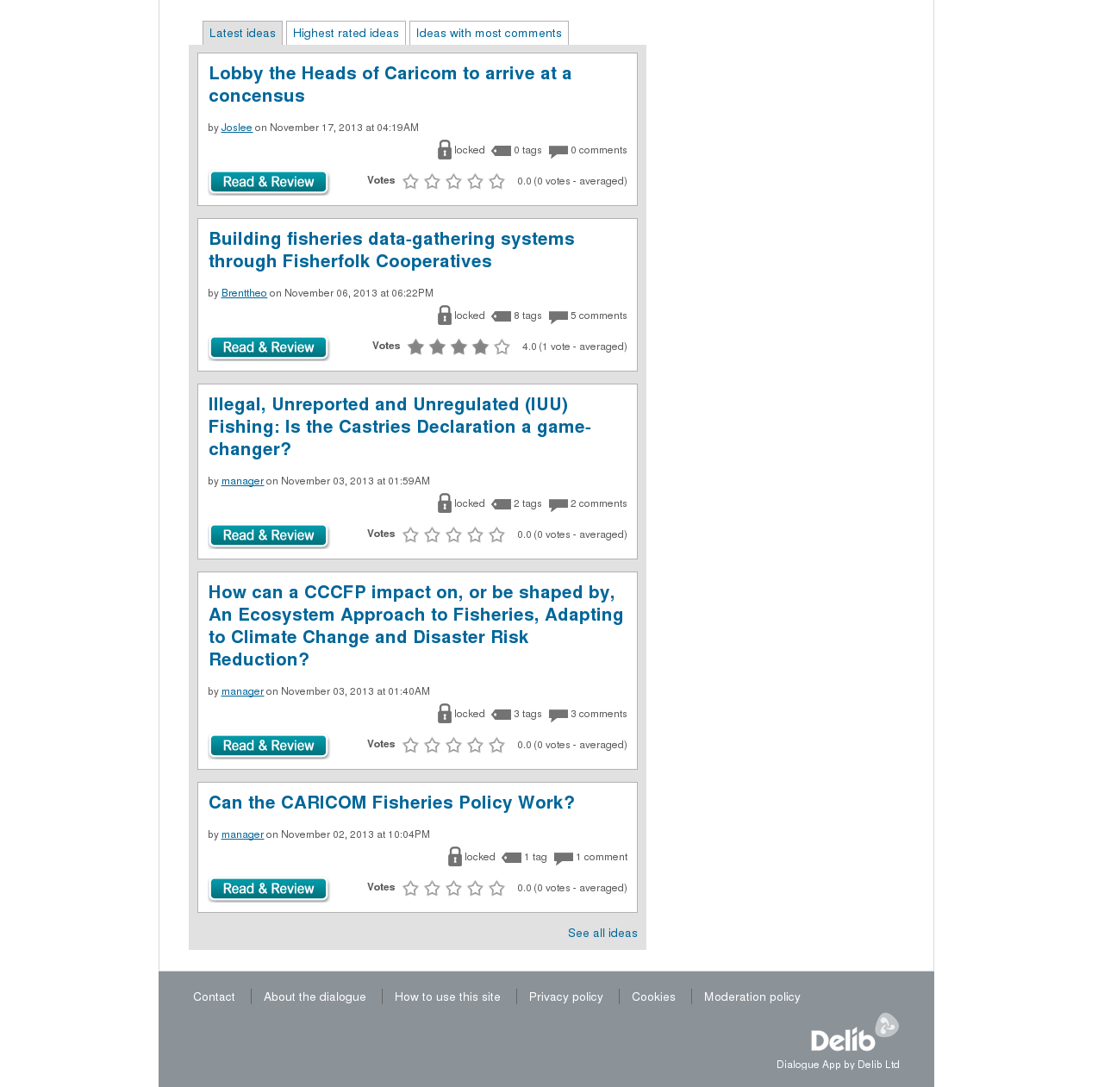

1. AGREEMENT ESTABLISHING THE CARIBBEAN COMMUNITY COMMON FISHERIES POLICY CCCFP (PDF) <http://www.caricom-fisheries.com/LinkClick.aspx?fileticket=FVQaSQ%2BDh68%3D&tabid=242>; retrieved on November 2, 2013
2. CASTRIES DECLARATION (PDF) <http://www.caricom-fisheries.com/LinkClick.aspx?fileticket=eeRVRXUBWGA%3D&tabid=37>; retrieved on November 2, 2013
3. ECONSULTATION FORUM <http://www.dialogue-app.com/910>; retrieved on November 2, 2013
4. IBID
5. ALL IDEAS <http://www.dialogue-app.com/910/ideas/all-ideas>; retrieved on November 2, 2013
6. *Registration was essential for participation under house rules and privacy policies as appended at Appendices 2 and 3.*
7. mFisheries is one of the projects executed by the Trinidad and Tobago segment of the Caribbean ICT Research Programme, CIRPTT; <http://cirp.org.tt/mfisheries/>; retrieved on November 16, 2013
8. CIRPTT mFisheries website: <http://cirp.org.tt/mfisheries/>; retrieved on November 16, 2013
9. A separate database spreadsheet of invitees names, email address, company/organisation and location is appended by separate document - e-consultation_database.xlsx (Excel 97 Workbook)
10. The relevant section of the Terms of Reference is appended at Appendix 1.
11. Campaigns (Newsletters) were pre-designed ahead of the dissemination date. Some were original reminders were made into templates.
12.